# Oxygen and Carbon Dioxide Transport in the Blood

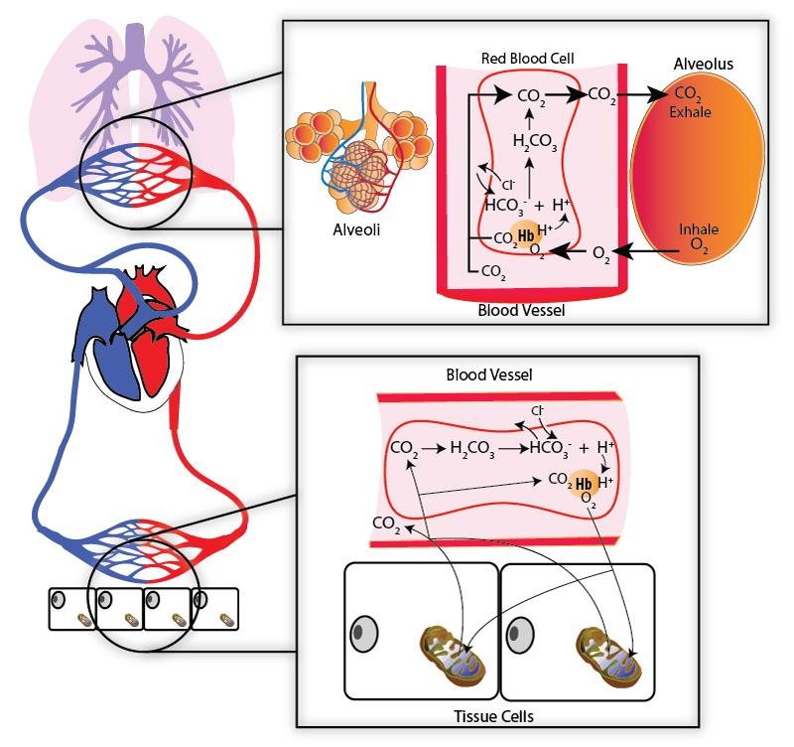

Drawn by J. Shaw at BYU-Idaho, Winter 2014

**The image above shows how oxygen and carbon dioxide move at the tissue level and the alveolus of the lung. Notice that oxygen is either dissolved in the plasma or attached to hemoglobin (really, only a small amount of the total oxygen is dissolved in the plasma at any given time). Carbon dioxide is carried either dissolved in the plasma (a small amount), or attached to the hemoglobin (but not at the same binding spot as oxygen) or converted to bicarbonate (this is what happens to most of the carbon dioxide that is carried in the blood).**

#### Oxygen Transport

In the alveoli, oxygen crosses the respiratory membrane by diffusing down its pressure gradient to pass into the blood where it is mostly transported bound to hemoglobin (98.5%). Since oxygen is not very soluble in water, only a small portion dissolves in the plasma (1.5%). In capillaries feeding the tissues, oxygen is released from hemoglobin and diffuses into the tissues where it is used for cellular respiration. Since oxygen is mostly transported by hemoglobin, the majority of our discussion will be about factors that influence how tightly hemoglobin binds to oxygen (hemoglobin’s affinity for oxygen) including oxygen partial pressures, pH of the blood, partial pressures of carbon dioxide, temperature, and effect of 2,3-diphosphoglycerate, sometimes referred to as 2,3 BPG (This may also be called 2,3 DPG).

#### The Oxygen-Hemoglobin Dissociation Curve

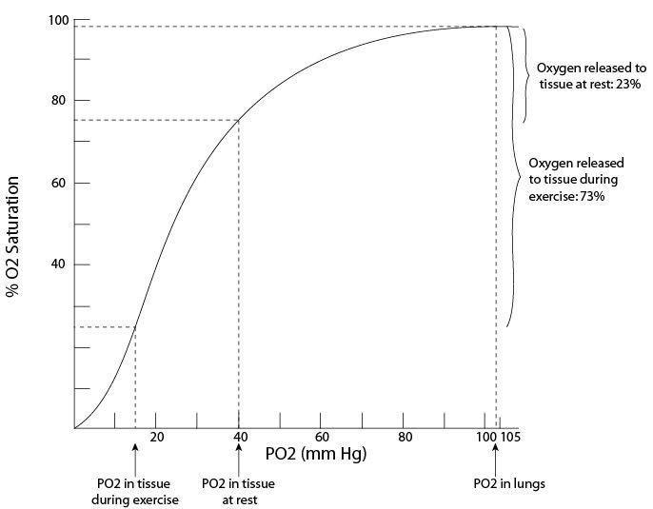

Drawn by J. Shaw at BYU-Idaho Winter 2014

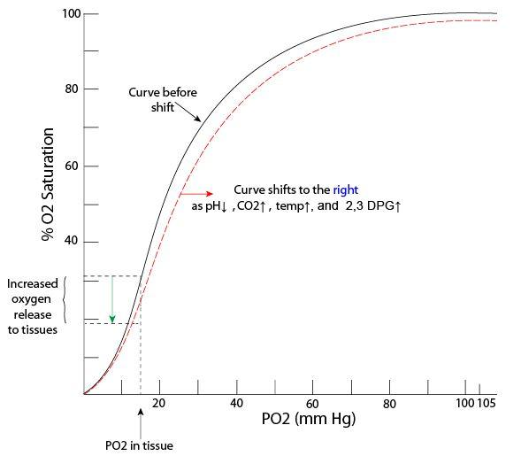

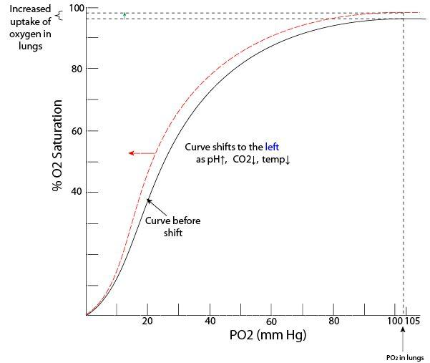

Drawn by J. Shaw at BYU-Idaho Winter 2014**The graphs above show the oxygen hemoglobin dissociation curve. Things such as pH, CO2, temperature and 2,3 DPG can change the affinity of hemoglobin to bind oxygen. This has the effect of shifting the curve to the right or the left.**

Let's first consider the effect of oxygen partial pressures. The percent oxygen saturation of hemoglobin at different partial pressures of oxygen is represented by the oxygen-hemoglobin dissociation curve shown in the images above. A hemoglobin molecule has four heme groups, each of which can bind to one molecule of oxygen. The partial pressure of oxygen in the alveoli is normally 104 mm Hg (sea level) and as the blood leaves the pulmonary capillaries, the hemoglobin becomes 98.7% saturated with oxygen.   
  
You can calculate this partial pressure by taking the atmospheric pressure, at sea level, of 760 mmHg multiplied by the partial pressure of oxygen in the Alveoli which is 13.7% pO2 (not to be confused with the partial pressure of oxygen in the atmosphere which is 21%). 760 mmHg x 13.7% pO2 = 104.12 pO2 mmHg. Find that number on the x-axis of the oxygen hemoglobin curve and you will see that it lands at about 98.7% oxygen saturation on the y-axis.  
  
Here in Rexburg our elevation is almost 5000 feet and at an atmospheric pressure of 632 mmHg. 632 mmHg x 13.7% pO2 = 86.58 pO2 mmHg. For that level, looking at the curve, our hemoglobin would still be about 96.5% saturated. With an asthma attack, our ability to ventilate is compromised and maybe our alveoli oxygen partial pressure drops to 60 mm Hg. Oh no, this isn't good. Luckily, viewing the curve, you can see that even with this extreme drop, hemoglobin is still able to become almost 90% saturated. A flatter curve at the top ensures that even with relatively large decreases in partial pressures for oxygen, hemoglobin is still able to become almost completely saturated. However, notice what happens to the curve at about 50 mm Hg - it starts to become much steeper. This means that at these lower partial pressures for oxygen, even small changes in partial pressures will result in big differences in hemoglobin's ability to bind oxygen. Such is the case in the tissues where the goal is to release oxygen from the hemoglobin so it can enter the cells that need it. With metabolically active tissue like skeletal muscle where tissue levels of oxygen can get down to 15 mm Hg, an even greater percentage will be released to resupply oxygen-starving tissue. To sum up, in the lungs where the partial pressure for oxygen is high, hemoglobin binds more tightly to oxygen so that more can be picked up. In the tissues, where partial pressures are low, hemoglobin's affinity for oxygen greatly decreases so that more oxygen can be released. Isn't it great that hemoglobin is designed this way?

As an interesting side note, this oxygen hemoglobin association curve illustrates why climbers who climb higher than 15,000 feet have oxygen saturation that drops below 90% and begin to experience acute altitude sickness. At 30,000 feet, the height of Mt. Everest, the pO2 mmHg drops to 31, which is only 60% O2 saturation on the curve. At this level, the tissues will not be able to get enough oxygen and every organ of the body will be impacted. The muscles, including the heart, lungs and brain, will be weak and you will not be able to think straight. If hypoxia (low oxygen) is prolonged it can lead to death. This is why climbers at high elevations may temporarily begin to hyperventilate. Hyperventilation decreases carbon dioxide levels, putting their body into a state of respiratory alkalosis that will shift the curve to the left in an attempt to get higher oxygen saturations. Besides allowing one’s body time to acclimatize and frequent periods of rest, it is vital for climbers to use oxygen tanks at heights greater than 15,000 feet and aviators to use pressurized cabins with supplemental oxygen available.

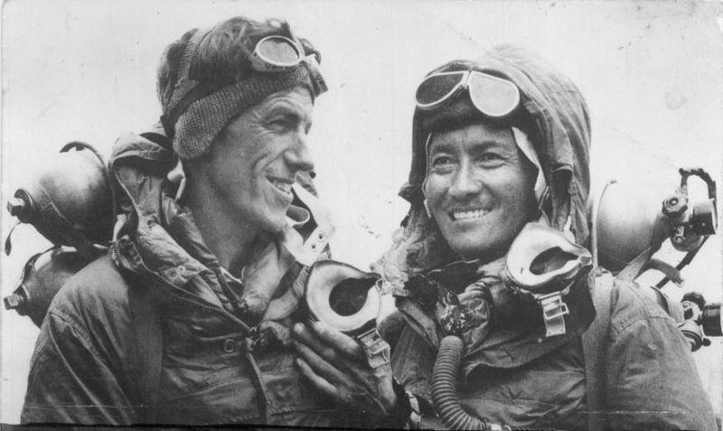

**Edmund Hillary and Tenzing Norgay, First successful ascent of Mt. Everest in 1953.** Author: Jamling Tenzing Norgay https://commons.wikimedia.org/wiki/File:Hillary_and_tenzing.jpg License: Creative Commons Attribution-Share Alike 3.0 Unported license via Wikimedia Commons

The second factor influencing hemoglobin's affinity for oxygen is pH of the blood. Hydrogen ions binding to hemoglobin cause it to have a lower binding affinity for oxygen. So lower pH of the blood means lower affinity. Lactic acid production increases in certain cells that are starved for oxygen. This acts as a signal to the hemoglobin that it needs to release more oxygen to these cells. The lower pH of the tissues will shift the oxygen-hemoglobin dissociation curve to the right; now hemoglobin has a lower affinity for oxygen at any given oxygen partial pressure. The opposite shift happens if pH increases. The effect of pH on hemoglobin binding to oxygen is known as the **Bohr effect.**

Increasing the partial pressures of carbon dioxide can result in changes in pH. The following reversible reaction has come back to haunt you - It is really important to know this!

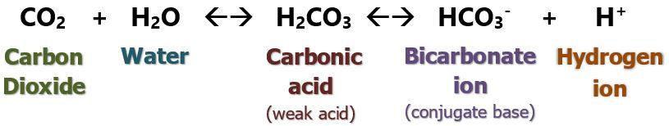

The enzyme carbonic anhydrase found inside red blood cells catalyzes the above reaction. Increasing levels of carbon dioxide will bring about increases in hydrogen ion and drop the pH. Cells that are metabolically active, such as during exercise, are producing lots of carbon dioxide. Wouldn't it be nice if they could get more oxygen? Elevated hydrogen ions and increased carbon dioxide both cause right shifts.  
  
Increased temperature and 2,3-bisphosphoglycerate (BPG) binding to hemoglobin also decreases hemoglobin's affinity for oxygen. Temperature is elevated in metabolic active tissues and 2,3 BPG is produced by red blood cells during glycolysis, which is an anaerobic process. Since red blood cells do not have mitochondria they produce all of their ATP by anaerobic metabolism so they produce significant quantities of 2,3 BPG. Low oxygen levels in the red blood cells stimulate increased glycolysis and even more BPG is produced. During acclimatization to high altitudes there is a decrease in oxygen levels and an increase in need for ATP in the red blood cells which stimulates an increase in 2,3 BPG. Decreased affinity caused by elevated temperatures and 2,3 BPG ensures that metabolically active tissues receive higher amounts of oxygen. The acronym “CADET” is an easy way to remember which factors will shift the oxygen-hemoglobin curve to the right: ‘C’ – Carbon Dioxide; ‘A’ – Acidic pH; ‘D’ – DPG; ‘E’ – Exercise; ‘T’ – temperature. A decrease in these factors would shift the curve to the left.

#### Carbon Dioxide Transport

See image below. Carbon dioxide is released in the tissues as a byproduct of cellular respiration and diffuses into the blood. It is transported to the lungs via the blood in three ways: dissolved in the blood (7%), bound to the amino acids of the globin portion of hemoglobin (23%), or dissolved in the blood as bicarbonate ion (HCO3-) (70%).



Drawn by J. Shaw at BYU-Idaho, Winter 2014

In the tissues, carbon dioxide levels elevate, so it diffuses into blood and enters the red blood cells to be converted to carbonic acid by the enzyme carbonic anhydrase. Hydrogen ions are released and bind to hemoglobin causing more oxygen to be released to the tissues (Bohr effect). Hydrogen ions are buffered since they bind to hemoglobin, so large pH changes of blood in the tissues doesn't change much (7.4 -7.34). Bicarbonate ions produced in the reaction leave the red blood cell in exchange for chloride ions. This process is called the **chloride shift** (see the first image in this reading. You may also [CLICK HERE](http://3.bp.blogspot.com/-Pdv8W87flP4/UNTa6oJGB9I/AAAAAAAAAP8/jeBpYsLJYdQ/s1600/respiratory+system27.png.jpg) to see another detailed image). Carbon dioxide more easily binds to hemoglobin that has released its oxygen (See "Haldane Effect below).

In the lungs, carbon dioxide diffuses down its gradient into the alveoli. This shifts the equation to the left and bicarbonate and hydrogen ions are more readily converted to carbonic acid which then breaks down into carbon dioxide that can cross into the alveoli. In the lungs, oxygen enters the red blood cells and binds to hemoglobin causing hemoglobin's affinity for carbon dioxide to decrease. The effect that oxygen has on carbon dioxide transport is called the **Haldane Effect.** Specifically, the Haldane effect can be explained like this. Oxygen leaving the hemoglobin at the tissue level increases the affinity that hemoglobin has for carbon dioxide. But, oxygen binds to hemoglobin in the lungs and this causes a decrease in affinity for carbon dioxide. The additional released carbon dioxide diffuses across the respiratory membrane into the alveoli to be exhaled.



Shaw at BYU-Idaho, Winter 2014

#### Carbon Monoxide and Fetal Hemoglobin

Carbon monoxide is released from fires and other forms of combustion (i.e., automobiles). It is an odorless, colorless gas and its toxicity arises from its strong affinity, up to 200 times that of oxygen, for hemoglobin. Carbon monoxide attaches to the same binding site as oxygen and severely reduces hemoglobin's ability to carry oxygen. When carbon monoxide binds to hemoglobin it forms a complex called carboxyhemoglobin. Carboxyhemoglobin can revert back to hemoglobin but it takes time, and time is not something that the person suffering from carbon monoxide poisoning has. Thus, to speed up the rate of recovery, treatment consists of giving 100% oxygen in a hyperbaric (high pressure) oxygen chamber. The higher pressure and 100% oxygen can work as antidotes by increasing the rate of removal of carbon monoxide from hemoglobin. Carbon monoxide poisoning is the most common type of fatal poisoning. The Symptoms of carbon monoxide poisoning include lightheadedness, confusion, headache and flu-like symptoms.  
  
The fetus is obviously unable to inhale oxygen, so a couple of cool modifications in design allow it to steal oxygen from the mother. Fetal hemoglobin is more concentrated in red blood cells and it also has a greater affinity for oxygen compared to maternal hemoglobin. Its oxygen-hemoglobin dissociation curve is to the left of that for maternal hemoglobin. This allows fetal blood to "grab" oxygen from maternal blood when they mix in the placenta. When oxygen attaches to fetal hemoglobin, more CO2 is released (Haldane effect).

Read this online at <https://books.byui.edu/bio_265_anatomy_phy_II/534__oxygen_and_carb>