# Respiratory Control by the Medulla Oblongata

Brainstem areas in the medulla oblongata and pons contain groups of neurons that are particularly important in regulating ventilation. The **ventral respiratory group (VRG)** and the **dorsal respiratory group (DRG)** are located in the medulla oblongata and make up the medullary respiratory center.

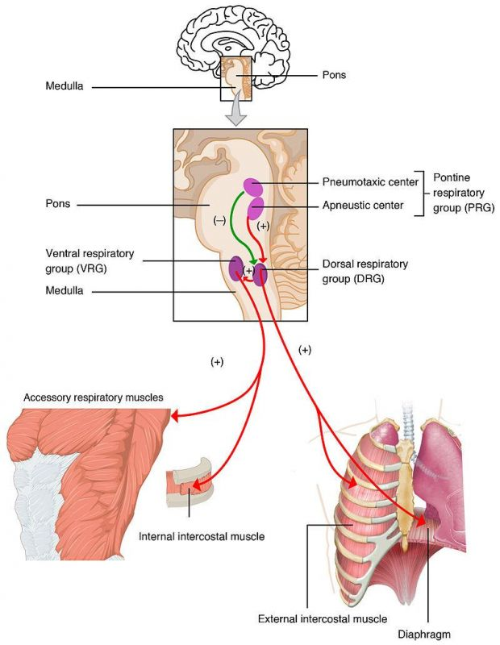

**Respiratory Centers of the Brain.** Author: Open Stax College, License: CC BY 3.0 via WikimediaLink: https://commons.wikimedia.org/wiki/File%3A2327_Respiratory_Centers_of_the_Brain.jpg

The DRG helps maintain a constant breathing rhythm by stimulating the muscles of inspiration to contract at regular intervals after a passive exhalation. The DRG is not active during passive exhalation. A normal and regular stimulating signal to inspiratory muscles will create a breathing rate that falls somewhere between 12-15 breaths/minute.

The VRG is involved in forced breathing. Activity in the VRG can cause accessory muscles to contract and increase the rate and expansion of the chest cavity for inspiration and neurons from the VRG can also stimulate muscles to force air out of the lungs (or forced expiration).

With alcohol and opioid narcotic overdose, these medullary centers may become suppressed to the point of complete breathing cessation. The drug BIMU-8 has the opposite effect and will stimulate medullary neurons to increase respiratory rate.

The **DRG** receives information coming from peripheral chemoreceptors (monitor blood gas levels) and mechanoreceptors (monitors movement of muscles and joints). The DRG also receives information from the pontine respiratory group. All of this information is assessed and then signals are sent to the VRG to modify its actions on ventilation to either breathe more rapidly or deeply or less frequently depending on the need of the muscles and body.

The **pontine respiratory group (PRG)receive** information from chemoreceptors and mechanoreceptors in the body. The PRG also receives signals from higher areas of the brain and acts to modify activities in the DRG. The PRG is in the pons of the brain and includes both the pneumotaxic center (which inhibits the DRG to slow down the respiratory rate) and the apneustic center (which controls deep breathing or gasping). The PRG helps adjust breathing rate and patterns for activities like sleep or exercise.

When we take a very large breath, what prevents us from over inflating the lungs? There are pulmonary stretch receptors in the lungs. Once these stretch receptors are activated, action potentials travel through the Vagus nerve to the inspiratory VRG area of the medulla and turn off or inhibit the signal of the inspiratory VRG to inhibit inspiration and begin expiration. This is known as the **Hering-Breuer Inspiratory Reflex.**

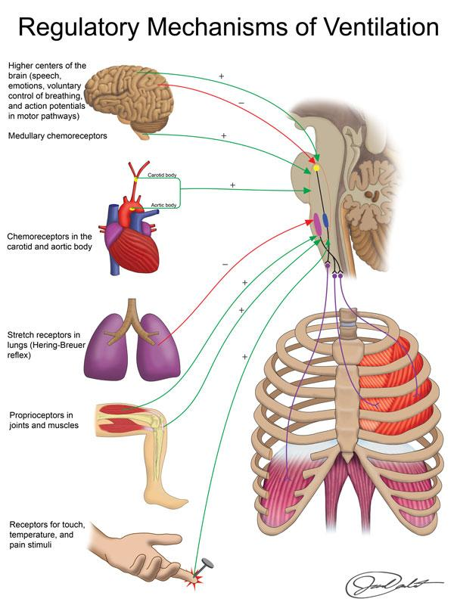

Image by BYU-Idaho Winter 2015

#### How Long Can You Hold Your Breath?

The cerebral motor cortex can override medullary control of respiration. We are well aware of our ability to voluntarily control breathing rate and depth or hold our breath. The average person in good health can hold their breath for up to 2 minutes. Going longer causes carbon dioxide to build up triggering a reflex that makes the diaphragm and intercostals start to spasm. If carbon dioxide levels get too high, the medullary respiratory center overrides voluntary centers of the brain forcing you to gasp for air. This is evidenced by the fact that those who drown almost always have water in their lungs - that gasp for air fills the lungs with water.  
  
Some competitive swimmers practice a somewhat dangerous technique called "oxygen loading". They force hyperventilate before the race so that they can hold their breath longer while underwater. Hyperventilation increases blood oxygen levels, but what does it do to carbon dioxide? Carbon dioxide levels will decrease to very low levels. Since the main stimulus telling you to take a breath is elevated CO2, by the time CO2 builds up again from holding one’s breath, oxygen levels have become dangerously low and the swimmer may "pass out" underwater. Essentially, they are removing their stimulus to breathe and then it may be too late!  
  
World-record holders for length of time holding breath, submerge themselves under cold water to reduce oxygen consumption by tissues and reduce carbon dioxide production. They also do something called "lung-packing" where they inhale very deeply to fill their lungs to capacity and then force additional air into their lungs through a glossopharyngeal "swallowing" technique. "Free divers" who dive to scuba diver depths without equipment use a similar technique. It also helps to inhale pure oxygen before you go down. The world record for holding one’s breath underwater is 22 minutes and 22 seconds after inhaling pure oxygen and 11 minutes 35 seconds without pre-inhaling pure oxygen.

Read this online at <https://books.byui.edu/bio_265_anatomy_phy_II/541___respiratory_co>