# Hyaline Cartilage

For us to understand bone we need to first discuss another connective tissue that is intimately associated with bone, hyaline cartilage. Most of the bones in our body started out as a hyaline cartilage model that was later converted to bone. The growth plates in growing bones are composed of hyaline cartilage and the articular ends of the long bones are lined with hyaline cartilage. (Note: an articulation is a joint, the articular ends of the bones are the part of the bone involved in forming the joint. The articular cartilage gives the bones a smooth, durable surface for forming the joint). As is true for all connective tissue, hyaline cartilage gets its characteristics from its extracellular matrix. This semi solid matrix is composed of “**ground substance**” and connective tissue fibers. The ground substance is composed of a huge complex of carbohydrates and protein. The core of the ground substance is **hyaluronic acid**, a long, unbranched polysaccharide composed of repeating disaccharides. Branching off of this back bone are large numbers of complex **proteoglycan** molecules. Picture in your mind a feather, hyaluronic acid would represent the central shaft of the feather and the proteoglycans would be the parts branching off of that shaft. In cartilage the ground substance is associated with extracellular proteins to create a strong, compression resistant matrix. These proteins, collagen and elastic fibers, also add strength and resiliency to the cartilage.

Two closely related cells are found in hyaline cartilage, the **chondroblasts** and the **chondrocytes**. Chondroblasts produce new matrices on the surface of the cartilage. Once the chondroblast is surrounded by a matrix it becomes a chondrocyte. Chondrocytes are housed in cavities in the matrix called **lacunae** (lacuna, singular) and can also produce new cartilage. The **perichondrium** surrounds the cartilage. As blood vessels enter this area it will be known as the **periosteum**. It is composed of two layers, an **outer fibrous layer** and an **inner chondrogenic layer**. The fibrous layer is composed of dense fibrous connective tissue, while the chondrogenic layer contains chondroblasts. Note that articular cartilage lacks the perichondrium. The figure below shows the components of hyaline cartilage.

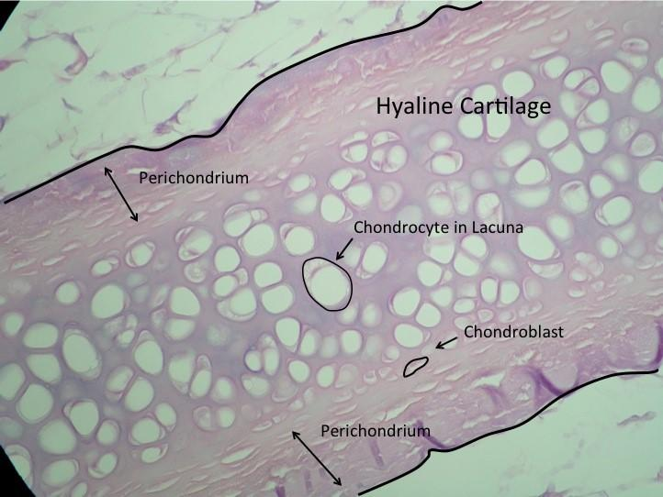

**Figure Showing the Structure of Hyaline Cartilage.**Image captured by BYU-Idaho professor.

Cartilage grows by two different processes, appositional growth and interstitial growth. **Appositional growth** occurs on the surface of the cartilage as chondroblasts lay down new layers of matrix. **Interstitial growth** occurs within the cartilage as chondrocytes proliferate and create new matrix internally.

Read this online at <https://books.byui.edu/bio_265_anatomy_phy_II/611_hyaline_cartilag>