# Bone Cells

Three cell types can be found in bone; **osteoblasts, osteocytes** and **osteoclasts**.

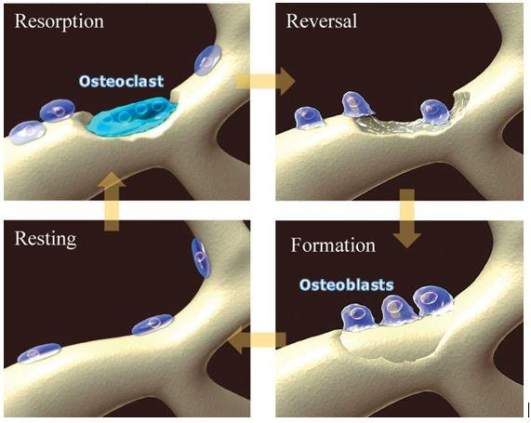

**Bone Remodeling: Osteoclasts breaking down bone and Osteoblasts rebuilding bone.** Author: Adapted from Novert’s Pharmaceuticals. License:https://images.nature.com/full/nature-assets/pcan/journal/v7/n2/images/4500705f1.jpg

Recall that the meaning of the following medical terminology to help you understand the role of each of these cells: **Osteo-** = bone; **-blast** = immature cell involved in development of tissue; **-cyte** = cell; **-clast** = breaks up or crushes.

The **osteoblasts** and osteocytes are actually different stages of the same cell. Osteoblasts are the cells that have the primary responsibility of producing new bone matrices. They are derived from mesenchyme cells found in the periosteum and the bone marrow. These **mesenchymal stem cells** or **osteoprogenitor cells** differentiate into osteoblasts.

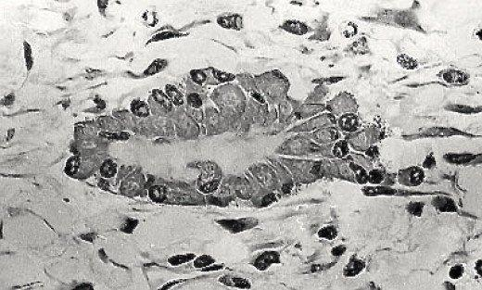

**Group of Osteoblasts making osteoid.** Title: Bony nidus 2.jpg Author: Robert M. Hunt License: CC BY 3.0 via Wikimedia Commons File: https://commons.wikimedia.org/wiki/File%3ABony_nidus_2.jpg

Osteoblasts are found on the outer and inner surfaces of bones. As they produce matrices they eventually become surrounded and encased in the bony matrix, at which point they become osteocytes (shown below).

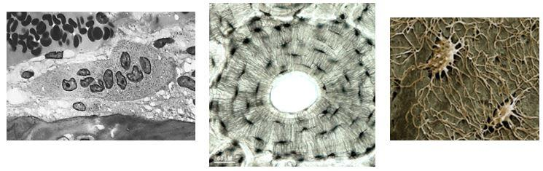

**Osteocytes encased in bony matrix; (2) Osteocytes in osteon; (3) Osteocytes closeup.**1) Robert M. Hunt; License: CC BY 3.0 via Wikimedia Commons File: https://commons.wikimedia.org/wiki/File%3AOsteoclast.jpg;2) Dr. Tim Arnett, University College London; License: Free use for non-commercial educational purposes with attribution. Permission kindly granted by Dr. Arnett via email on October 19, 2017. http://boneresearchsociety.org/media/gallery/6l.jpg.2000x2000_q85_autocrop.jpg; 3) Kevin Mackenzie, University of Aberdeen, Wellcome Images (B0008430). License: CC BY-NC-ND 4.0, https://62e528761d0685343e1c-f3d1b99a743ffa4142d9d7f1978d9686.ssl.cf2.rackcdn.com/files/74575/width668/image-20150312-13485-1x9zt8u.jpg

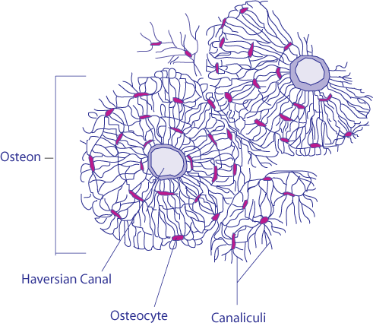

**Osteocytes:** Recall from your study of bone histology that osteocytes are found in the **lacunae** of the **osteons**. In the picture below of an osteon, the dark circle in the center is the **central canal** (also called Haversian Canal) which houses blood vessels. Notice the **concentric lamellae** (layers of matrix) surrounding the central canal. Between the individual lamellae are dark oval shaped structures, these are the lacunae and within these lacunae reside the osteocytes. Finally notice the tiny crack-like features stretching between the lacunae, these are the **canaliculi** that contain processes extending from the osteocytes, allowing them to communicate with each other. Once encased by matrices the exact function of the osteocytes is not clear. They may act as sensors that detect stresses on the bone and then release growth factors that stimulate the osteoblasts to create new bone to withstand the stress.

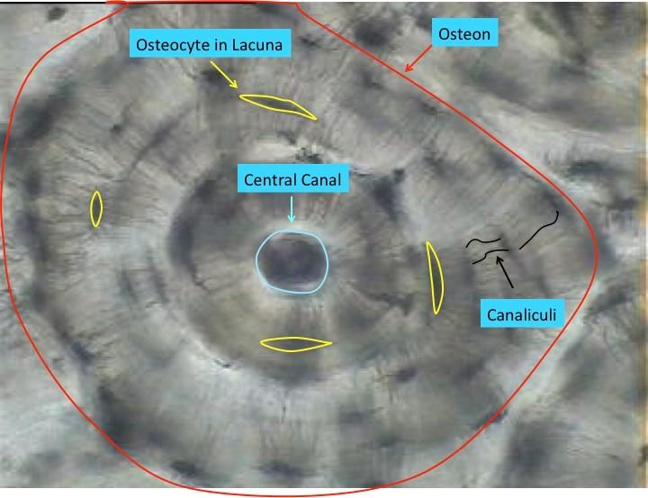

**High Power micrograph of a single osteon.** Image captured by BYU-Idaho professor.

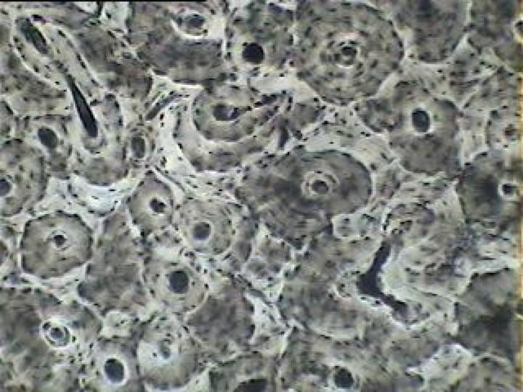

**Low power image of compact bone showing many osteons.** Image captured by BYU Idaho professor

Our current understanding is that the **osteoclasts** descend from macrophages (monocytes). Several macrophages fuse together to form the osteoclasts. These cells are quite large and multinucleated. Their role is to break down bone, a process referred to as **resorption**.

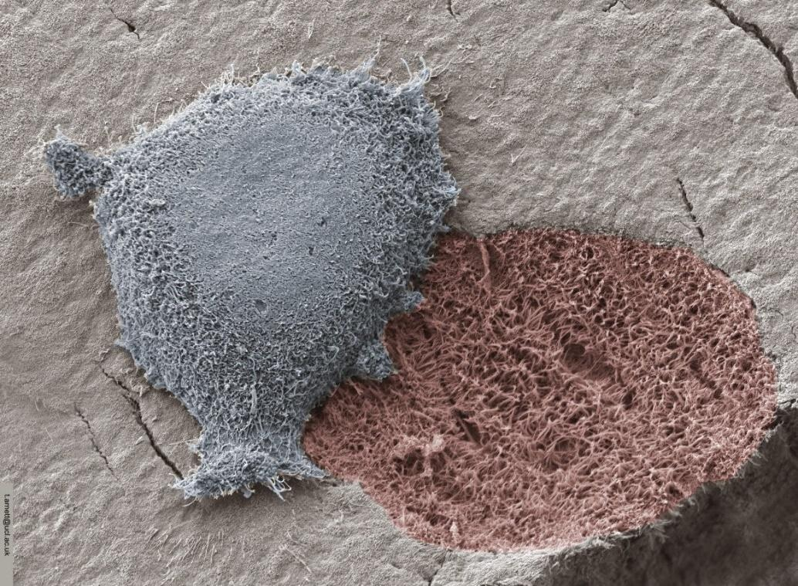

**Osteoclast and resorption pit from scanning electron micrograph.** Image by: Dr. Tim Arnett at University College London. License: Free use for non-commercial educational purposes with attribution. Permission kindly granted by Dr. Arnett via email Oct. 19, 2017. http://boneresearchsociety.org/media/gallery/Osteoclast_resorption_04.jpg.2000x2000_q85_autocrop.jpg

At first this might seem counterintuitive for our bodies to break down bone but it is necessary for a number of functions including remodeling of bone to withstand new stresses, releasing Ca2+ into the blood to maintain Ca2+ homeostasis, conversion of woven bone to mature bone and maintaining proper proportions of bones as they grow. Bone is known to be a very dynamic tissue that is constantly changing. It is estimated that we recycle all of our bone about once every ten years.

The process of bone resorption occurs in two parts, first the liberation of the minerals and second, the enzymatic digestion of the collagen. Osteoclasts secrete lysosomal enzymes to digest the organic matrix, and protons (H+) to create an acidic environment which acts to liberate the minerals. The “digested” bone matrix is then endocytosed into the osteoclast, transported through the cell and released on the opposite side into the interstitium and the blood.

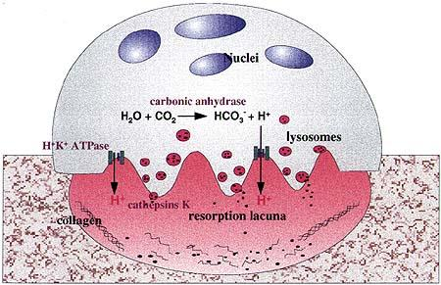

**Resorption of Bone by Osteoclasts.** Author: Dietrich Bromme, Journal of Drug News and Perspective. Volume 12 Issue 2, March 1999.  https://journals.prous.com/journals/dnp/19991202/html/dn120073/images/Brom2.JPG Permission for educational reuse kindly granted by Josh Johnson via email from Clarivate in December 2017.

This can be a very important homeostatic step in helping to maintain blood Ca2+ levels. Calcium homeostasis will be discussed in detail later in this module.

Check out this link to see the Bone Remodeling Process: <https://vimeo.com/54792406>

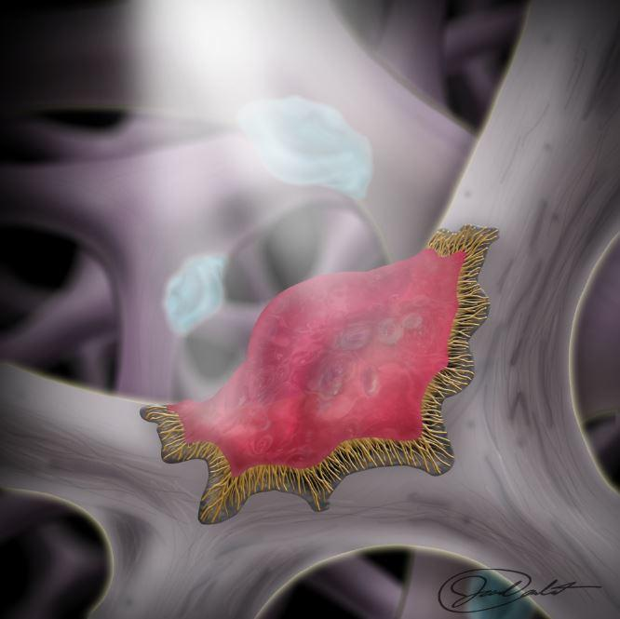

**Osteoclast.** BYU-Idaho image created Winter 2015 by Jared C.

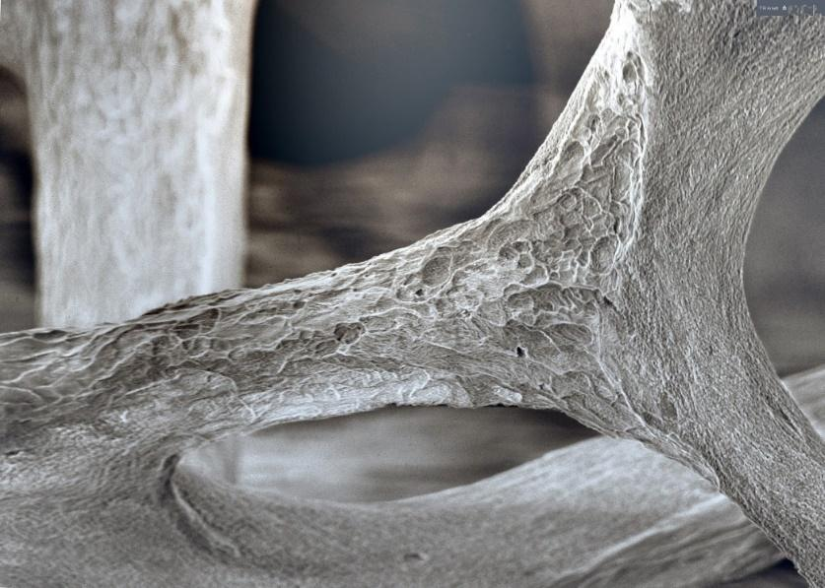

**Bone Resorption in Osteoporotic Bone.Trabecular bone eroded by osteoclasts in 3rd lumbar vertebra of 71-year-old woman.** Image by: Dr. Tim Arnett at University College London. License: Free use for non-commercial educational purposes with attribution. Permission kindly granted by Dr. Arnett via email Oct. 19, 2017. http://boneresearchsociety.org/media/gallery/13lg.jpg.2000x2000_q85_autocrop.jpg

Read this online at <https://books.byui.edu/bio_265_anatomy_phy_II/614_bone_cells>