# Bone Growth in Children and Repair of Bones

As we watch children grow it becomes obvious that bones continue to grow for many years after we are born. During this growth, bones increase in length as well as diameter. Two types of bone growth allow for these changes, **appositional bone growth** and **endochondral bone growth.**

#### Appositional Bone Growth

Appositional growth occurs as osteoblasts lay down new layers on the surface of the bone and increase the bone width. Osteoblasts in the periosteum begin to form new bone in long ridges, creating grooves of bone. Blood vessels grow into these grooves and the osteoblasts continue to make the walls of the grooves taller until they completely surround the blood vessel forming a tube. The osteoblasts continue to create new bone within the tube until a new osteon has been formed. To create a smooth surface, osteoblasts lay down a layer of bone around the entire circumference of the bone creating circumferential lamellae. As is the case with all bone formation, osteoclasts become involved with remodeling of the bone. For example, as osteoblasts lay down new layers on the surface of the shafts of long bones, osteoclasts remove bone from the medullary canal to maintain a constant ratio between the thickness of the bone and the diameter of the bone. Hence, as the outside diameter of the bone gets larger so does the diameter of the medullary cavity. Appositional growth is responsible for the increase in diameter of long bones and for virtually all growth in flat, short and irregular bones.

#### Endochondral Bone Growth

Recall that when the long bones formed, a disk of hyaline cartilage remained between the diaphysis and the epiphyses of the bone. This cartilage continues to grow by interstitial cartilage growth allowing the bone to increase in length. At the same time, endochondral ossification continues in the diaphysis. As we are growing these two processes occur at approximately the same rate and the width of the growth plate remains constant as new cartilage forms and the older cartilage is converted to bone. Think of two runners in a race that are about 10 yards apart running at the same pace. The front-runner is hyaline cartilage growth and the rear runner is endochondral ossification. As long as they run at the same pace they will both be moving towards the finish line but the space between them will remain constant. This is what is happening during endochondral bone growth.

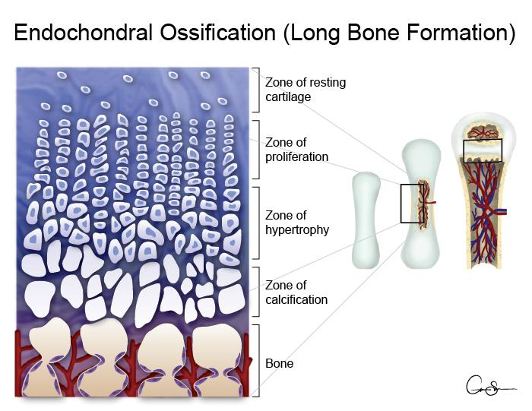

Image Created by BYU-Idaho student Cameron Sprouse Spring 2016

The image above has been shown before, but is here again to remind us of the zones of endochondral ossification. As one moves from the epiphysis towards the diaphysis we find younger cartilage near the epiphysis and older cartilage/ossified bone as we move toward the diaphysis. Because new cartilage is constantly being formed the epiphyses gradually move away from the diaphysis and the bone grows. If we were to examine the growth plates microscopically we would observe advancing stages of ossification as we moved toward the diaphysis. For the purpose of study, histologists have divided the growth plates into different zones based on the stage of ossification. If we start on the epiphyseal side of the plate, we first see the zone of resting cartilage. In this zone the chondrocytes are randomly arranged and are not dividing rapidly. The next zone is the zone of proliferation. In this zone the chondrocytes are dividing rapidly, producing new cartilage by interstitial growth. The chondrocytes in this zone are seen as long columns of cells. The columns form as the chondrocytes divide, always in the same plane, creating a stack of cells kind of like a stack of plates. In these stacks the younger cells are near the epiphyses and the older cells towards the diaphysis. Next, comes the zone of hypertrophy. In this zone the chondrocytes enlarge. Again, the younger cells are those closest to the epiphyses. The final region is the zone of calcification. In this zone the chondrocytes produce calcified cartilage and then die. Blood vessels from the medullary cavity grow into the calcified cartilage bringing osteoblasts that then convert the calcified cartilage to bone. The final step is remodeling of the woven bone to form lamellar bone. As long as our two runners are going at the same pace the growth plate remains and the bone continues to grow. At puberty, when new hormones begin to appear in the blood, the dynamics of our race changes. Both runners see the finish line and begin to run faster. This is the cause of the growth spurt in adolescent boys and girls. It is not unusual to see several inches of rapid growth during this period of time. However, the second runner starts to pick up the pace and begins to catch the lead runner. In other words, the rate of ossification becomes faster than the rate of cartilage growth. Eventually the second runner catches the front runner and the race is over. In the bone, the growth plate is completely ossified and linear growth ceases. The growth plate is no longer called an epiphyseal plate at this time, it is now called an epiphyseal line.

Read this online at <https://books.byui.edu/bio_265_anatomy_phy_II/622_bone_growth_in_c>