Functional Anatomy of the Urinary System
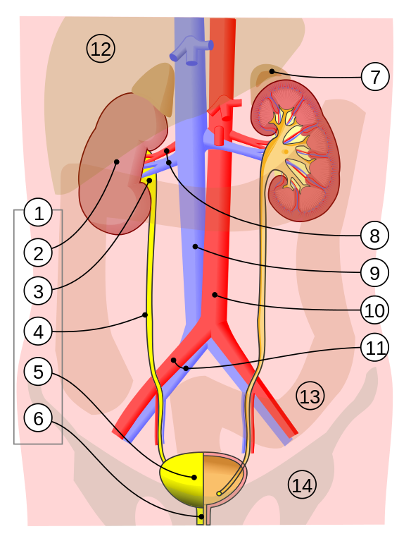
Urinary System: 1. Human urinary system: 2. Kidney, 3. Renal pelvis, 4. Ureter, 5. Urinary bladder, 6. Urethra (Left side with frontal section) 7. Adrenal gland, 8. Renal artery and vein,
9. Inferior vena cava, 10. Abdominal aorta, 11. Common iliac artery and vein.
With transparency: 12. Liver, 13. Large intestine, 14. Pelvis

Title: :Urinary system.svg; Author: Jordi March I Nogué;
Site: https://books.byui.edu/-kyb;

License: Creative Commons Attribution-Share Alike 3.0 Unported license.

Imagine stepping aboard the magic school bus and entering the urinary system through the exit, or the urethral orifice. Perhaps going backward through the direction of urine flow of the kidneys will help us see the design of the system. Moving through the urethral orifice will lead to the urinary bladder. The urinary bladder is designed to expand and fill with urine to a maximum capacity of approximately 500ml. Despite rumors of more frequent female urination, there is probably no inherent difference between male and female bladders, except for in pregnancy as the baby sits right on top of the bladder. Lesson one, never travel great distances with a full term pregnant woman unless you like to stop at all bathrooms en route. The habit of urination (micturition) has a direct bearing on the discomfort felt with bladder stretching. If the individual has the habit of urinating frequently, he (or she) may be "uncomfortable" retaining the average amount and therefore will need to urinate more frequently. Of course, there is also the possibility that the bladder of the individual has a smaller capacity. There is, however, a difference between men and women in the length of the urethra. The shorter length of the female urethra and its proximity of the urethral orifice to the anus makes women more susceptible to developing bacterial infections of the bladder (urinary tract infections or UTIs).

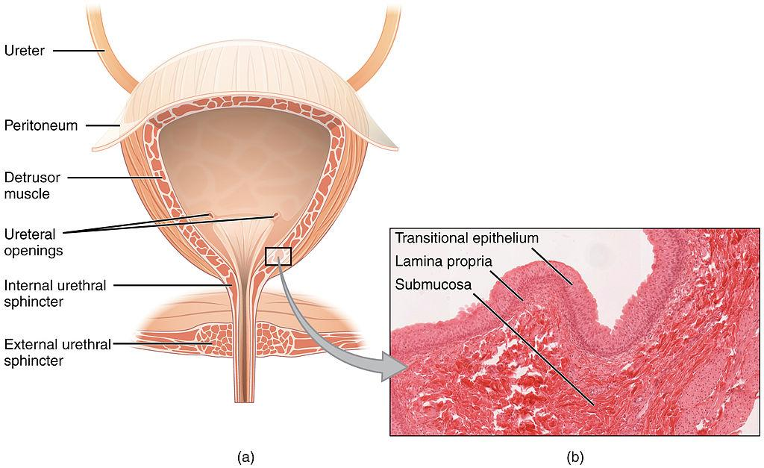
Anatomy of the Bladder.
File: 2605 The Bladder.jpg; Author: OpenStax College;
Site: Wikimedia commons: https://books.byui.edu/-WjCS;
License: This file is licensed under the Creative Commons Attribution 3.0 Unported license.
There are three semi-sealed openings in the bladder; the urethral opening, and two ureteral openings (notice the subtle spelling between urethral and ureteral). At the bottom of the bladder is the opening to the urethra which is sealed by the internal urinary sphincter, a reflexively controlled muscle. On the posterior side, also near the bottom of the bladder are two ureteral openings, each is associated with a hollow tube called a ureter that leads to each kidney. The smooth muscle walls of the ureters propel the urine along to the bladder. They compress in a series of wavelike contractions known as peristalsis to move the urine through the ureters in only one direction. Let's take the magic school bus through the urethral opening on the right. Entering the ureter will lead us through a tube (ureter; 10 - 12 inches long) towards the right kidney. The ureter is about 3-4mm in diameter and is composed of transitional epithelium, smooth muscle and pain fibers. Fortunately, the magic school bus is only 2mm in diameter, imagine trying to squeeze a 6mm crystalized (meaning sharp pointing edges) kidney stone down the ureter….yeeouziee! (Click Here to see a Kidney Stone Pictures)

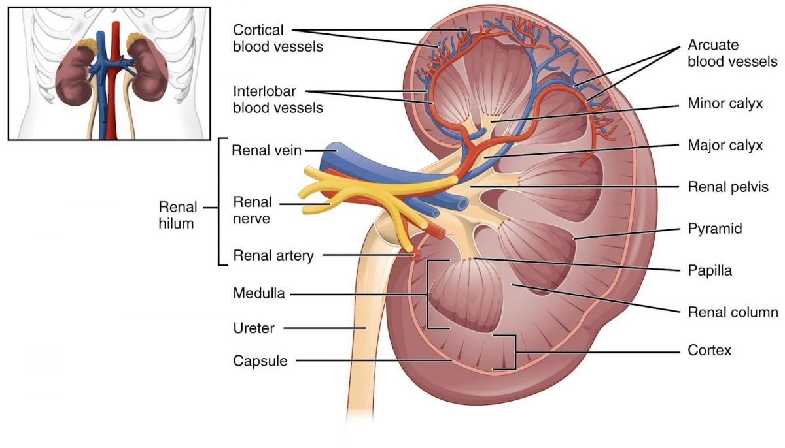
The Kidney.
Title: 2610_The_Kidney.jpg; Author: OpenStax; Site: http://cnx.org/contents/14fb4ad7-39a1-4eee-ab6e-3ef2482e3e22@6.17:173/Anatomy_&_Physiology; License: licensed under a Creative Commons Attribution 4.0 License.

As we enter the kidney, the ureter will widen and form a structure called the renal pelvis which will branch into 5-6 different extensions called major calyces (Calyx is singular). The point that we entered the kidney into the renal pelvis is known as the hilum, represented by a concave structure of the kidney (think of a kidney bean). The hilum is also the entry point of the renal artery and nerves and the exit point for the renal vein, lymphatics and the ureter. If we continue to move, the major calyces branch into the minor calyces that end at a wall with thousands of small holes. Each of the small holes dumps urine into the minor calyx. Shrinking the bus down further we could enter one of the holes to try and trace the source of the urine. Entering one of these small holes we enter a collecting duct which will eventually take us to the functional unit of the kidney, the nephron.

Read this online at https://books.byui.edu/bio_265_anatomy_phy_II/712___functional_ana

