Tubular Reabsorption
Image produced by BYU-Idaho

Up to this point, we have discussed one structure of the nephron (the renal corpuscle) and its relation to filtration, the first step in urine formation. We will now move our discussion to the remaining tubule compartments of the nephron. The tubule compartments of the nephron include: the proximal tubule, the loop of Henle, the distal tubule and the collecting duct (Fig. Nephron). The purpose of the tubule components is to selectively reabsorb tubule fluid back into the blood. If the majority of the fluid was not recovered, the kidneys would excrete the entire blood plasma volume in about 20 minutes!

Nephron Segment | Substance | Reabsorption
Proximal Tubule | Water  Na⁺  Glucose | 67%  67%  100%
Loop of Henle | Water  Na⁺ | 15%  25%
Early Distal Tubule | Water  Na⁺ | 0%  5%
Late Distal Tubule Collecting Duct | Water  Na⁺ | 8-17%  3%

Table: Reabsorption of key elements along the nephron tubules
As mentioned, the capillary beds of the nephron are unique in that they form two capillary beds in succession. The first capillary bed, the glomerulus, functions as the site of filtration. The second capillary bed, the peritubular capillaries and vasa recta, which are associated with the tubular components, function as the site of reabsorption. Reabsorption is necessary because the process of filtration does not decipher between what is "good" and what is "bad". The filtration system only works through pressure, size and charge. Thus, things like glucose (good), that are necessary for all cells, are filtered out of the blood.
The nephron must selectively put glucose back into the blood so that it is not lost in the urine. In fact, the nephron is so efficient at reabsorbing glucose that glucose in the urine is a sure sign that things are terribly wrong in the body (diabetes). Thus, the main function of the nephron tubules is to recover most of the fluid (water) and solutes filtered at the glomerulus.
The proximal tubule is responsible for the reabsorption of the largest fraction of filtrate. It reabsorbs about 70% of filtered NaCl and water and 100% of the filtered glucose and amino acids. Reabsorption is a highly specific process that occurs through specific proteins located on the apical membrane of kidney tubule cells. Reabsorption of substances mainly occurs through secondary active transport with Na⁺. This transport is made possible by the activity of the primary active transporter, the Na⁺/K⁺ ATPase pump. This pump creates a large gradient for the reabsorption of Na⁺ which can be coupled with a variety of other substances. Because this process is protein specific it can become saturated. For example, in diabetics, the blood glucose can become so high (> 350mg/dl; normal 100mg/dl) that the reabsorption proteins in the proximal tubule can become saturated with glucose. As a result, glucose reabsorption may be incomplete since glucose reabsorbing proteins are only found in the proximal tubule. Any glucose that is not reabsorbed will be found in the urine. The Nephron has enough transporters to compensate for an increased glucose load in the blood plasma of 200 mg/dl, and anything greater will exceed the renal threshold. Each substance filtered by the nephron has an independent renal threshold value (Fig. Nephron transport).

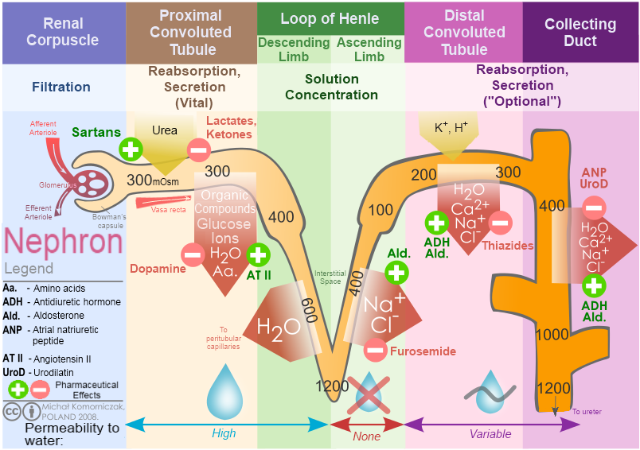
https://books.byui.edu/-ofo License: Creative Commons Attribution 4.0 License.

The main function of the loop of Henle is to help concentrate or dilute the filtrate. The loop can change the amount NaCl that it pumps into the medullary interstitium. This pumping action of NaCl can increase or decrease the tonicity of the surrounding tissue. The late distal and collecting ducts can then use this gradient (hypertonic) to regulate the reabsorption of the remaining water. In conditions of over hydration, the pumping of NaCl is reduced by the loop of Henle resulting in less water being reabsorbed and, therefore, a higher urine output. In contrast, under-hydration produces conditions of hypertonicity in the medullary interstitium which serves to increase reabsorption of water and reduce the urine output. The loop structure of this section allows for the regulation of water reabsorption to occur. The exact mechanism of this regulation will be discussed later.

Read this online at https://books.byui.edu/bio_265_anatomy_phy_II/722__tubular_reabsor

