# Buffers

You may recall from last semester that buffers are substances in the body fluids that resist changes in pH. Buffers are composed of weak acids and the conjugate bases of those acids. They have the advantage of acting very quickly, almost immediately. So, when you eat citrus fruit and absorb the acids in them, the pH of the blood remains relatively constant because of the action of blood buffers. The weakness of buffers is they only resist changes, they do not prevent changes. Therefore, in a buffered system if you add an acid or a base you will see a small change in pH, but not nearly as large a change as would be observed in the absence of a buffer.

The most important buffer in the blood is the bicarbonate buffer system, see below.

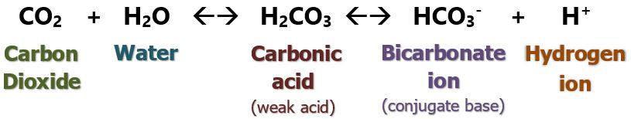

H2CO3 = carbonic acid (the weak acid)

HCO3- = bicarbonate ion (the conjugate base of carbonic acid)

A chemist would tell you that the bicarbonate buffer system should not be very efficient in the body. Indeed, if you placed this buffer into a beaker and tried to maintain a pH of 7.4, it would not do a very good job. Why then is it so effective in the body? The answer lies in its close ties to the other two lines of defense, the lungs and the kidneys. If we look at just the first part of the equation above, CO2 + H2O <-> H2CO3 , we note that one of the key components is carbon dioxide. Therefore, it is directly related to the respiratory system, since the levels of carbon dioxide in the blood can be regulated by increasing or decreasing our respiration. For example, if an acid is added, carbon dioxide is produced which can be excreted in the lungs. The last half of the equation H2CO3 <-> H+ + HCO3- is linked to the kidneys. The kidneys can either excrete or reabsorb bicarbonate or H+, as needed. Because the concentrations of both carbon dioxide and bicarbonate can be regulated via the lungs and kidneys, this buffer system becomes the centerpiece of the body’s mechanisms for maintaining proper pH.

Although the bicarbonate system is the most important blood buffer, other buffer systems play important roles in other parts of the body. Acid-base changes inside cells are buffered by the intracellular proteins as well as the phosphate buffer system. The phosphate buffer system also plays an important role in the urine, along with the ammonia/ammonium ion buffer system.

Read this online at <https://books.byui.edu/bio_265_anatomy_phy_II/741___buffers>