Organs of the Digestive System
The overall function of the digestive system design is to take food into the body by ingesting it, digesting that food by mechanically and enzymatically convert complex substances such as carbohydrates, proteins and fats (or lipids) to simpler forms that can be absorbed to provide energy to the cells, assimilating those nutrients the body needs through absorption, and eliminating the unnecessary remaining wastes. The organs involved in this process are illustrated below. Each of these hollow organs is separated throughout by strategically placed sphincters.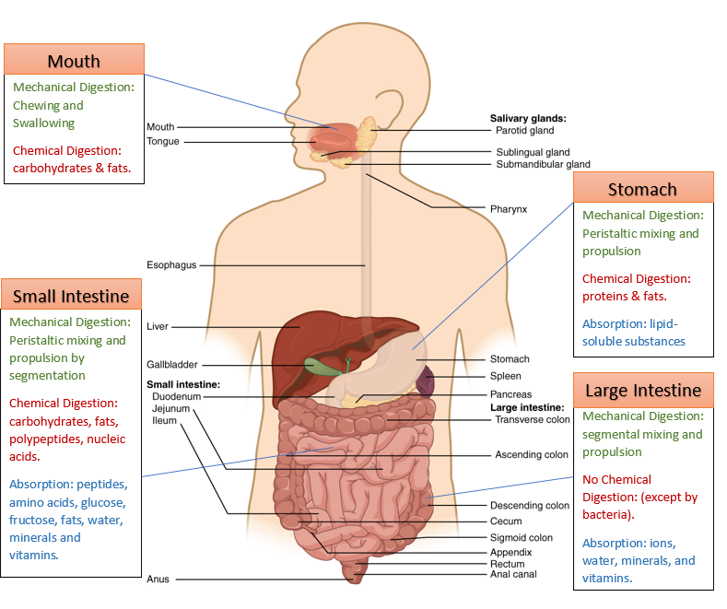
Digestive System. Author: Open Stax. License: [CC BY 4.0 (http://creativecommons.org/licenses/by/4.0)], Labels added. Link:https://cnx.org/resources/be99b5de127eabcdb09445e384d5a47a9564eeeb/2401_Components_of_the_Digestive_System.jpg

Mouth
The mouth has three structures which aid in digestion; teeth, salivary glands and the tongue. The teeth begin the process of mechanical digestion by grinding (mastication) of the food and breaking it into smaller pieces. These smaller pieces allow the nutrients from food to more easily be dissolved during chemical digestion. The salivary glands secrete saliva and the tongue aids in swallowing. Saliva helps form a bolus (definition: small rounded mass of substance) which can be swallowed into the esophagus to pass to the stomach. Saliva also contains an enzyme (alpha amylase) that starts the breakdown of carbohydrates, or the process known as chemical digestion. Chemical digestion is the breaking down of food using enzymes or acids, and both mechanical and chemical digestion occur all throughout the digestive system. The saliva also plays an important role in mucosal immunity as it cleanses the teeth and mouth and contains IgA antibodies. Saliva also contains lysozymes, which are enzymes that break down the cell wall of bacteria that can also be found in the tears, breast milk and mucus and assists in protecting the body from bacterial infection.

Esophagus
The bolus of food is diverted to the stomach through the esophagus by the epiglottis. The epiglottis is a flap of elastic cartilage that guards the entrance to the trachea and prevents food from entering the trachea. Once in the esophagus, the bolus of food will continue to move through the digestive system via rhythmic muscular contractions called peristalsis. The mouth is separated from the esophagus by the upper esophageal sphincter. The esophagus is a conduit to the stomach and is separated from the stomach by the lower esophageal sphincter also known as the cardiac sphincter. Irritation of the lower esophageal sphincter and esophagus by stomach acid can cause the uncomfortable symptoms of acid reflux or heartburn.
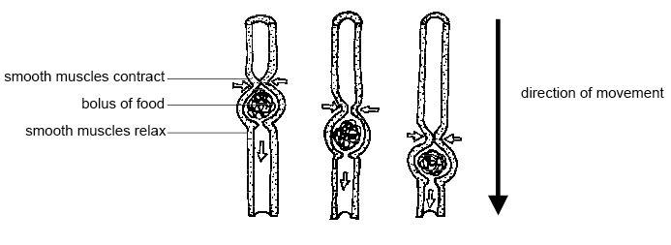
Peristalsis in action. Author: Sunshineconnelly at en.wikibooks; License: CC BY 3.0;Link: https://commons.wikimedia.org/wiki/File%3AAnatomy_and_physiology_of_animals_Peristalis.jpg

Stomach
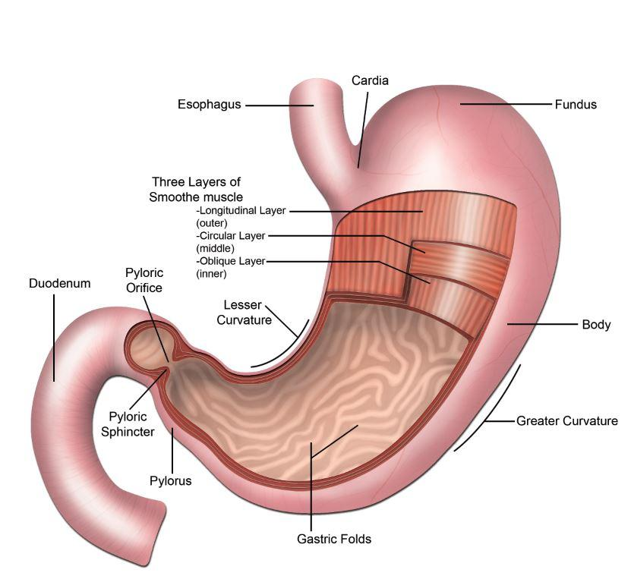
The Stomach. Image by BYU-Idaho Student, Nathan Fall 2015

The stomach is a temporary storage chamber and churning apparatus that contains hydrochloric acid and the enzyme pepsin which together initiate protein breakdown. As the bolus of food mixes with the digestive juices of the stomach it becomes chyme, a thick, highly acidic semifluid material that moves through the rest of the digestive system. The stomach is a distensible (Definition: can be extended) chamber that can range in size from 50ml to 1000ml (1liter). This is accomplished by gastric folds, also known as rugae. The surface area of stomach is greatly enhanced by the presence of gastric glands that contain several cell types including: mucous secreting cells, parietal cells, chief cells and various endocrine cells. The epithelium creates divots or indentations (like wells) in the surface called gastric pits. This is where the gland cells release substances. These substances help aid in both chemical and mechanical digestion and are described in a future section. The stomach is separated from the small intestine by the pyloric sphincter.

Small Intestine
The small intestine is the primary site of enzymatic digestion and absorption. In fact, 95% of absorption of nutrients into the blood occurs in the small intestine. Also, most of the water that we absorb happens in the small intestine. The small intestine is divided into three sections; the duodenum (length: 20-25cm), the jejunum (length 2.5m) and ileum (length 3 m), with each section specializing in different types of absorption. The duodenum is the shortest section but also the most important section for digestion as it receives secretions from accessory organs such as gallbladder and the pancreas. The duodenum is also the site where local hormonal feedback regulates the process of stomach emptying.

The surface area of the small intestine is increased 600-fold by several modifications in its structure. The first is a series of folds in the walls of the organ called circular folds. Second, the walls contain villi which are finger-like projections that protrude from the mucosa. Finally, each intestinal cell (enterocyte) has microvilli that project from the apical surface of the cell. Due to their appearance in micrographs of these cells they are also referred to as the brush border of the epithelial cells. Each structure is essential for increased absorption.

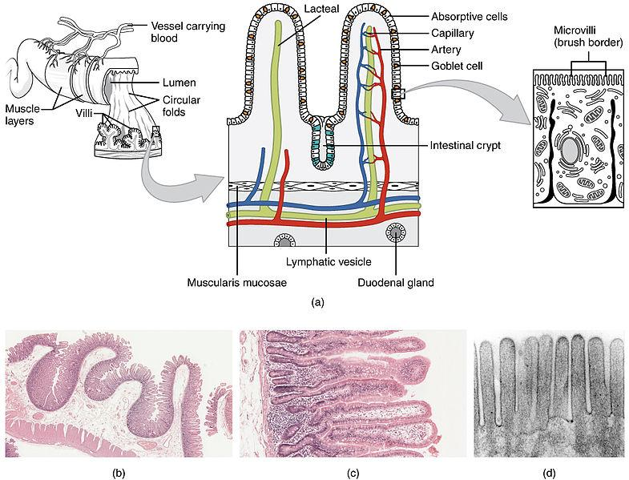
(a) Small Intestines (b) Circular Folds (c) Villi (d) Brush border or Microvilli.Author: By OpenStax College; License: CC BY 3.0 (http://creativecommons.org/licenses/by/3.0);Link: https://commons.wikimedia.org/wiki/File%3A2418_Histology_Small_IntestinesN.jpg

Liver & Gallbladder
Not only does the liver filter the blood and synthesize plasma proteins such as albumin and clotting factors, but the liver also plays a critical role in the digestive process. The digestive functions of the liver are mainly associated with processing of the nutrients it receives from absorption by the small intestine. The liver can store carbohydrates, lipids, vitamins and minerals as well as synthesize various kinds of carbohydrates, proteins and lipids from substrates that arrive from the blood. For example, the liver takes the glucose and stores it as glycogen, or takes in amino acids and converts them to glucose. Depending on the metabolic needs or demands of the body, the liver can store or provide substrates needed to maintain nutrient homeostasis. In addition, the liver produces bile which is essential for the digestion of lipids in the small intestine. The bile produced by the liver is stored in a hollow organ called the gallbladder that sits just beneath the liver. The gallbladder, when activated to contract by cholecystokinin, will propel bile into the duodenum through the common bile duct. The common bile duct joins with the pancreatic duct and enters into the duodenum of the small intestines through the sphincter of Oddi.

Pancreas
The pancreas has both an exocrine, or digestive function, as well as an endocrine, or hormonal function. Via the pancreatic duct and through the sphincter of Oddi, the pancreas secretes a plethora of digestive enzymes and buffers into the small intestines. The digestive enzymes secreted by the pancreas are vital for carbohydrate, protein and lipid breakdown. These enzymes are produced by the exocrine acinar cells of the pancreas and include pancreatic amylase, pancreatic lipase, and trypsin.Bicarbonate, a buffer produced and secreted by the epithelial cells lining the pancreatic duct, reduces the acidity of the chyme entering from the stomach into the small intestine. The production of bicarbonate is regulated by secretin, a hormone we will learn about later in this module.
Another critical role of the pancreas is the secretion of hormones from the islets of Langerhans cells. There are five different types of endocrine cells in the pancreas and each secretes a different hormone. Alpha cells produce glucagon, a hormone that raises blood glucose levels by stimulating the liver to convert glycogen to glucose. Beta cells produce insulin and amylin. Insulin lowers blood glucose levels by stimulating cells to take up glucose from the blood, and amylin slows gastric emptying which prevents the blood glucose levels from spiking. Delta cells produce somatostatin, which is a hormone that suppresses the release of other hormones of the pancreas. Gamma cells produce pancreatic polypeptide which regulates the endocrine and exocrine pancreas secretions. The last hormone producing cell is the epsilon cells which produce ghrelin, a protein that stimulates hunger. We will discuss insulin and glucagon in further depth as we study the endocrine system.

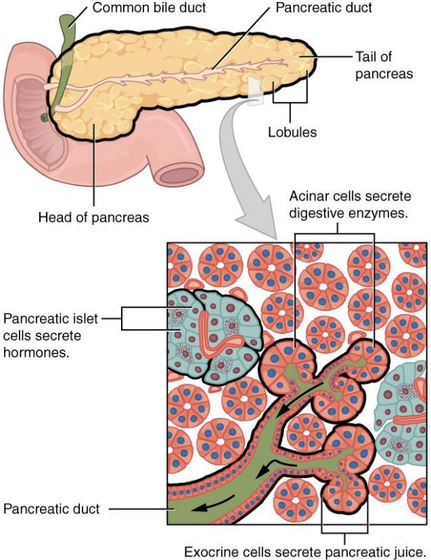
Pancreas delivers pancreatic juice to the duodenum through the pancreatic duct.Author: OpenStax License: [CC BY 4.0 (http://creativecommons.org/licenses/by/4.0)],Link: https://cnx.org/resources/65de80fe9396d266a09772aa978551d22566f5d8/2424_Exocrine_and_Endocrine_Pancreas.jpg

Large Intestines
The small intestine is separated from the large intestine by the ileocecal sphincter. The large intestine absorbs fluids and stores fecal matter before expulsion from the body (note expulsion, not explosion, although in some instances they may be one in the same). While most digestion of food is completed in the small intestine, some undigested macromolecues witll be broken down by the gut microbiota in the large intestine. A main function of the large intestine is to absorb salts and some remaining water and convert the chyme to fecal matter. In addition, the large intestine is necessary for the absorption of vitamin K that is important for blood clotting processes in the blood. Some Vitamin K is produced by "friendly" bacteria that reside in the large intestine. Expulsion brings us to the final two sphincters, the internal and external anal sphincters. The internal sphincter is reflexively controlled but the external anal sphincter is voluntarily controlled.

Read this online at https://books.byui.edu/bio_265_anatomy_phy_II/813__organs_of_the_d

