# Carbohydrate Digestion and Absorption

The process of digestion is really a discussion of enzymes and their ability to cleave or break bonds. Polysaccharides are put together using three different kinds of bonds between the monomers, these bonds are called: alpha 1- 4, alpha 1- 6 and beta 1- 4 linkages. The first enzyme that a carbohydrate will encounter is found in the salivary secretions of the mouth and is known as **salivary amylase.** Salivary amylase can hydrolyze (break) alpha 1- 4 bonds but is quickly inactivated by the stomach acid. The majority of carbohydrate digestion occurs in the small intestine through the actions of **pancreatic amylase.**

Pancreatic amylase is also specific for most alpha 1- 4 bonds but since carbohydrates are a combination of all types of bonds the digestion is incomplete.

Amylase only acts on internal bonds in the polysaccharide chain, it cannot cleave individual glucose molecules from the chain. To complete digestion the small intestine has specific enzymes that are located on the apical membranes of the enterocytes (small intestinal epithelial cells), called **brush border enzymes.** These enzymes are able to hydrolyze alpha 1- 4 bonds left by amylase as well as alpha 1- 6 bonds and some beta 1-4 bonds. You have probably heard of some of these brush border enzymes as they are named after the carbohydrate that they are most specific for, for example, **lactase, sucrase and maltase.** Lactase is specific for the disaccharide lactose, and sucrase is specific for the disaccharide sucrose. Maltase digests maltose, which is a product of the action of amylase on starch and glycogen. The end result is that all of the ingested carbohydrates are converted to their simplest form; **glucose, galactose** or **fructose.**

Most animals do not contain enzymes that can break beta 1- 4 bonds. These bonds are found in fiber, however, certain types of bacteria can break down the bonds. Cows or animals that eat grass (high in fiber) have large amounts of bacteria in different chambers of their stomachs that help them break down the fiber to usable sources of monosaccharides. Even though we cannot break down fiber, it is still an important component of a healthy diet to help keep the stool loose and moving. High fiber diets have also been shown to reduce the risk of colon cancer and to decrease absorption of cholesterol. Individuals that are lactose intolerant have stopped making the brush border enzyme lactase and therefore have lost the capacity to digest lactose. This is actually the normal process since most mammals do not consume milk as adults. It is only humans that are descendants of groups that have domesticated cattle and goats that are not predominantly lactose intolerant. Undigested carbohydrates that are washed down to the large intestine can cause a plethora of unwanted side effects, such as diarrhea, cramping and extreme flatulence, the latter is only desirable at a few unique events like scout camp or when you stay up too late with your friends.

#### Carbohydrate Absorption

Once carbohydrates are partially digested in the mouth, followed by complete digestion in the small intestines, they need to be absorbed. From the lumen, the three monosaccharides, glucose, galactose, and fructose must enter through the apical membrane of the enterocyte and exit through the basal membrane to be absorbed into the blood. Glucose is brought through the apical membrane by a Na+ cotransporter known as the sodium-glucose transport protein (SGLT -1). Galactose is also transported across the apical membrane through the same transporter. This cotransporter is a secondary active transporter that is driven by the Na+ gradient which is established by the primary active transporter Na+/K+ ATPase. Without this primary active transporter, glucose and galactose absorption would rapidly decrease. Fructose is transported across the apical membrane through facilitated diffusion by a transporter called GLUT 5. Fructose does not require Na+ to be transported across the apical membrane. Once inside the cell, glucose, galactose, and fructose are transported across the basal membrane through a transporter called GLUT 2 and are then reabsorbed into the blood.

Carbohydrate Absorption image: [https://books.byui.edu/-UavX](https://qph.fs.quoracdn.net/main-qimg-9f184c775dfe8e845ca41346a59c71eb-c) and image below:

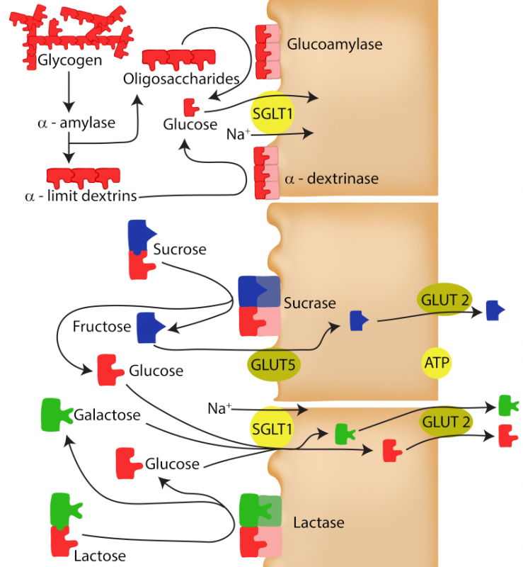

Image by Becky T. BYU-I S20.

**Absorption of Carbohydrates.**

#### High Fructose Corn Syrup

What's the big deal about high fructose corn syrup? Isn't sugar just sugar? The answer is yes, sugar is sugar but not all sugar is created equal. Sugar in any form will cause obesity and disease when consumed in high doses. Scientifically speaking, sugar doses of over 140 pounds per person per year are harmful. Doesn't 140 pounds sound like a lot? It does, but consider that a typical 20-ounce sweetened soda has approximately 17 teaspoons of sugar. There are 96 teaspoons in 1 pound. Thus, to exceed the 140 pounds per year mark you would need to drink 2 sodas a day for a year. This math does not take into account any other sugar that you might consume, so yes, it is pretty easy for us to exceed the 140 pounds per year mark, especially if you drink soda. You might be thinking, "Well, it's a good thing I drink diet soda!" Not to dash your hopes, but recent research, as of 2014, demonstrated that artificial sweeteners in diet soda and other foods can actually raise blood sugar instead of reduce it. The research showed that artificial sweeteners can alter the population of gut bacteria, and these gut bacteria can then change how the body regulates blood sugar. Other researchers have shown that the gut contains receptors that can sense sweetness. We have always known that the tongue could do this and it is because of the tongue that we like artificial sweeteners. Although the sweet receptors in the gut don't send messages to the brain telling us how sweet something is (like the tongue does), the sweet receptors in the gut do seem important for helping our bodies regulate things like glucose transporters and insulin release. Some researchers are finding evidence that we mess with the homeostatic mechanisms that regulate our blood sugar when we consume things like diet soda. Loss of the ability to regulate blood glucose is the hallmark sign of diabetes and weight gain.  
  
In addition to the amount of sugar, there are some biochemical differences between sucrose (50:50 ratio of glucose to fructose) and high fructose corn syrup (45-55 ratio of glucose to fructose). Believe it or not, that subtle change in ratio causes big changes in the waste line. For one, fructose is much sweeter tasting than glucose so changing the ratio has allowed manufacturers to move from 8 ounces to 20 ounces without incurring a loss in profit. With more ounces come larger amounts of sugar per serving. Moreover, the process of extracting glucose and fructose from corn results in glucose and fructose that are unbound. In other words, sucrose is composed of one molecule of glucose and one molecule of fructose linked through an alpha 1- 2 bond hence the body needs an enzyme (sucrase) to cleave the bond. High fructose corn syrup generates glucose and fructose that are unbound, thus we do not need enzymes to break them down. Instead the two molecules are delivered in a form that is perfect for absorption. Once in the blood, glucose and fructose must be taken into cells for use, but most cells do not contain a glucose transporter, instead they need insulin to signal the insertion of the transporter. Furthermore, almost no cells contain the fructose transporter (GLUT 5) with the exception of the liver. Thus, fructose goes right to the liver, triggering biochemical pathways such as lipogenesis (the production of fat). This same event happens with sucrose ingestion but remember the ratio of high fructose corn syrup has more fructose per serving than sucrose so that the effect is increased slightly. In summary, sugar (sucrose) and sugar (high fructose corn syrup) are not biochemically nor physiologically the same.

Read this online at <https://books.byui.edu/bio_265_anatomy_phy_II/821___carbohydrate_d>