# Protein Digestion and Absorption

### 

**Digestion of Proteins.**

Author: OpenStax License: Creative Commons Attribution License 4.0 license. Link: https://books.byui.edu/-IGh

Digestion and absorption of proteins presents some interesting problems for the human body, for one, proteins are an integral part of membrane structure. Thus, how do we digest dietary proteins without digesting our own cell membranes? The answer lies in the structure of protein digesting enzymes or **proteases.** Proteases are secreted as inactive proteins called **zymogens** that require conversion to their active forms. For example, stomach cells secrete pepsinogen (an inactive protease) that is converted to pepsin (the active protease) in the presence of acid. Once pepsin is activated in the lumen of the stomach, the enterocytes of the mucosa are protected by a thick mucus layer produced by goblet cells in the epithelium. Pepsin is irreversibly inactivated by the change in pH when it moves from the stomach (pH 1.8 to 3) to the small intestine (pH 6-7). Pepsin is responsible for the digestion of about 10% of dietary proteins.

Once in the small intestine a new set of enzymes is necessary to continue protein digestion. These enzymes come from the pancreas and are secreted in the inactive form. There are 5 proteolytic enzymes from the pancreas. The first of these is an inactive protease called **trypsinogen.** Trypsinogen is converted to its active form, trypsin, by the brush border enzyme **enterokinase.** Trypsin then activates the other four enzymes **(chymotrypsin, elastase, carboxypeptidase A and carboxypeptidase B).** This chain of activation ensures that the enzymes are only activated when needed and when there are plenty of other dietary proteins to keep them busy. Trypsin, elastase and chymotrypsin are **endopeptidases** capable of cleaving proteins at internal bonds within the peptide chain. They are quite specific and target certain sequences of amino acids. The peptides that result from actions of the endopeptidases are further acted on by the exopeptidases (carboxypeptidases A or B). These enzymes along with a brush border carboxypeptidase cleave off single amino acids from the carboxy-terminus of peptide chains. Meanwhile the brush border enzyme **aminopeptidase** cleaves single amino acids from the amino-terminus.

#### Protein Absorption

Similar to carbohydrate absorption, individual amino acids in the lumen are transported across the apical membrane of the enterocytes by a Na+ cotransporter. However, in contrast to carbohydrate absorption in which only monomers can be absorbed, proteins can be absorbed through the apical membrane as amino acids or as di and tripeptides. However, to be transported across the basal membrane the proteins must be broken down to single amino acids. Once inside the cell, the di and tripeptides are subjected to further digestion by intracellular proteases in the lysosomes. In terms of the different sections of the small intestine, although the duodenum is by far the most active for both single amino acids and di and tripeptides, the ileum is more active reabsorbing single amino acids while the jejunum is more active with di and tripeptides.

In young infants, before the age of 6 months, whole proteins can be brought into the cell through the process of endocytosis. This is one of the ways that immunity is transferred from mother to child as antibodies from the mother’s milk are taken into the baby’s blood. Even adults can absorb small amounts of intact proteins and although these proteins are not dietaryly significant they do play important roles in providing the immune system with a sample of the luminal contents. In fact, many food allergies are caused by an overactive immune system responding to intact proteins that it thinks are bad, examples being celiac sprue (gluten intolerance) or nut allergies.

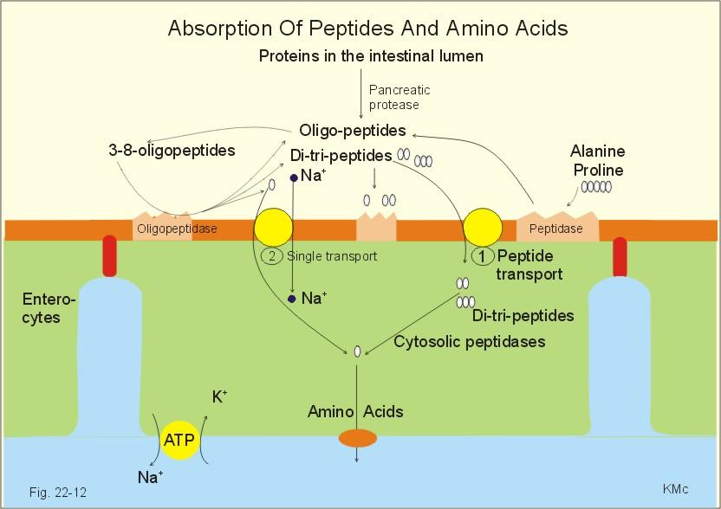

**Absorption of Proteins.**

Author: New Human Physiology, Paulev-Zubieta 2nd ed., illustrator Kirsten McCord. License: CC BY-NC-ND-4.0 Creative Commons Attribution-Noncommercial-No Derivatives 4.0 International. Link: https://books.byui.edu/-tcgj

Read this online at <https://books.byui.edu/bio_265_anatomy_phy_II/822___protein_digest>