Overview of the Endocrine System
Perhaps more than any other discipline, the study of endocrinology is dependent upon observation. Observation is essential in science. Observation is something we do instinctively. Scientific observation involves the collection and recording of data in order to construct a hypothesis and eventually a theory. The first recorded endocrine experiment was published in 1849 by the German scientist Arnold Berthold. Berthold observed that castrated roosters failed to develop their combs and wattles and they failed to exhibit typical male rooster behavior. He formulated a hypothesis that the testis had something to do with his observations so he tested his hypothesis by transplanting a testis back into the abdominal cavity of a castrated bird. With the transplanted testis in the abdominal cavity, the birds developed their comb and wattles, showed a renewed interest in hens and started being aggressive towards the other males. Perhaps most interesting was the fact that the transplanted testis was functional, and seemed to function independent of the nervous system. Thus began the birth of endocrinology, the study of internal secretions, for it was later discovered that the testes secrete testosterone (a hormone) into the blood which helps regulate the physiology of the body.
In contrast to the nervous system that controls tissue functions through neurons and synapses, the endocrine system uses chemical messengers, or hormones, to regulate metabolic processes, contraction, relaxation and metabolism of smooth and cardiac muscle, reproductive processes, cellular proliferation, even behavior. In short, the endocrine system affects whole body homeostasis. At the simplest level the endocrine system consists of several glands that secrete hormones into the blood. The major glands of the endocrine system are: the hypothalamus, the pituitary gland, the thyroid gland, the parathyroid glands, the pancreas, the adrenal glands and the gonads (testes and ovaries).

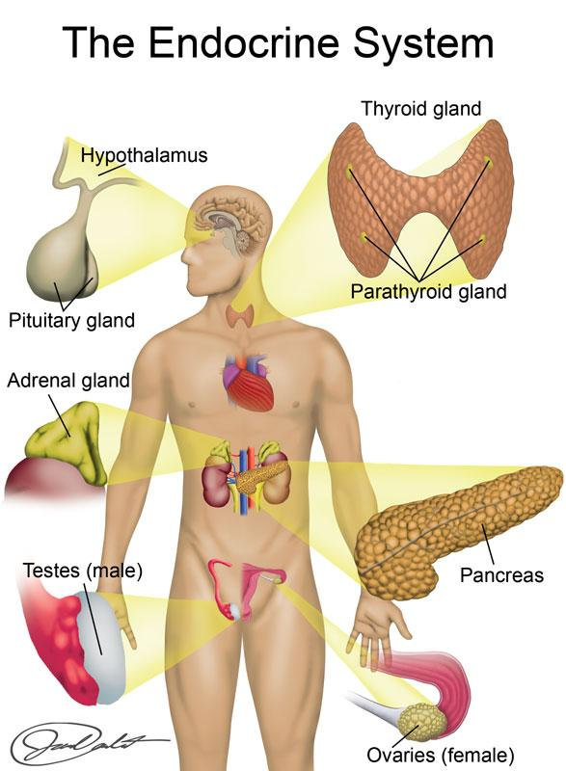
Image created by BYU-Idaho Spring 2015
These organs have the primary function of producing and secreting hormones and are considered the classic endocrine glands. However, it is now recognized that nearly every organ in the body has the capacity to produce and release hormones. Interestingly, control of the endocrine system is often a complex process in which several glands function in concert, one endocrine gland controlling the activity of another. Hormones that regulate the secretion of another hormone are called tropic hormones. A great example is the relationship between the hypothalamus and the anterior pituitary. The hypothalamus secretes tropic hormones that regulate the anterior pituitary. These hypothalamic hormones are referred to as releasing hormones. The anterior pituitary, in turn, releases other tropic hormones that control the actions of peripheral endocrine glands which then release hormones that act on target tissues. It may seem odd to have such a complex regulatory mechanism but it provides multiple levels of control for precise regulation of body functions.
The classical definition of a hormone is a chemical produced by a group of specialized cells, released into the blood in minute quantities, and transported to act on distant target tissues. This definition was coined in 1902 and still holds true for many hormones. Today we refer to this type of signaling as endocrine signaling.
Other signaling pathways include paracrine and autocrine signaling. These are both local, short distance signaling. In paracrine signaling, the hormone is released into the extracellular space and regulates nearby cells of a different type without ever entering the blood. For example, endothelial cells send signals that regulate smooth muscle activity in the walls of a blood vessel. Autocrine signaling refers to the action of a hormone on the same cell that secreted it or on another cell of the same type that produces the hormone. For example, a lymphocyte releases signals that affect itself as well as other lymphocytes.
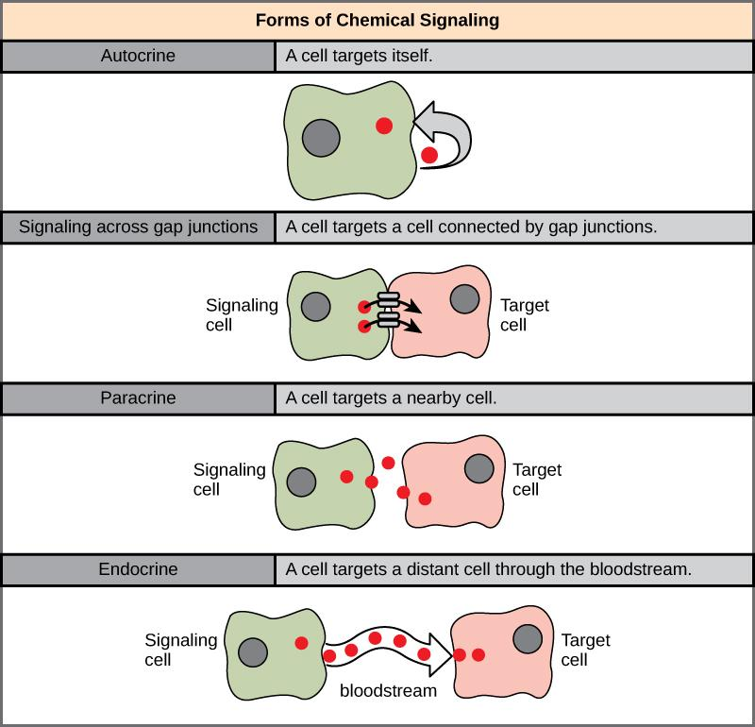
Endocrine, Autocrine, Paracrine Signaling.
Author: By CNX OpenStax License: [CC BY 4.0 (http://creativecommons.org/licenses/by/4.0)], via Wikimedia Commons
Link: https://books.byui.edu/-rRR

Read this online at https://books.byui.edu/bio_265_anatomy_phy_II/911_overview_of_the_

