# Hormones of the Body

#### Regulation of Release

Hormone release is controlled by three general mechanisms:

1. Secretion can be regulated by another endocrine gland. As explained above, the anterior pituitary gland releases tropic hormones that control the release of other hormones.
2. Secretion can be regulated by some other substance in the blood. Insulin secretion is regulated by the amount of glucose in the blood.
3. Secretion can be regulated by the nervous system. Epinephrine release from the adrenal gland is controlled by the autonomic nervous system.

Regardless of the mechanism of control, hormone release is typically regulated through **negative feedback loops** (Module 1: Bio 264). For example, if blood glucose levels increase, insulin secretion will increase which will lower the levels of glucose in the blood. As glucose levels return toward normal insulin secretion will decrease.

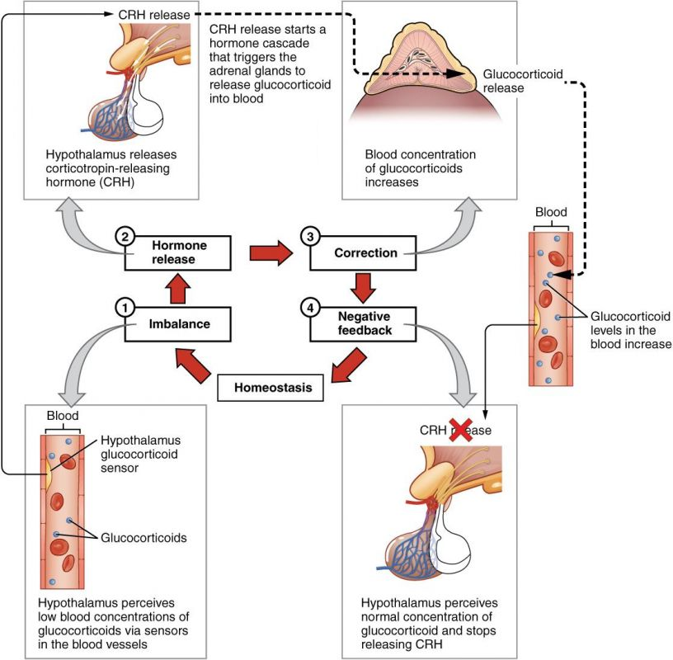

**Negative Feedback Loop using example Glucocorticoids. When hormone levels become elevated, a negative signal is sent to the pituitary gland and hypothalamus to turn down the release of further hormone.**

Author: Open Stax; License: [CC BY 3.0 (http://creativecommons.org/licenses/by/3.0)], via Wikimedia Commons

Link: https://books.byui.edu/-SzwI

**Transport:** Endocrine hormones are transported to their target tissues via the blood plasma. Since the plasma is mostly water this presents a problem for some hormones. Hydrophilic hormones easily dissolve in the plasma and pose no major problem for transport. Hydrophobic hormones, on the other hand, cannot dissolve in the plasma and so this presents a challenge for their transport. These hormones must bind to plasma proteins produced by the liver in order to be transported. These "carrier" proteins have hydrophobic cores that shield the hormones from the aqueous plasma. However, even for these hydrophobic hormones a small fraction does circulate free in the plasma. We distinguish between the two forms as "bound" and "free" hormones. It is the ratio of bound to free that determines the overall potency of the hormone. The free hormone is the biologically active form and as the levels of free hormone drop, more bound hormones will be released from the transport proteins to maintain the equilibrium ratio of bound to free.

**Lifespan of a hormone:** The only way to turn off an endocrine response is to remove the hormone from the circulation. There are several mechanisms for removing the hormones. These include: removal by the kidneys, removal by the liver, enzymatic destruction of the hormone, and re-uptake and recycling of the hormone. Steroid hormones, for example, are usually removed from the blood by the liver while protein hormones often end up in the urine. We express the lifespan of a hormone in the blood as its **half-life** (T ½). Recall that one half-life is the amount of time necessary to remove 50% of the hormone from the circulation. Half-lives for hormones range from a few minutes to several days. The concentration in the blood of hormones with short half-lives tend to fluctuate markedly while the concentrations of hormones with longer half-lives tend to be more constant. Since hormones bound to carrier molecules are shielded from the mechanisms that remove them from the blood their half-lives tend to be longer and their concentrations do not fluctuate as rapidly.

The concentrations of hormones in the blood are typically very low, ranging from 10-11 to 10-9 moles/Liter. Thus, hormone receptors must have very high affinities for their particular hormone. The affinity of a hormone for its receptor is a measure of how easily and strongly it binds to the receptor. Hormone affinities are expressed as the **dissociation constant** (KD) for the hormone. The units of the dissociation constants are molar units (M) and correspond to the concentration of the hormone required to bind exactly one-half of available receptors. The lower the KD number the higher the affinity of the receptor to the hormone.

There are many different hormones in the body, and making an accurate count is nearly impossible as new hormones are discovered every year. However, there are general groupings that can help distinguish the characteristics of the vast arrays of hormones. One common method of classifying hormones is based on their chemical structure, this type of classification results in three main classes of hormones: **peptide/protein** hormones, **steroid** hormones, and **amino-acid** derived hormones. The hormones within each class have similar functional properties. The table below describes the characteristics of each class of hormones based on the 5 properties defined below.

1. **Synthesis:** How is the hormone synthesized? It may be produced on demand or stored for later release.
2. **Mode of release:** Is the hormone released from vesicles through exocytosis or simply produced and allowed to diffuse out of the cell.
3. **Transport:** How is the hormone transported in the blood? It may circulate free or it may be bound to carrier proteins.
4. **Half-life:** How long does the hormone circulate in the blood before being broken down. It may be broken down quickly or it may stay in circulation for hours or even days.
5. **Receptor:** Which kind of receptors does it interact with (See Table below)

#### Classes of Hormones

|  |  |  |  |
| --- | --- | --- | --- |
|  | **Peptide/Protein** | **Steroid** | **Amino-acid derived** |
|  |  |  | **Catecholamines** | **Thyroid** |
| **Synthesis** | Produced as inactive forms and stored in vesicles | Made on demand from cholesterol | Produced and stored in vesicles | Produced and stored as precursor |
| **Release** | Exocytosis | Diffusion | Exocytosis | Facilitated diffusion using a carrier |
| **Transport** | Dissolved in plasma (water-soluble) | Bound to carrier proteins (lipid-soluble) | Dissolved in plasma (water-soluble) | Bound to carrier proteins (lipid-soluble) |
| **Circulatory half-life** | Minutes | 100s of minutes | Less than a minute | Days |
| **Receptor type** | Membrane bound receptors | Cytosolic or nuclear receptors | Membrane bound receptors | Nuclear receptors |
| **Examples** | Insulin, Growth Hormone | Estrogen, Testosterone | Epinephrine, Norepinephrine | Thyroxine |

As the name suggests, peptide/protein hormones are produced from amino acids and range in size from three amino acids to hundreds of amino acids. This is the most diverse and abundant type of hormone group and is made by tissues located throughout the body. Steroid hormones are always derived from cholesterol (and therefore hydrophobic) and are made by only a few organs, specifically the gonads and adrenal cortex. Hormones categorized as amino-acid derived are created from the amino acid tyrosine (catecholamines and thyroid hormones) or tryptophan (melatonin and serotonin). The tables below list the major endocrine glands, the hormones they produce and the major actions of the hormones.

#### Major Endocrine Glands and the Hormones They Secrete

|  |
| --- |
| **Hypothalamus** |
| **Hormone** | **Target Tissue** | **Primary Action** |
| Gonadotropin-Releasing Hormone (GnRH) | Anterior Pituitary | Stimulate secretion of Follicle Stimulating Hormone (FSH) and Luteinizing Hormone (LH) |
| Thyrotropin-Releasing Hormone (TRH) | Anterior Pituitary | Stimulate secretion of Thyroid Stimulating Hormone (TSH) |
| Corticotropin-Releasing Hormone (CRH) | Anterior Pituitary | Stimulate secretion of Adrenocorticotropic Hormone (ACTH) |
| Growth Hormone-Releasing Hormone (GHRH) | Anterior Pituitary | Stimulate secretion of Growth Hormone (GH) |
| Growth Hormone-Inhibiting Hormone (GHIH, somatostatin) | Anterior Pituitary | Inhibit secretion of GH |
| Prolactin-Inhibiting Hormone (PIF, dopamine) | Anterior Pituitary | Inhibit secretion of Prolactin (PRL) |

|  |
| --- |
| **Anterior Pituitary** |
| **Hormone** | **Target Tissue** | **Primary Action** |
| Thyroid-stimulating Hormone (TSH) | Thyroid Gland | Stimulate secretion of Thyroxin (T4) and Triiodothyronine (T3) |
| Follicle-stimulating Hormone (FSH) | Ovaries and Testes | Male: Sperm production  Female: Follicle development and Estrogen secretion |
| Luteinizing Hormone (LH) | Ovaries and Testes | Male: Testosterone production  Female: Ovulation, Progesterone secretion |
| Adrenocorticotropic Hormone (ACTH) | Adrenal Cortex | Stimulate secretion of Glucocorticoids (Cortisol) |
| Growth Hormone (GH) | Most tissues | Stimulates tissue growth  Regulation of metabolism |
| Prolactin | Mammary glands and ovaries | Stimulates milk production  Up-regulation of FSH and LH receptors |

|  |
| --- |
| **Posterior Pituitary** |
| **Hormone** | **Target Tissue** | **Primary Action** |
| Oxytocin | Uterus and mammary glands | Stimulates uterine contractions  Stimulates release of milk  Social and moral feelings (Brain) |
| Antidiuretic Hormone (ADH) (Vasopressin) | Kidneys and blood vessels | Renal water reabsorption (reduced urine volume)  Vasoconstriction |

|  |
| --- |
| **Thyroid gland** |
| **Hormone** | **Target Tissue** | **Primary Action** |
| Thyroxine (T4) | Whole Body | Metabolism and Growth |
| Triiodothyronine (T3) | Whole Body | Metabolism and Growth |

|  |
| --- |
| **Parathyroid glands** |
| **Hormone** | **Target Tissue** | **Primary Action** |
| Parathyroid Hormone (PTH) | Bone | Increase blood calcium |

|  |
| --- |
| **Pancreas** |
| **Hormone** | **Target Tissue** | **Primary Action** |
| Insulin | Skeletal muscle, Adipose tissue, Liver | Lowers blood glucose levels |
| Glucagon | Liver | Raises blood sugar levels by stimulating glycogen breakdown and glucose synthesis |

|  |
| --- |
| **Adrenal glands** |
| **Hormone** | **Target Tissue** | **Primary Action** |
| Adrenal Cortex:  Mineralocorticoids (Aldosterone) | Kidney | Increased Na+ reabsorption and K+ excretion, increased water reabsorption |
| Adrenal Cortex:  Glucocorticoids (Cortisol) | Most tissues | Increased protein and lipid breakdown  Increased glucose production (increased blood sugar)  Anti-inflammatory |
| Adrenal Cortex:  Androgens | Many tissues | Not as important in males  In females stimulates growth of axillary and pubic hair |
| Adrenal Medulla:  Epinephrine and Norepinephrine | Many tissues | Increase blood glucose (glycogen breakdown)  Fight-or-flight response |

|  |
| --- |
| **Gonads** |
| **Hormone** | **Target Tissue** | **Primary Action** |
| Testosterone (Male) | Most tissues | Male sexual development  Spermatogenesis |
| Estrogen (Female) | Most tissues | Female sexual development |
| Progesterone (Female) | Many tissues | Gestation  Maternal behavior |

|  |
| --- |
| **Digestive Tract** |
| **Hormone** | **Target Tissue** | **Primary Action** |
| Gastrin | Parietal Cells | Gastric acid secretion |
| Cholecystokinin (CCK) | Gallbladder, Pancreas, Stomach | Release of bile from gallbladder  Secretion of digestive enzymes by pancreas  Decreased stomach emptying |
| Secretin | Pancreas, Liver | Increased bicarbonate secretion by pancreas and liver |
| Gastric Inhibitory Peptide (GIP) | Beta cells of pancreas | Increased insulin secretion |

Read this online at <https://books.byui.edu/bio_265_anatomy_phy_II/913__hormones_of_the>