# THE HYPOTHALAMUS AND PITUITARY GLAND

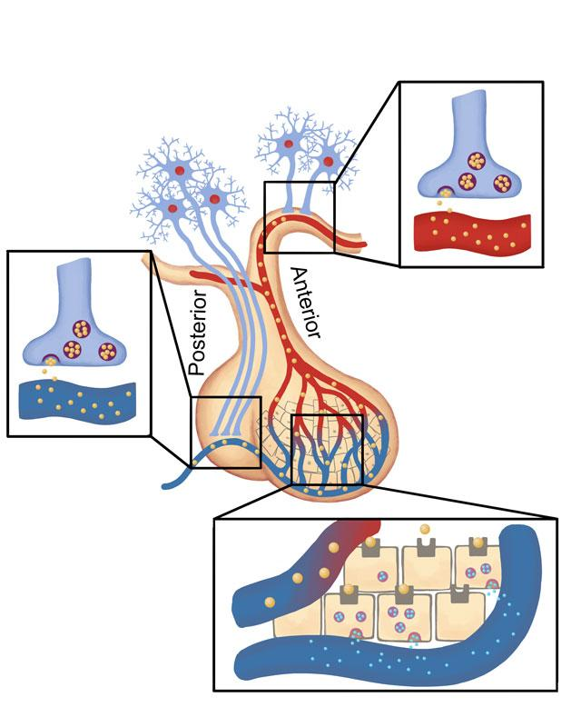

**Pituitary Gland and Hypothalamus.** Created by BYU-Idaho Fall 2014**The image just above shows the pituitary gland and how it communicates with the hypothalamus. Notice that the posterior pituitary gland contains the axons and terminal ends of neurons that originate in the hypothalamus. The anterior pituitary gland contains cells that respond to signaling hormones from the hypothalamus. Neurons of the hypothalamus release a signaling hormone (represented by the tan balls in the image). These signaling hormones will stimulate anterior pituitary cells to either increase or decrease their release of other hormones that will travel through the body and act on specific target cells.**

Note that the anterior pituitary may change in an image depending on whether the artist assumed the human specimen was facing right or left.   
  
The pituitary gland has been referred to as the "master gland" due to its important role in regulating body functions. It is actually two glands in one, the **anterior pituitary** or **adenohypophysis** and the **posterior pituitary** or **neurohypophysis.**  
  
The anterior pituitary is derived from epithelial tissue and thus has glandular properties. The posterior pituitary is composed of neural tissues and is actually an extension of the brain. Together, these two structures, or lobes, compose the pituitary gland. The pituitary is located in the sella turcica of the sphenoid bone and is connected to the hypothalamus by a stalk of tissue called the infundibulum. Although the pituitary regulates many other endocrine glands, its activity is controlled by the hypothalamus. Recall that the hypothalamus is the most inferior portion of the diencephalon and sits directly above the pituitary. The hypothalamus has the essential role of functioning as the interface between the nervous system and the endocrine system. Since these two systems are key for regulation of body function it stands to reason that there needs to be communication between the two and the hypothalamus is key in this interaction. It receives input from higher brain centers and, depending on the need, conveys that information to the endocrine system. Structurally the hypothalamus is composed of small clusters of neuron cell bodies called nuclei. Each nucleus has a unique function, such as secreting the neurohormones that regulate the anterior pituitary or producing hormones to be secreted by the posterior pituitary. The relationship between the hypothalamus and the pituitary is explained below.

**Regulation of the anterior pituitary:**

As mentioned above, the anterior pituitary is composed of true glandular tissue capable of producing and secreting hormones. There are unique populations of glandular cells that secrete the various anterior pituitary hormones in response to the hypothalamic hormones, for example GnRH from the hypothalamus stimulates the secretion of FSH and LH from the anterior pituitary. This control is mediated through a special vascular arrangement between the hypothalamus and the anterior pituitary called the **hypothalamo hypophyseal portal system.** A portal system is composed of two capillary networks that are connected in series (most capillary networks in the body are connected in parallel). Neurons in the hypothalamus secrete hormones (technically neurohormones since they are produced by neurons) that are taken up into the first capillary network. The blood leaving these capillaries converges on a portal vein that goes into the anterior pituitary and immediately enters the second capillary network. This system provides a direct connection between the hypothalamus and the anterior pituitary; therefore, only extremely small amounts of the hypothalamic hormones are required for control of the anterior pituitary. If the hypothalamic hormones were secreted in the general circulation they would be greatly diluted by the 5 liters or so of blood and much larger quantities would need to be produced.

**Regulation of the posterior pituitary:**

Recall that the posterior pituitary is not composed of glandular tissue, rather it is an extension of the hypothalamus. Rather than produce hormones, its function is to store neurohormones that are produced in the hypothalamus. The connection between the hypothalamus and the posterior pituitary is the **hypothalamo hypophyseal tract.**Neurons in specialized nuclei in the hypothalamus produce neurohormones. The axons of these neurons pass down the hypothalamo hypophyseal tract to the posterior pituitary. The neurohormones are transported in vesicles down the axons to the posterior pituitary where they are stored in the axon terminals. When these same neurons receive the proper signal, they send action potentials down those same axons which stimulate release of the neurohormones in the same way that action potentials in other neurons stimulate the release of neurotransmitters.

In the upcoming sections we will describe the functions of various hormones. However, not all will be covered in this unit since we have already discussed them or will in the future. Epinephrine and Norepinephrine were covered with the autonomic nervous system, parathyroid hormone was covered with the skeletal system, Aldosterone and antidiuretic hormones were covered in the kidney unit, the gastrointestinal hormones were covered in the digestive system and the gonadotropins and gonadal steroids will be covered in the reproduction unit.  
  
Link to image of the organs influenced by hormones of the pituitary gland: [https://books.byui.edu/-rCPc](http://slideplayer.com/6590434/23/images/21/Pituitary+Hormones+and+Their+Targets.jpg)

Endocrine System, Pituitary Gland Introduction Video: <https://youtu.be/Vae5CcaPN_8>

Read this online at <https://books.byui.edu/bio_265_anatomy_phy_II/92___the_hypothalamu>