# Simplified View

A simplified view of every textbook chapter is provided to any reader by easily appending the word /simple to the end of any chapter URL.

The simplified view removes site navigation bars and only delivers the chapter content on a plain, white background. This is useful for improving user experiences and stripping away unnecessary distractors.

You can try it by typing "/simple" at the end of the chapter name in the address bar.

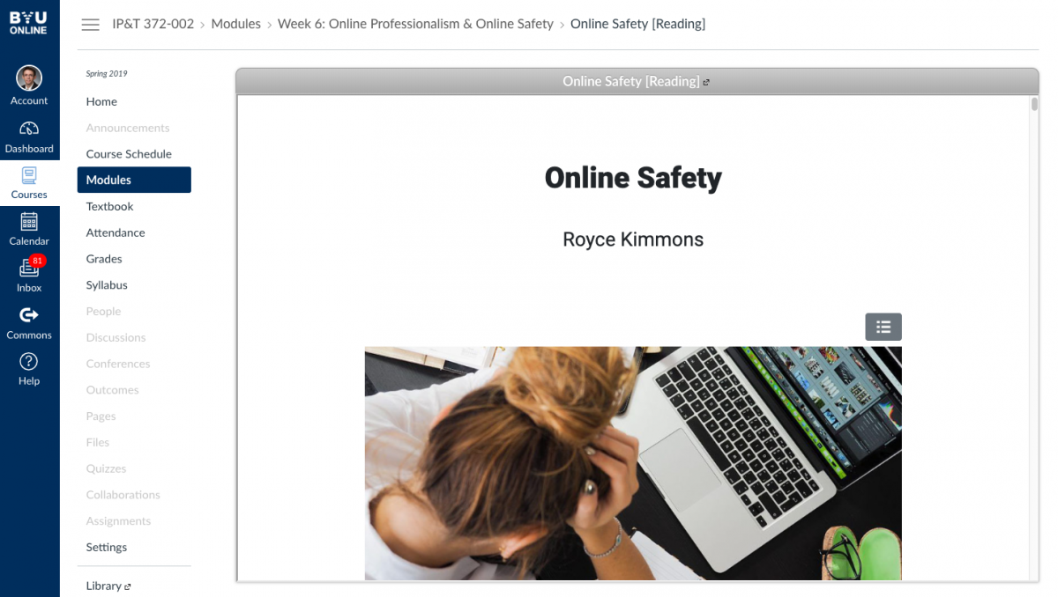

For instance, if you'd like to see the simplified view of this page, click here: [https://edtechbooks.org/userguide/simplified_view/simple](/userguide/simplified_view/simple)

This feature is especially useful if you are embedding chapters into an iframe and do not want readers clicking on navigation items in the book.

For instance, if you are creating a series of course modules in Canvas and want to embed a chapter into Canvas without allowing students to click on other chapters in the textbook or to be confused by the EdTech Books logo, you could simply provide a link to the simplified view of the chapter as an External URL (in this case https://edtechbooks.org/k12handbook/online_safety/simple).

Read this online at <https://books.byui.edu/userguide/simplified_view>