# Insulin

**Actions:** The primary target tissues for insulin are skeletal muscle, adipose tissue and the liver. The actions of insulin are mediated through a tyrosine kinase receptor on the cell membrane of the target tissues. Tyrosine kinase receptors phosphorylate enzymes inside the cell turning them on. In the liver, insulin stimulates glycogen synthase which increases conversion of glucose to glycogen (recall that glycogen is a storage molecule). Insulin also decreases enzymes associated with gluconeogenesis. In muscle, insulin increases the number of GLUT4 transporters in the cell membrane which allows for glucose to move into the muscle cell. Interestingly, under resting conditions, muscle cells are not permeable to glucose but can become permeable in response to insulin or exercise. Once inside the muscle cell, the glucose is either converted to glycogen for storage or utilized to provide energy. Insulin also increases amino acid uptake and protein synthesis in muscle cells. Similar to muscle, insulin increases the number of GLUT4 transporters in the membranes of the fat cells (adipocytes). In addition, insulin promotes the breakdown of glucose to metabolites that will be used to synthesize triacylglycerol (fat). Collectively, the actions of insulin are to reduce the amount of glucose in the blood and to promote energy storage in these organs.

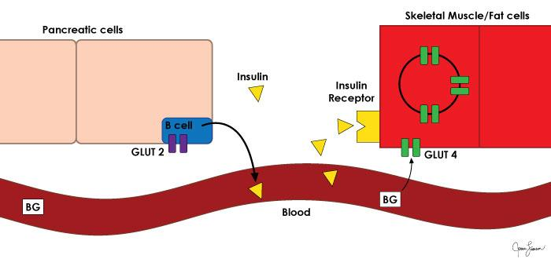

Image created by BYU-Idaho student Jenna Fransen, Spring 2017

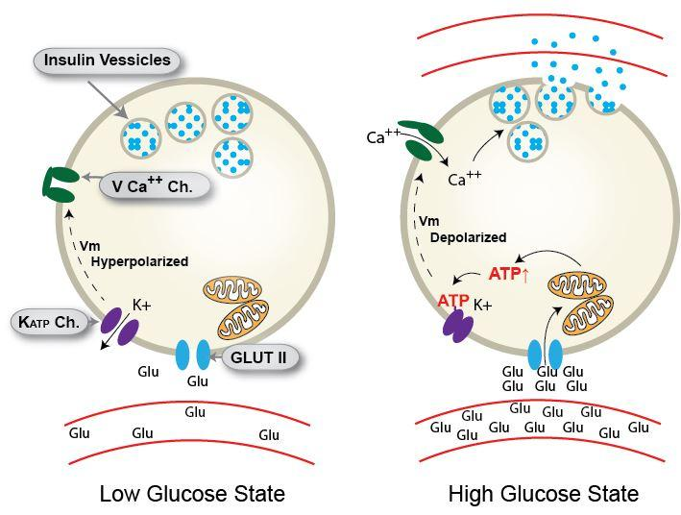

Image created by J. Shaw at BYU-Idaho Spring 2015

To view a video resource showing the Mechanism of Action of Insulin go to: https://youtu.be/X0ezy1t6N08

Read this online at <https://books.byui.edu/bio_265_anatomy_phy_II/941___insulin>