# Anatomy of the Male Reproductive System

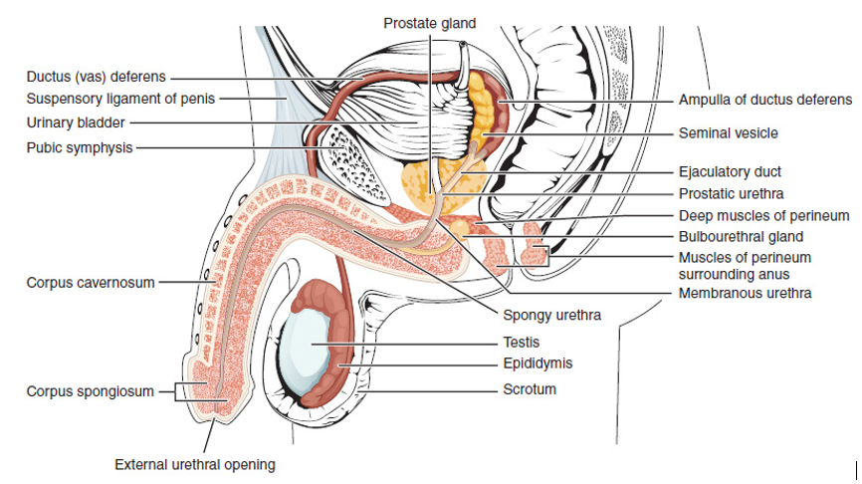

**Lateral view of the Male Reproductive System.**Author: OpenStax Anatomy and Physiology. License: Creative Commons Attribution License 4.0 license.Link: https://books.byui.edu/-hBIb

The key components of the male reproductive system are shown in the images above. This system consists of a network of tubes that begins in the testes and eventually leads to the urethra, which then exits the body. Along the way are several accessory organs that contribute to the formation of the semen. Let's begin our discussion with the **testes,** the male gonads. Although they develop in the abdominal cavity, the testes are housed externally in the scrotum (we will explain how this happens later). This is essential for their function since sperm formation (spermatogenesis) requires a temperature slightly lower than normal body temperature. To assist in the regulation of temperature the walls of the scrotum contain a layer of smooth muscle, the **dartos muscles,** and the spermatic cord that passes through the inguinal canal contains skeletal muscle, the **cremaster muscle.**

These muscles can contract or relax depending on the outside temperature. When ambient temperature is warm the muscles relax allowing the testes to move away from the body to lower testicular temperature and when ambient temperature is cold they contract pulling the testes up against the body to increase temperature. Can you think of a reason why Sam's doctor suggested that he wear looser undergarments as a cheap and easy way to possibly increase fertility? The adult testes are ovoid organs about 4-5 cm long. They are housed in the scrotum and each is surrounded by a connective tissue sheath called the **tunica albuginea.** This sheath branches internally forming septa which divide the testes into numerous smaller compartments called **lobules.** Each lobule houses a long, highly coiled **seminiferous tubule.** It is within these tubules that spermatogenesis occurs. The tissue that surrounds the seminiferous tubules is the interstitial tissue and contains the cells that produce testosterone. These cells are the **interstitial cells of Leydig** or more commonly simply called the Leydig cells. The seminiferous tubules come together and converge into a system of ducts known as the rete testis, which further converges into a group of efferent ductules. The **efferent ductules** exit the testes and unite to form the **epididymis.**

The epididymis is a single, long, convoluted duct that forms a comma-shaped structure which sits on the surface of the testes. Although the sperm form in the seminiferous tubules of the testes, final maturation takes place in the epididymis. For example, sperm taken directly from the seminiferous tubules are not motile (they can't swim) and would not be able to move through the female system. Only after spending about 10-14 days in the epididymis do they become motile. The sperm remain in the epididymis until ejaculation. The epididymis is continuous with the **vas deferens** or **ductus deferens.** This duct exits the scrotum and passes through the inguinal canal into the abdominal cavity. In addition to the vas deferens and the cremaster muscles, the spermatic cord that passes through the inguinal canal also contains the testicular arteries and veins. Once in the pelvic cavity, the vas deferens runs up the anterior surface and then across the roof of the bladder to the posterior side of the bladder. As it begins to descend the posterior side of the bladder the tubes enlarge to form the **ampulla** of the vas deferens. The ampulla then unites with the ducts of the paired **seminal vesicles** forming the **ejaculatory duct.**

The seminal vesicles are the first of the accessory organs that contribute to the semen. They produce approximately 60% of the seminal fluid. The seminal vesicles provide several important components to the sperm. These include:

1) Fructose and citric acid to provide nutrients to fuel the sperm;

2) Fibrinogen that contributes to a weak, transient coagulation reaction once the semen enters the female tract which helps the semen adhere to the vaginal walls near the cervix as well as protecting the sperm from destruction by the acid environment of the vagina; and

3) Prostaglandins which help decrease the viscosity of the cervical mucus allowing the sperm to more easily enter the uterus. Prostaglandins also stimulate uterine contractions, helping the sperm move up the female tract.

The ejaculatory duct then enters the second of the accessory organs, the **prostate gland,** where it unites with the **urethra.** The prostate accounts for approximately 30% of the seminal fluid. Prostatic secretions include clotting factors that participate with the fibrinogen from the seminal vesicles in the coagulation reaction as well as fibrinolysis, which breaks down the clot and frees the sperm. In addition, the prostatic secretion has a high pH, which helps neutralize the acidic environment of both the male urethra and the female tract.

After the urethra exits the prostate it receives secretions from the last of the accessory organs, the **bulbourethral glands,** also known as Cowper’s gland, which contribute about 5% of the seminal volume. Secretions of the bulbourethral glands contain mucus to lubricate the urethra and buffers to neutralize acids in the urethra and vagina. The final 5% of the seminal volume is the sperm that comes from the epididymis.

The male urethra participates in both the urinary system and the reproductive system. Anatomically it is divided into three segments; the **prostatic urethra** exits the bladder and passes through the prostate gland; the **membranous urethra** passes through the muscles in the floor of the pelvic cavity and the **spongy** or **penile urethra** passes through the penis and opens to the exterior via the external urethral orifice. The final structure of the male reproductive system to be discussed is the **penis.** The penis is the male organ of copulation that is inserted into the female vagina during sexual intercourse. In performing this function, it is necessary that the penis become rigid. To make this possible the penis is composed of three parallel columns of erectile tissue, the two **corpora cavernosa** that run side by side just above the urethra, and the **corpus spongiosum** that surrounds the urethra. At the tip of the penis the corpus spongiosum expands to form the **glans penis.** We will discuss how these erectile tissues produce an erection later. In uncircumcised boys the glans penis is covered by the **prepuce** or foreskin. The prepuce is cut away during circumcision.

Video link to the Sperm Pathway of Release: [https://books.byui.edu/-PGG](https://medlineplus.gov/ency/anatomyvideos/000121.htm)

Read this online at <https://books.byui.edu/bio_265_anatomy_phy_II/1011___anatomy_of_th>