# Oogenesis

Similar to the male, female germ cells migrate from the yolk sac in early fetal life to the site of the developing ovaries in the pelvic cavity. Once these germ cells reach the ovaries they become the oogonia and begin to undergo mitosis. By the end of the fourth month of fetal development there are roughly 7 million **oogonia** in the ovaries. Oogonia are analogous to spermatogonia and are the cells that will develop to become the egg or oocyte (also called an ovum). Unlike spermatogonia that remain quiescent until puberty, the oogonia begin meiosis I even before birth. However, the future ova, at this point, called primary oocytes, arrest in Prophase I where they will remain until puberty. Many of these oocytes degenerate and by birth only about 2 million remain. 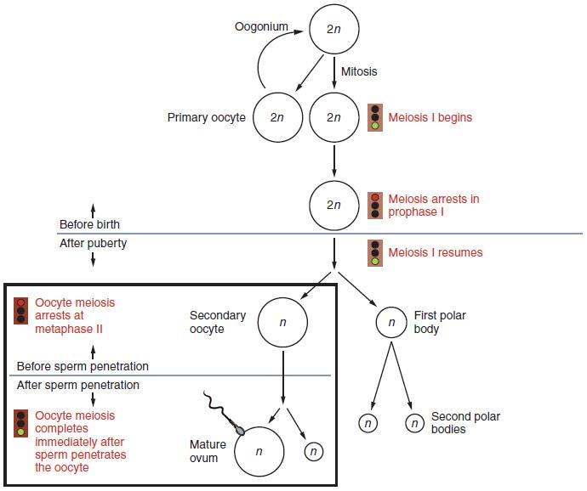

**Oogenesis.**

Author: OpenStax Anatomy and Physiology. License: Creative Commons Attribution License 4.0 license.

Link: https://books.byui.edu/-cvsF

The process of attrition continues and by puberty there are only around 400,000 primary oocytes remaining, of which only 400 will be ovulated. Beginning at puberty and continuing throughout the reproduction years of the female, each menstrual cycle some oocytes will complete meiosis I to become secondary oocytes. These secondary oocytes begin meiosis II but again stop, this time at Metaphase II. Typically, only one oocyte will be ovulated each month and then, if it is fertilized, it will complete the second meiotic division. If it is not fertilized, it doesn't complete meiosis II and degenerates within about 24 hours after ovulation.

Recall that the two meiotic divisions of the spermatocytes result in the production of 4 spermatids. However, when the oocytes undergo meiosis the divisions produce only one daughter cell and one polar body. It is essential that the ovum, when ovulated, have enough stored energy to keep the developing embryo alive until it implants in the uterine wall. Consequently, the meiotic divisions are unequal. The daughter cell retains all of the stored nutrients and cellular organelles while the polar body contains only the chromosomes from the nuclear division.

Read this online at <https://books.byui.edu/bio_265_anatomy_phy_II/1031___oogenesis>