# Ovulation and Fertilization

Ovulation is the event that releases the oocyte from the follicle. This event is under the control of LH. As we will discuss later, just prior to ovulation there is a sharp increase in the levels of LH. This increase is referred to as the LH surge and is the apparent trigger for the events of ovulation. The Graafian follicle moves to the surface of the ovary and appears like a small blister on the ovarian wall. Ovulation is achieved when this "blister" bursts and the oocyte, the follicular fluid, and the cumulus layer of granulosa cells is expelled from the follicle. The cumulus cells surrounding the oocyte at ovulation are called the **corona radiata.** One other important event of ovulation is that the LH surge triggers the completion of meiosis I and the beginning of meiosis II (meiosis II will be completed only if fertilization occurs).

The granulosa cells and thecal cells that remain as the post ovulatory ovarian follicle become the **corpus luteum** (luteum = yellow, corpus = body). This change of the follicle to a corpus luteum is called luteinization and is brought about by the increase of luteinizing hormone (LH). The corpus luteum becomes the endocrine portion of the ovary and secretes estrogen and progesterone (described later). Progesterone is a hormone critical for establishing and maintaining pregnancy. The progesterone levels secreted by the corpus luteum during pregnancy send negative feedback to the hypothalamus and pituitary gland to keep GnRH, LH and FSH secretions low so that no other dominant follicles develop while a woman is pregnant.

If the oocyte is not fertilized, the corpus luteum survives about 10-12 days and then begins to degenerate becoming the **corpus albicans** (albicans – white). If the oocyte is fertilized, the corpus luteum is maintained throughout the first part of pregnancy, but later, the placenta will take over the job of producing estrogen and progesterone. After ovulation, the oocyte, along with its corona radiata, will enter the **fallopian tubes.**

Fertilization typically takes place in the ampulla (distal end) of the Fallopian tube. In order to penetrate the ovum, the sperm will have to negotiate their way through the corona radiata cells and the zona pellucida. Many sperm cells will die trying to do this and only one will ultimately be successful. Penetration of the sperm triggers completion of the 2nd meiotic division. The union of the sperm and the ovum forms a **zygote** (a fertilized egg).

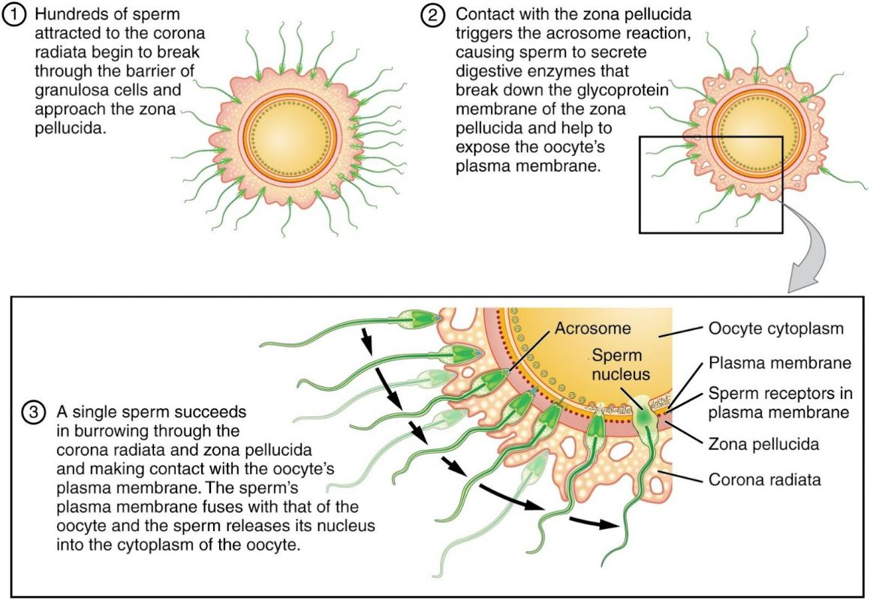

**Fertilization.**By OpenStax College License: [CC BY 3.0 (http://creativecommons.org/licenses/by/3.0)], via Wikimedia Commons Link: https://books.byui.edu/-uyTf

While still in the Fallopian tube, the zygote begins the process of cell division, mitosis, and becomes an embryo. The embryo continues to grow by cell division as it travels towards the uterus. The fallopian tubes contain mucus secreting cells and ciliated cells. During the time of ovulation, high estrogen levels cause the cilia to beat more strongly toward the uterus. High estrogen levels also create regular contractions, every 4-8 seconds, of the smooth muscle along the length of the fallopian tube resulting in a sweeping movement slowly moving the ovum toward the uterus.

Implantation generally occurs on the endometrium at the superior end of the uterus, typically 6-7 days after fertilization. The image below shows the path of an oocyte after it has been ovulated.

An ectopic pregnancy is a rare situation that occurs if the fertilized ovum implants in a place other than the uterus, such as in the fallopian tube. Because the fallopian tube cannot expand to accommodate a growing baby, it could rupture leading to a life-threatening situation for the mother.

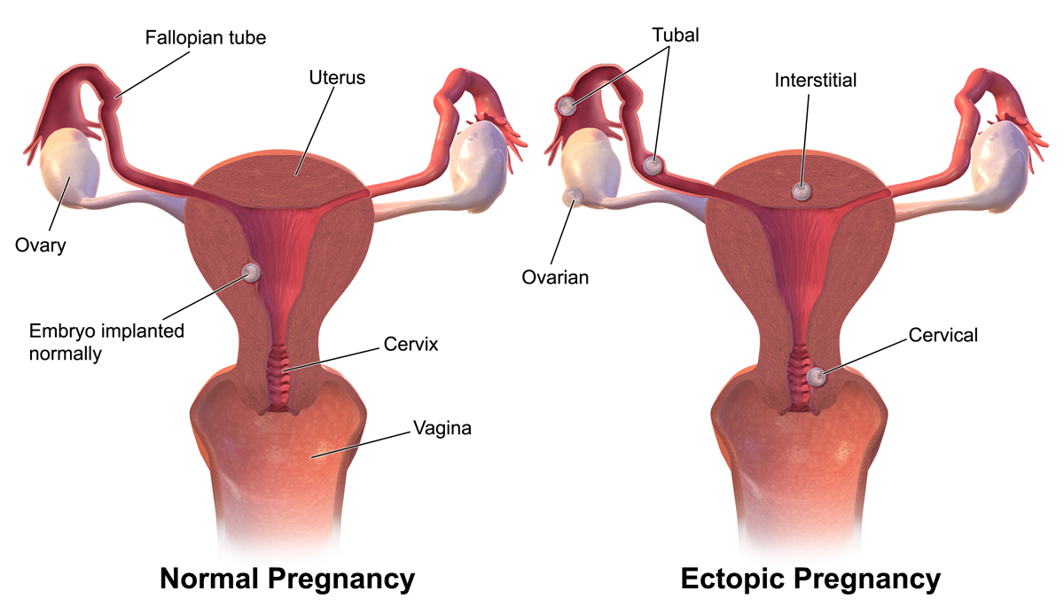

**Ectopic Pregnancy.** Author: By BruceBlaus (Own work); License: CC BY-SA 4.0 (https://creativecommons.org/licenses/by-sa/4.0)], via Wikimedia Commons. Link: https://books.byui.edu/-PXaZ

Read this online at <https://books.byui.edu/bio_265_anatomy_phy_II/1033__ovulation_and_>