# Ovarian Cycle

The ovarian cycle describes the hormonal changes that occur during the menstrual cycle as well as the changes taking place in the follicles. First a quick review of the key hormones involved and their regulation. This control system is often referred to as the hypothalamic-pituitary-ovarian axis. Gonadotropin-releasing hormone (GnRH) from the hypothalamus stimulates secretion of the gonadotropins, FSH and LH, from the anterior pituitary. FSH acts on the granulosa cells of the follicle and LH acts on the thecal cells of the follicle. The follicle then produces estrogen and progesterone. Estrogen and progesterone, in turn, usually feedback on the hypothalamus and pituitary to inhibit their activity, thus reducing FSH and LH secretion. This is a classic negative feedback loop. However, at a key point in the cycle the feedback briefly changes to positive feedback. This switch from negative to positive feedback control causes a sudden 10-fold increase in LH secretion and to a lesser extent more FSH secretion as well. The mechanisms that produce this sudden positive feedback are not well understood. It is known that estrogen is a very important part of this mechanism and progesterone may contribute as well. However, there are other unknown signaling processes involved, because administering just estrogen and progesterone to women in their mid-follicular phase does not achieve this positive feedback. There is more to be discovered and learned about this positive feedback switch.

As was also true in the male, inhibin acts on the pituitary to selectively inhibit FSH secretion allowing for differential secretion of the two gonadotropins. In the female, inhibin is produced by the granulosa cells of the follicle. The normal cyclic pattern of hormone secretion observed in the ovarian cycle is coordinated by the negative and positive feedback actions of this system.

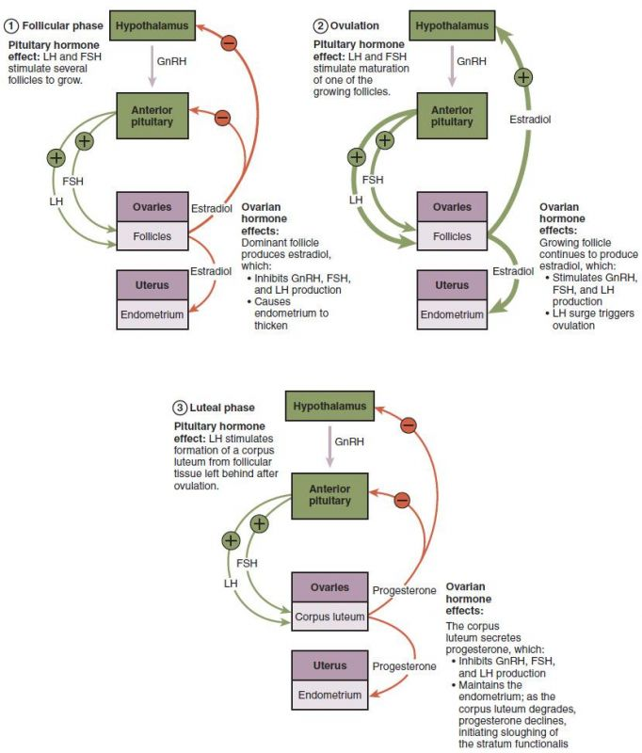

**Hormonal Regulation of Ovulation.**

Author: OpenStax Anatomy and Physiology. License: Creative Commons Attribution License 4.0 license.

Link: https://books.byui.edu/-zqaU

The ovarian cycle can be divided into two distinct phases, the follicular phase and the luteal phase. The event that separates these two phases is ovulation, thus the follicular phase begins on day 1 of the cycle and ends at ovulation and the luteal phase begins at ovulation and ends at the beginning of the next menses. Each phase lasts approximately 14 days.

#### Follicular phase

The follicular phase gets its name from the fact that during this part of the cycle the follicle is developing and preparing for ovulation. During the early follicular phase, estrogen levels are low but are gradually increasing. The estrogen exerts a negative feedback on the hypothalamus and pituitary, inhibiting FSH and LH secretion. Although the FSH levels are low, the follicles are still being stimulated by FSH. The dominant follicle up-regulates its FSH receptors and is therefore more sensitive to the FSH, stimulating its further development. Estrogen secretion by the dominant follicle increases while in the less mature follicles estrogen secretion declines, eventually contributing to their degeneration. During the final portion of the follicular phase, the increased estrogen levels cause a switch from negative to positive feedback. This results in a sudden increase in GnRH secretion producing a marked rise in both LH and FSH. The rise is much more pronounced for LH and its levels nearly triple. FSH also increases but not as dramatically, probably due to the presence of inhibin which selectively inhibits its secretion. The surge in LH is the event that is responsible for ovulation. Ovulation usually occurs about 12 hours after the peak of the surge. The LH surge appears to stimulate the ovum in the rapidly growing follicle to complete its first meiotic division. Also, LH triggers a cascade of events that weaken the follicular wall and ultimately causes the follicle to rupture, releasing the egg.

#### Luteal phase

Once ovulation is complete the remaining cells of the follicle, under the influence of LH, are transformed to become the corpus luteum. The second half of the ovarian cycle, the luteal phase, is named for the presence of the corpus luteum. After ovulation, hypothalamus and pituitary control reverts back to negative feedback resulting in a dramatic reduction in LH and FSH secretion. Additionally, the structural changes in the corpus luteum result in a switch from mainly estrogen secretion to mainly progesterone secretion. Progesterone levels increase markedly and reach peak levels about 7 days after ovulation. Estrogen levels follow the same general pattern but its overall concentration is significantly lower. In the absence of fertilization, the corpus luteum survives 10-12 days and begins to regress. This results in a sharp drop in progesterone and estrogen levels resulting in the onset of menses and the end of the cycle. About 2 days prior to menses, as the negative feedback from estrogen and progesterone decreases due to decreasing concentrations, FSH levels increase slightly. It is this small spike in FSH that is thought to be the stimulus that recruits a new cohort of follicles to begin development. If the ovum is fertilized, the developing embryo will begin to produce a hormone called human chorionic gonadotropin (hCG). hCG is nearly identical to LH and stimulates the corpus luteum to continue producing progesterone and estrogen. Under the influence of hCG the corpus luteum continues functioning for about the first trimester (1st 3 months) of gestation. By the end of the 1st trimester the placenta has started producing progesterone and estrogen and the corpus luteum is no longer needed and will begin to regress.

Read this online at <https://books.byui.edu/bio_265_anatomy_phy_II/1035___ovarian_cycle>