# Uterine Cycle

The uterus is where a fertilized egg will implant and develop. However, the uterus is receptive to implantation for only a short time each month. The uterine cycle is a series of events that occur to prepare the endometrium or inner lining of the uterus to be ready for possible implantation. The events of the uterine cycle are regulated by the estrogen and progesterone produced by the ovaries during the ovarian cycle.  
  
The uterine cycle is divided into three phases: the menstrual phase (menses), the proliferative phase and the secretory phase.

#### Menses (Days 1-5)

Menstruation or menses is marked by the degeneration of the endometrium. The endometrium is a layer of cells, glands and blood vessels that is dependent on the ovarian hormones (estrogen and progesterone) to remain viable and healthy. In the absence of sufficient hormonal support, this layer of tissue dies and detaches from the deeper muscular layer of the uterus and sloughs off into the lumen of the uterus where it exits the body through the vaginal canal resulting in the blood and tissue flow associated with the menstrual period. The first day of menstrual bleeding is designated as day 1 of the menstrual cycle.

#### Proliferative (Preovulatory) Phase

At the completion of menses, the functional layer of the endometrium has been sloughed off and must be replaced. The regeneration of the functional layer is under the control of estrogen. Recall that during the follicular phase of the ovarian cycle, estrogen levels increase. Estrogen stimulates stromal cells from the basal layer of the endometrium and epithelial cells that were not lost during menses (mainly from the lower portion of the uterus and near where the fallopian tubes attach) to increase in number or proliferate. The stromal cells replace the connective tissue portion of the endometrium and the epithelial cells produce the glandular portion. As these cells increase in number the endometrium thickens from about 0.5 mm to about 5.0 mm. Additionally, spiral arteries arise to feed the new tissue and glandular structures develop. During this phase, estrogen also induces the endometrial cells to express large numbers of progesterone receptors in preparation for the events of the next phase of the cycle. This phase is completed at about the time of ovulation.

#### Secretory (Postovulatory) Phase

After ovulation, the luteal stage of the ovarian cycle gets underway and progesterone levels rise. The progesterone binds to the progesterone receptors in the endometrium. Under the influence of progesterone, the endometrial glands enlarge, coil, and begin to produce a glandular secretion high in nutritious organic molecules such as glycogen. Also, progesterone stimulates the rapid expansion of the spiral arteries in the endometrium. During the Secretory Phase, progesterone encourages the development of a very vascular and glandular endometrium capable of secreting fluids, nutrients and supplying blood to an implanted embryo. Progesterone also has an anti-estrogen effect and prevents further proliferation of the endometrial cells.

Recall that the corpus luteum degenerates at the end of the luteal stage of the ovarian cycle unless there is a pregnancy. With the degeneration of the corpus luteum, progesterone (and estrogen) levels decrease. Without this hormonal support, the spiral arteries spasm rhythmically, leading to constriction of the blood vessels reaching the endometrium. The spasms last longer and longer resulting in a reduction in levels of oxygen and the tissues become ischemic. This eventually leads to the death of the endometrial tissue and the shedding of the lining, starting the cycle again.

The image, shown again below, illustrates how the ovarian and uterine cycles are coordinated. It also demonstrates the time period involved in these cycles. While the cycles are shown on a 28-day time frame, in reality, there is great variability in cycle length. The follicular phase represents the cause of most of this variability with some research showing follicular phases ranging from 11 to 27 days. The luteal stage for most women is generally more consistent at about 14 days, although occasional variability of 7 to 15 days has been recorded (Fehring, 2006).

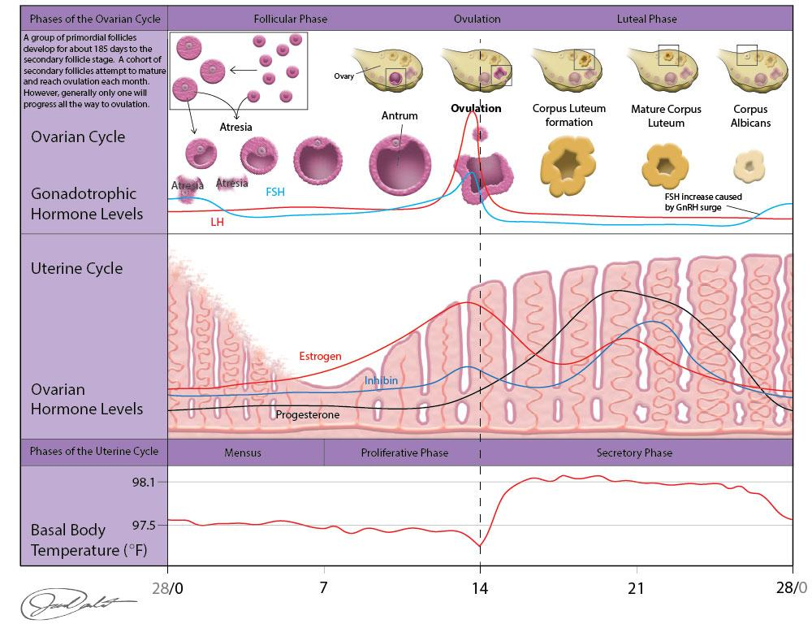

**Uterine and Ovarian Cycle.**

Image drawn by BYU-Idaho Spring 2015

Read this online at <https://books.byui.edu/bio_265_anatomy_phy_II/1036__uterine_cycle>