Physiology of the Male Erection and Ejaculation

Erection
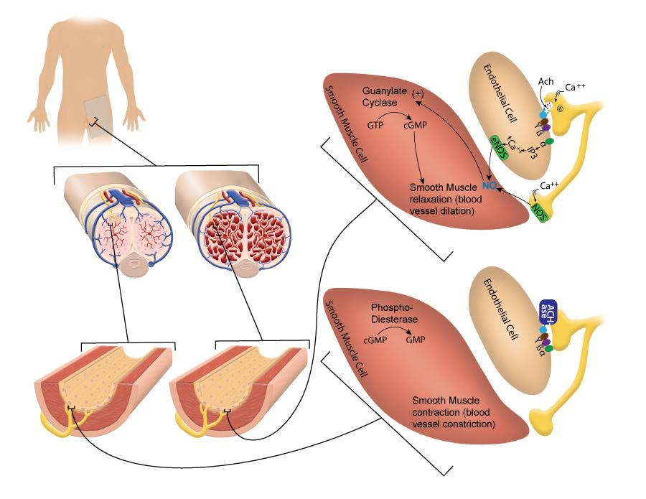
Physiology of an Erection.
This image by Nathan Shoemaker BYU-Idaho 2015

This image above shows penile tissue engorged with blood on the right and the normal state on the left. The cellular events are depicted in the blow out portions showing the relationship between endothelial cells and smooth muscle. "ACHase" represents Acetylcholinesterase. "NO" represents nitric oxide.

As described earlier, the penis contains three parallel shafts of erectile tissue, the two corpora cavernosa and the corpus spongiosum. The corpus spongiosum surrounds the penile urethra and expands distally to become the glans penis. Erectile tissue is composed of a network of branching blood vessels connected to larger cavernous spaces or sinuses. When the penis is flaccid most of the arteries are constricted and very little blood flows into the sinuses. However, with sexual arousal the blood vessels dilate and blood begins to fill the sinuses. As the sinuses fill, there is an increase in pressure in the erectile tissues causing the veins that drain these tissues to become constricted. As a consequence, the erectile tissues become fully engorged with blood causing the penis to become rigid. This event is referred to as an erection.
Erection is under control of the parasympathetic nervous system. With sexual arousal, action potentials travel down parasympathetic neurons to the arteries that supply blood to the erectile tissues. This is one of the few examples of parasympathetic innervation of blood vessels. These parasympathetic nerve fibers release acetylcholine onto muscarinic receptors of the endothelial cells in the blood vessels. The muscarinic receptor is a G-protein coupled receptor and when it is activated, the alpha subunit causes a second messenger cascade in the endothelial cell resulting in the activation of the enzyme nitric oxide synthase (NOS). NOS produces nitric oxide (NO) which diffuses from the endothelial cell into the surrounding smooth muscle. NO activates the enzyme Guanylate cyclase. Guanylate cyclase converts GTP into cGMP which activates another second messenger cascade resulting in the relaxation of the smooth muscle cells. When calcium enters the nerve terminal to trigger the release of acetylcholine it activates NOS in the nerve terminal causing additional production of NO. This NO diffuses from the nerve terminal and makes its way into the smooth muscle where it contributes to the relaxation of the smooth muscle. Together these two mechanisms result in a large increase in blood flow to the erectile tissues of the penis and cause the erection response. You may have heard of the drug Viagra. Viagra is a phosphodiesterase inhibitor. Phosphodiesterase is the enzyme that breaks down cGMP. With the inhibition of phosphodiesterase, cGMP remains active allowing for the increased blood flow necessary for an erection.

Ejaculation
As described above, erection occurs in response to parasympathetic stimulation of the blood vessels of the penis. Following erection, if tactile stimulation of the penis continues, release of semen can occur. This event is under sympathetic control and involves two events. The first is the movement of the sperm from the epididymis and vas deferens, where it is stored, to the prostatic urethra. This process is called emission and occurs when the smooth muscle in the walls of the vas deferens undergoes peristaltic contractions in response to sympathetic activity. Occurring simultaneously with emission, the accessory glands contract making their contributions to the semen (see the earlier discussion on male anatomy). Recall that the seminal vesicles contribute about 60% of the seminal volume, the prostate another 30% and the bulbourethral glands about 5%. The final 5% comes from the sperm. A normal semen volume for an ejaculate is 1.5 mL or greater, although the average is closer to 2-5 mL (5 mL is a teaspoon). The second event in the release of the semen is ejaculation, which propels the semen out of the penis and into the female vagina. Again, this process is triggered by sympathetic activity, which results in peristaltic contractions of the smooth muscle in the walls of the urethra.

Read this online at https://books.byui.edu/bio_265_anatomy_phy_II/1023__physiology_of_

