The Inflammatory Response
Inflammation is important for tissue healing, but excessive or prolonged inflammation can be harmful. Watch the video The Inflammatory Response

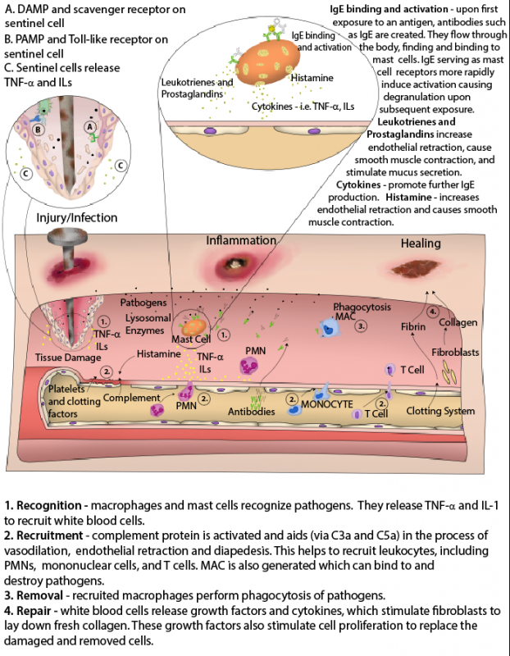
Image by BYU-I Becky T. F 19
There are four main steps of inflammation. First is the recognition of the pathogen. Within our bodies are cells called sentinel cells. These include resident macrophages, dendritic cells and mast cells that are always “lying in wait” for damaged cells or pathogens. Some examples of resident macrophages are the Kupffer cells in the liver, alveolar macrophages in the lungs (sometimes called “dust cells”), splenic macrophages in the spleen, microglial cells in the CNS, Langerhans cells in the epithelium, and mast cells near blood vessels. The function of sentinel cells is to encounter pathogens or damaged cells. This is accomplished through receptors. Two receptors are sentinel cell-specific: scavenger receptors and toll-like receptors (TLRs).
Scavenger receptors recognize molecules associated with damage called damage associated molecular patterns (DAMPs). DAMPs are proteins expressed by or released from damaged cells. Alternatively, toll-like receptors recognize molecules associated with pathogens called pathogen associated molecular patterns (PAMPs). Some examples of PAMPs are bacterial lipopolysaccharides, peptidoglycan, lipoproteins, yeast zymosan, viral coat proteins, bacterial flagellum and microbial nucleic acid. When a sentinel cell recognizes a PAMP or a DAMP, it releases cytokines such as tumor necrosis factor alpha (TNF-α) and interleukin 1 (IL-1). These two cytokines act on endothelial cells and cause them to express adhesion protein molecules known as selectins.
Selectins start the second step on inflammation: recruitment. They allow white blood cells to be recruited to the site of inflammation in the tissues. Recruitment continues with something called endothelial retraction, which is where the endothelial cells of blood vessels move apart to allow incoming white blood cells to the area of damage or pathogenic activity. When the endothelial cells move apart, white blood cells are not the only thing that come through. Albumin, the most plentiful plasma protein, also enters the tissue. Water will follow albumin, and this leads to increased swelling.
The next stage of inflammation is removal, which occurs when the recently recruited macrophages phagocytose pathogens and damaged cells in an effort to clean up the area. The final stage of inflammation is called repair. Repair starts with white blood cells releasing cytokines and growth factors that stimulate fibroblasts to lay down a new collagen matrix to repair the basement membrane.

Mediators of Inflammation
There are many inflammatory mediators that come from the plasma or are produced by cells locally. These mediators are often referred to as cytokines or chemokines. Cytokines are important in cell signaling. They are produced by cells of the immune system and have effects on many other cells throughout the body. The effects of the cytokines are generally to regulate the immune response. Chemokines are a subtype of cytokines. Chemokines are chemical signals that attract leukocytes to a site undergoing an immune response. The movement of leukocytes to an area of injury by following a chemical gradient is called chemotaxis. Chemokines create a chemical gradient that leukocytes can follow. The leukocytes maneuver and move towards the higher gradient which ends up being the sources of the chemokine secretion.
Plasma derived mediators are mostly produced by the liver. There are three major protein cascades we learn about in anatomy and physiology:
- 1st is the kallikrein-kininogen system that generates kinins. Kinins are produced by the liver and mediate the inflammatory response. One in specific, bradykinin, causes increased permeability of the capillaries that results in inflammation and pain.
- 2nd is the coagulation system that produces fibrin. Fibrin plays an important role in blood clotting and interacts with platelets as well.
- 3rd is the complement system. The proteins activated by the complement system cause increased vasodilation, vascular permeability, phagocytosis, and inflammation overall. We will go over the complement system more in depth in the later part of this chapter.

The other type of inflammatory mediators are cell-derived and are released from the cells at the site of inflammation. Tissue macrophages, mast cells, endothelial cells, and leukocytes are all capable of releasing cell-derived inflammatory mediators. Histamine and serotonin are examples of cell-derived mediators. Both are classified as vasoactive amines, which means that they come from amino acids. Histamine and serotonin molecules are stored in mast cells and influence the diameter of blood vessels. They both cause vasodilation and increase vascular permeability. Arachidonic acid metabolites are another type of cell-derived mediators. Arachidonic acid is an unsaturated fatty acid found in the plasma membrane. Following irritation or injury, the enzyme phospholipase A2 (PLA2) will pull an arachidonic acid out of the cell membrane. Several other enzymes then act on the arachidonic acid and eventually produce many inflammatory mediators such as prostaglandins and leukotrienes. Prostaglandins increase pain and the inflammatory response while leukotrienes can cause bronchoconstriction. Drugs that inhibit the enzymes that are necessary for these inflammatory mediators are known as anti-inflammatory drugs.
Another important thing that happens during inflammation is that IL1 and TNF-α released from the sentinel cells can travel to the brain where they act as pyrogens. A pyrogen is a substance that produces fever when introduced or released into the blood (they are typically produced by bacteria). IL1 and TNF-α also travel to the liver where they stimulate it to produce acute phase reactants like mannose binding lectin (MBL). MBL will be discussed more later and you will learn that it activates the complement system that, in turn, increases opsonization, membrane attack complexes, cytolysis and degranulation of mast cells.

The Cells of Inflammation
The cells that mediate inflammation can be broken down into two major categories: granulocytes and agranulocytes.
Granulocyte is a broad term given to white blood cells that contain secretory granules in their cytoplasm. Several types of granulocytes are in our blood. The first we will discuss are neutrophils. Neutrophils are nicknamed the “first responders” because they are the first to reach the sight of inflammation. They do not live long (approximately 24-48 hours) and are the primary component of pus.
Neutrophils are often measured for quantity as clinicians assess health and disease. The neutrophils will likely be referred to as PMN cells or just PMNs which stands for polymorphonuclear cells, which are a type of white blood cell (leukocyte) characterized by a multi-lobed nucleus and granules in their cytoplasm. While clinically, the term is most commonly used to refer to neutrophils, it can also include eosinophils and basophils because these cells also have multi-lobed nuclei.

Eosinophils are another type of granulocyte. These cells live longer than neutrophils and perform many diverse jobs such as participating in allergic reactions, anti-parasitic activities, and bactericidal activities. Eosinophils increase in number during parasite infections.
Basophils are another type of granulocyte. Basophils are the blood equivalent of mast cells, which are also granulocytes. Mast cells are found in the tissues of the gastrointestinal (GI) tract, genitourinary (GU) tract, respiratory tract, dermis of the skin, and other places. Basophils and mast cells both release histamine, an inflammatory cytokine and neurotransmitter that is a main contributor to inflammation. Mast cells and basophils are increased in number in those who have allergies.
Agranulocyte is a broad term given to white blood cells with a one-lobed nucleus that lack granules in their cytoplasm. Macrophages are agranulocytes and are found most everywhere in the body. Those that stay in a certain area are called resident macrophages. As discussed earlier, these can have specific names like the Kupffer cells in the liver. Although some macrophages stay in a specific area, others travel through the blood searching for invaders. Macrophages in systemic circulation that have not yet entered the tissue are called monocytes. When monocytes enter the tissue they are officially called macrophages.
Natural Killer (NK) cells are another important type of cell that participates in the innate immune system. NK cells are cytotoxic, meaning they have granules in their cytoplasm that contain proteins such as perforin and granzymes that can lyse cells and disrupt their intracellular organelles. Body cells under stress will manifest new and unique cell surface markers that can be recognized by NK cells. The NK cells then use their cytotoxic substances to cause the apoptosis (programmed cell death) of that cell. This can prevent an infection from spreading. NK cells respond to cytokines called interferons and they are particularly effective at helping to contain viral infections. NK cells are part of the innate immune system even though they are of lymphocyte origin (which is the same origin as B-cells and T-cells). While their mechanism of action may seem similar to cytotoxic T-cells, they do not target cells in the same highly specified way. Because they act as a more general protection, NK cells are considered part of the innate immune system. They help contain viral infections before the adaptive immune system is fully online.

Acute Inflammation
Acute inflammation is an early and almost immediate reaction of local tissues and nearby blood vessels to injury. It consists of two main stages: the vascular stage and the cellular stage.
The vascular stage consists of changes in the small vessels near the area of damage. It begins with a brief period of vasoconstriction followed by rapid vasodilation. This vasodilation results in increased blood flow which accounts for the redness and heat present with an injury. Along with vasodilation, vascular permeability is also increased so that immune cells can reach the area of damage. This increased permeability also allows proteins into the interstitial space which draws water and increases swelling. This protein-rich fluid is known as exudate, of which there are several different kinds. Serous exudates are more watery and lower in protein concentration. Hemorrhagic exudates are present when there is severe tissue damage that allows red blood cells to leak from the capillaries. Fibrinous exudates contain large amounts of fibrinogen and form a sticky and thick mesh work. Membranous or pseudomembranous exudates are found on mucous membranes. Purulent exudate contains pus which is made of dead white blood cells and tissues. This outpouring of protein-rich fluid (exudate) into the tissue decreases the blood colloid osmotic pressure (BCOP) and increases the interstitial colloid osmotic pressure (ICOP). This leads to the accumulation of fluid in the interstitium that is responsible for the swelling, pain and loss of function of the injured area. As this fluid continues to build up, clots begin to form because of the lack of blood flow through the area. These clots allow the body to localize microbes and limit the spread of infection.
The second stage of acute inflammation is the cellular stage. This stage mostly consists of the migration of white blood cells (mainly first responder neutrophils) to the site of damage. The delivery and activation of leukocytes can be divided into three mains steps:
- Margination and adhesion/tethering
- Transmigration and chemotaxis
- Phagocytosis

Throughout the early stages of the inflammatory response, signaling between endothelial cells and white blood cells allows for the buildup of leukocytes along the endothelium. This process is called margination. As more leukocytes experience margination, blood flow slows and additional cytokines are exchanged between leukocytes and endothelial cells. This release of cytokines causes the endothelial cells to express adhesion molecules that bind to glycoprotein expressed on the plasma membranes of leukocytes. This mechanism is called tethering and is responsible for the slowing of blood flow and the adhesion of white blood cells to the endothelium. Leukocytes can then use their pseudopodia to transmigrate through the widened gaps between the endothelial cells that result from the simultaneous occurrence of endothelial retraction. Once leukocytes enter the interstitium they are guided by a chemoattractant gradient to the area of damage. This process is called chemotaxis and is a process of cell migration. The chemoattractants are called chemokines (described previously) and may include bacterial and cellular debris as well as activated protein fragments in the complement system. The final step of acute inflammation is phagocytosis. For phagocytosis to occur the macrophage or neutrophil must recognize foreign material by binding via toll-like receptors to a microbial PAMP. The PAMP adheres to the sentinel cell and is then engulfed. Once engulfed, the TLR/PAMP combo are considered a phagosome. The phagosome then fuses with a cytoplasmic lysosome called a phagolysosome. This lysosome contains antibacterial molecules and enzymes that kill and digest the microbe. The intracellular killing phase is completed by toxic reactive oxygen species (hydrogen peroxide) and toxic reactive nitrogen species (nitric oxide) within the phagolysosome. Any indigestible material is then expelled through exocytosis.
Watch the video Phagocytosis
Leukocyte adhesion deficiency (LAD) is a condition where adhesion molecules between white blood cells and endothelium are mutated in a way that leukocytes do not easily leave the circulation to enter the tissue. There are different types of LAD depending on what gene is mutated and if it is an issue with the endothelial cells or the leukocytes. For example, LAD type 1 is due to a mutated beta-2 integrin protein that prevents WBCs from binding to the endothelial selectin proteins. The net result of LAD is that while these individuals may have a chemokine gradient and increased signaling to marginalize and extravasate white blood cells to an area of inflammation, their white blood cells are not able to leave circulation. This results in more white blood cells staying in the circulation and less white blood cells making it to the tissue to participate in clean up and healing. Individuals with LAD are much more predisposed to all types of infections, have much less pus production, and have a harder time healing. One classic symptom that can be observed in an infant born with this condition is a prolonged period of time to slough off the umbilical cord stump. It is more difficult to detach this dead tissue if white blood cells cannot leave the circulation to remove dead and dying material.

Read this online at https://books.byui.edu/bio_381_pathophysiol/122__the_inflammator

