# Disorders of the Red Blood Cell Membrane

#### Spherocytosis

Watch Video on [Hereditary Spherocytosis](https://video.byui.edu/media/t/1_4qwe8klc)

Red blood cells are characterized by their biconcave shape that allows them to fold so they can fit through smaller areas. **Hereditary spherocytosis** (HS), the most common inherited disorder of red blood cells, causes RBCs to lose their biconcave shape and become round. Normal and healthy red blood cells are held together by a network of proteins called **spectrin** and **ankyrin** in the membrane that support the biconcave structure. With spherocytosis, there is a genetic defect in the gene that codes for these proteins. Their decreased function leads to the loss of RBC surface area which causes the cell to look like a sphere. The spherical red blood cells are still able to carry hemoglobin, but they are more susceptible to destruction as they pass through the cords of Billroth in the spleen. Spherocytosis decreases the RBC lifespan to only about 10-20 days, a dramatic decrease from the normal 120 lifespan.

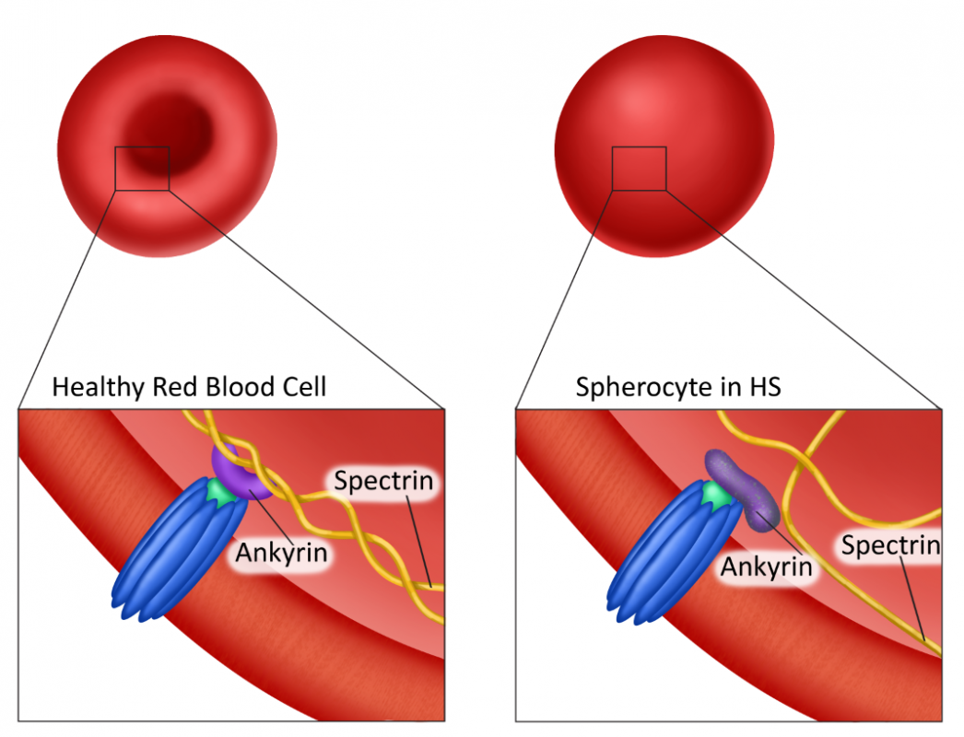

**Changes in ankyrin and spectrin due to hereditary spherocytosis** Image by Becky T. BYU-I S2020

Common clinical signs of hereditary spherocytosis due to the decreased flexion of RBCs and increased cell turnover are erythrostasis (stoppage of erythrocytes in capillaries), hemolytic anemia, jaundice, splenomegaly, and bilirubin gallstones. A life-threatening aplastic crisis (failure of the bone marrow to make red blood cells) can occur if a HS patient becomes infected with the parvovirus B19 (fifth disease). Parvovirus B19 invades red blood cell precursors and diminishes erythropoiesis. Patients with spherocytosis rely more heavily on constant erythropoiesis because of the reduced life span of their RBCs. Therefore, this virus can cause an aplastic crisis for these patients as erythropoiesis will not be able to keep up with the RBC production demand.

A common treatment for HS is a splenectomy to decrease the destruction of RBCs. Although this treatment is effective, it does increase the patient’s risk for certain bacterial infections. Asplenic patients also show abnormal results in peripheral blood smears including anisocytosis and Howell-Jolly bodies. Anisocytosis is a condition where RBCs are different sizes. This is a common result with anemia due to rapid production of red blood cells. Howell-Jolly bodies are nuclear remnants that are normally removed by the spleen.

#### Sickle Cell Anemia

Another inherited disorder that causes a pathological shape change to the RBC is **sickle cell disease** which can result in **sickle cell anemia**. In sickle cell disease, there is an inherited gene mutation called HbS that results in the synthesis of abnormal hemoglobin beta chains. The point mutation in the beta-globin gene of hemoglobin induces an amino acid substitution in the translated protein where a polar glutamic acid is replaced by a non-polar valine residue. This change alters the way the globin protein folds which causes a shape change in the RBC membrane. The result is the sickle shape of RBCs when deoxygenated. The sickling of RBCs can be reversed if proper oxygenation occurs in the lungs, but if the RBCs goes through reoccurring deoxygenation, the cells become permanently sickled.

The two major consequences of red blood cell sickling are chronic hemolytic anemia and blood vessel occlusion. Hemolytic anemia occurs because the misshapen red blood cells are recognized and destroyed as they pass through the spleen, leading to the shortened life of the red blood cells. Vessel occlusion occurs because sickle cells do not pass through blood vessels as well and their attachment to the endothelium triggers the release of substances that increase platelet activation and clotting. This disrupts the blood flow and causes tissue ischemia, pain, and can lead to organ failure.

Factors that increase sickling include cold, stress, physical exertion, infections and illnesses that cause hypoxia, dehydration, and acidosis. Dehydration increases sickling because it increases the hemoglobin concentration and that leads to increased polymerization of hemoglobin inside the cell. Acidosis decreases the affinity that hemoglobin has for oxygen and therefore causes more deoxygenation and more sickling.

The HbS gene is transmitted by recessive inheritance and presents most aggressively in individuals who are homozygous with two HbS genes. Individuals who are heterozygous with one HbS gene present with less severe symptoms and may even be asymptomatic. People with a single copy of the HbS gene are said to have the sickle cell trait but not the sickle cell disease.

As mentioned previously in the chapter, newborn infants don’t have beta and alpha hemoglobin chains but instead have gamma and alpha hemoglobin chains. Gamma hemoglobin has a higher affinity for oxygen and enables more efficient transfer of oxygen from the mother to the fetus in the womb. These gamma hemoglobin chains are replaced by beta chains 8-10 weeks after birth. Because of this, babies who have sickle cell disease will be asymptomatic until they present with beta hemoglobin many weeks later. One treatment for sickle cell anemia is a medication called hydroxyurea which can reactivate fetal hemoglobin production. This is helpful because RBCs with gamma hemoglobin would not have the mutation of the beta hemoglobin and thus wouldn’t sickle. Blood transfusions can also be used in severe and acute cases of anemia. Bone marrow transplant is the only known “cure” for sickle cell disease, however, bone marrow transplants are difficult to obtain successfully because of the need to match specific HLA typing requirements.

Read this online at <https://books.byui.edu/bio_381_pathophysiol/323__disorders_of_th>