Role of Iron and Iron Deficiency Anemia
Please watch the video Iron & Iron Deficiency Anemia Part 1
Iron is essential for health because it is involved in three major body processes: DNA synthesis conducted by iron-requiring enzymes, transport and storage of oxygen, and the electron transport chain for ATP production. At any given moment, there are about 4 grams of iron in the entire human body. Some iron is stored in ferritin protein in various cells (especially in the liver), but the majority of these 4 grams is found in hemoglobin. The iron atom located in the heme group of each of the four protein chains in a hemoglobin molecule attaches to oxygen so it can be transported in the blood. Iron in hemoglobin is in the form Fe2⁺ or ferrous iron. Myoglobin, a molecule similar to hemoglobin but specific to muscle tissue, also contains iron. Myoglobin is used for muscle oxygen storage and delivery. Iron is also an important component of cytochrome enzymes that participate in ATP production. Cytochrome enzymes are iron-containing heme proteins embedded in the inner membrane of the mitochondria. They help with the electron transport chain which accounts for the majority of ATP production in cells.

Dietary Iron and Iron Absorption
There are two forms of dietary iron. The first is referred to as heme iron because it is found in the porphyrin ring of a heme molecule. Heme iron comes from the hemoglobin and myoglobin found in animals. Plants are not a source of heme iron. Heme iron is more readily absorbed because the heme molecule acts as a ligand for special transporters on the enterocytes of the gut. It is estimated that about one third of the dietary iron for Americans comes from heme iron. The other form of dietary iron is non-heme iron or ferric iron (Fe3⁺). It comes mostly from plant sources such as enriched cereal, lentils, beans, tofu, leafy greens, seeds, nuts and wheat. Non-heme iron is less readily absorbed than heme iron.
Because heme iron and non-heme iron are absorbed differently, we will break down iron absorption into two categories:
- Heme iron absorption: Heme iron is transported through heme transporters on the apical membrane of enterocytes primarily in the proximal duodenum. Once in the cytoplasm of the enterocyte, the heme is metabolized by the enzyme heme oxygenase to release ferrous iron (Fe2⁺). From here, the ferrous iron can go one of two pathways:
- The first pathway is the ferrous iron could cross the basolateral membrane of the enterocyte through ferroportin 1 and then be oxidized by another basolateral protein called hephaestin into ferric iron (Fe3⁺). Ferric iron will then bind to a plasma protein made by the liver called transferrin to be transported in the blood.
- The second option for ferrous iron in the enterocyte is to be oxidized into Fe3⁺ and stored as mucosal ferritin. Mucosal ferritin is sloughed off into the intestinal lumen as the enterocytes die at the end of their three day life span.
- Non-heme iron absorption: Non-heme iron must be reduced to ferrous iron (Fe2⁺) by duodenal cytochrome B on the apical membrane of enterocytes in order to be able to cross the apical membrane and enter the enterocyte. After being reduced, the ferrous iron passes through the apical membrane through the divalent metal transporter I (DMT-I) accompanied by a hydrogen ion. Once inside the enterocyte, ferrous iron can (a) be transported into the blood or (b) incorporated into mucosal ferritin as described above.
Various factors can influence iron absorption and retention in the body. Some foods can affect the absorption of iron. Foods with vitamin C increase iron absorption but things like caffeine and calcium rich foods decrease iron absorption. Some health conditions can decrease iron absorption as well. Celiac disease, which is an allergy to barley, wheat and rye, results in decreased absorption of many nutrients including iron. A gastrectomy increases the pH in the duodenum and also decreases iron absorption. Chronic blood loss can decrease iron retention and lead to increased risk of iron-deficiency and anemia. Conditions like ulcerative colitis, bleeding gastrointestinal cancer, bleeding ulcers, and polycystic kidney disease can all cause excessive losses of iron.
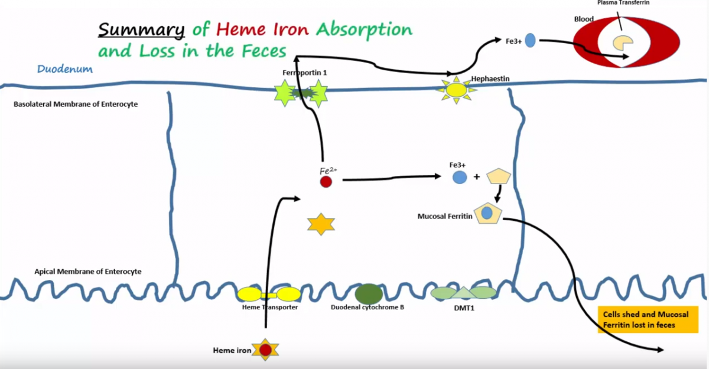
Image by BYU-Idaho S18

Image by BYU-Idaho S18

Iron Transport, Storage, and Regulation
Please watch Iron & Iron Deficiency Anemia Part 2
As mentioned previously, transferrin is made by the liver and secreted into the plasma where it binds to Fe3⁺ and transports it all over the body. The brain and testes are also capable of making transferrin since these proteins don’t readily cross the blood-brain barrier or the blood testes barrier. Most of the iron transported in the blood ends up in the bone marrow where it is recycled and used to make RBCs. Other iron bound by transferrin will travel to the liver for storage. Iron is also high in the reticuloendothelial cells of the spleen because that is where old RBCs are broken down.
Iron is taken into the cell by transferrin receptors embedded in the cell membrane. These receptors are composed of a protein dimer of two identical subunits with 760 amino acids in each. These dimers connect together by disulfide bridges. After binding, both the iron bound transferrin and the transferrin receptor complex are internalized by receptor mediated endocytosis. The transferrin receptor is not degraded inside the cell but instead is recycled back to the cell membrane. The endocytosed ferric iron is shuttled via an intracellular carrier to be incorporated into ferritin. Ferritin is a complex protein of 24 different subunits that come together to form a sphere and contains many iron atoms. Over time, ferritin will combine with other ferritin to form complexes that are digested by lysosomes. This leads to the production of hemosiderin, a more insoluble storage form of iron.
Iron is very important for erythropoiesis, so it is vital for the body to be able to regulate its levels in the blood. If the level of iron gets too low, ferritin can transfer its stored iron back into the blood. To prevent iron from reaching toxic levels, more iron can be sequestered inside cells and stored as ferritin to bring down iron levels. The regulation of iron levels in the blood is mainly accomplished by increasing or decreasing levels of the hormone hepcidin. Hepcidin is a small peptide made by the liver. It blocks ferroportin 1, which is found on the basolateral membrane of the enterocytes and on macrophages. This blockage prevents iron from being released from these cells and reduces iron levels in the blood. Hepcidin’s main job is to prevent the absorption of iron into the blood from the duodenum, but it also prevents the release of iron into the blood from macrophages in the liver and spleen. When erythropoiesis increases and iron is low in the blood, the liver will produce less hepcidin. This means that a decreased amount of ferroportin 1 is blocked, the activity of ferroportin 1 is increased, and more iron is released/absorbed into the blood. When body stores of iron are high and erythropoiesis is normal, hepcidin is increased and the iron that is trapped in the enterocytes is sloughed off and lost from the body as normal gut epithelial cell turnover occurs. Because hepcidin is made in the liver, it is regulated by the iron levels in the hepatocytes. High levels of hepatocyte iron storage increase hepcidin production while low levels of hepatocyte iron storage decrease hepcidin production.
When hepcidin function is impaired or blocked in any way, the uninhibited enterocytes dump their iron stores into the blood at a much higher rate than necessary. This excess iron release will lead to excessive iron deposits in organs throughout the body and cause a condition called hemochromatosis. Symptoms of this condition include fatigue, joint pain, endocrine organ damage, and liver damage. There may be a bronze color to the skin as well. Practitioners refer to the triad of symptoms that often suggest a diagnosis of hemochromatosis as cirrhosis, bronze skin, and onset of diabetes.
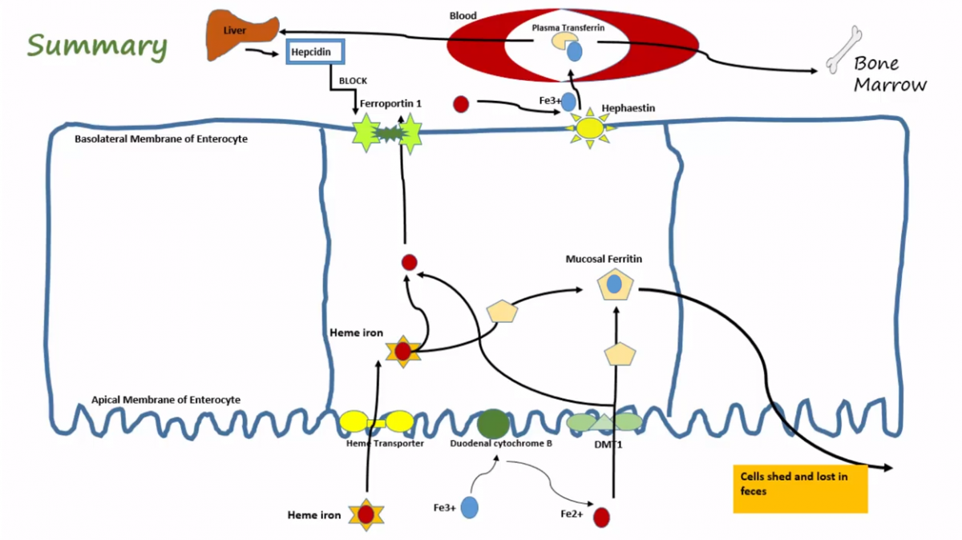
Summary of Iron Absorption, Transport, and RegulationImage by BYU-I F18

Characteristics, Etiology, and Prevention of Iron Deficiency Anemia

Please watch the video Iron & Iron Deficiency Anemia Part 3
Iron deficiency anemia is the most common nutritional deficiency. A mild iron deficiency is found in 9% of people in the world and it is more common in women. Infants, toddlers, teenagers, pregnant women, and the elderly are at a higher risk for developing iron deficiency anemia. Some common characteristics of iron deficiency anemia are low levels of serum iron and low levels of ferritin, decreased hemoglobin, decreased hematocrit, decreased MCV (because of smaller RBCs), and decreased MCHC. A lack of iron makes it difficult to make full sized and fully hemoglobin-loaded red blood cells, which leads to the overall decrease in these bloodwork levels. There are also several common manifestations of iron deficiency anemia such as fatigue, dizziness, muscle weakness, and pallor due to the decreased levels of hemoglobin that leads to decreased oxygen delivery to tissues. The body attempts to compensate for the lack of oxygen by increasing the respiratory rate and heart rate. Epithelial cells also start to break down which is manifested by brittle hair and nails, smooth tongue, difficulty swallowing, and decreased acid production. Sometimes pica may develop the desire to eat dirt, ice or other unusual things. Long-untreated iron deficiency anemia may lead to mental, motor, and emotional deficits in infants and children.
There are four main root causes of iron deficiency anemia: dietary deficiency, decreased absorption, increased demand, and blood loss. A variety of conditions can contribute to these root causes. Dietary deficiency is more common in underdeveloped countries, but poor diet in general can lead to it. Iron deficiency anemia risk can be reduced by avoiding cow’s milk in infants because calcium inhibits iron absorption. It may also help to supplement with iron fortified formula and food. Decreased absorption can be due to diseases of the duodenum or issues with hepcidin. A classic example of increased demand for iron is pregnancy. And finally, if the deficiency is caused by blood loss, the effective treatment is to control the blood loss and give supplemental iron.

Read this online at https://books.byui.edu/bio_381_pathophysiol/325__role_of_iron_an

