Hypothalamic-Pituitary Regulation
As you’ve learned in previous physiology classes, many of the hormones of the body come from the hypothalamus and the anterior or posterior pituitary. It may be helpful for you to go back and review the chapters on the endocrine system from your physiology class (at BYU-Idaho, this would be in Bio 265). We will review a few endocrine concepts here.
The hypothalamo-hypophyseal portal system refers to the capillary network that allows neurohormones to travel in the bloodstream from the hypothalamus to the anterior pituitary. Another name for the anterior pituitary is the adenohypophysis. The hypothalamo-hypophyseal tract refers to the axonal extension of the hypothalamus to the posterior pituitary. Another name for the posterior pituitary is neurohypophysis.

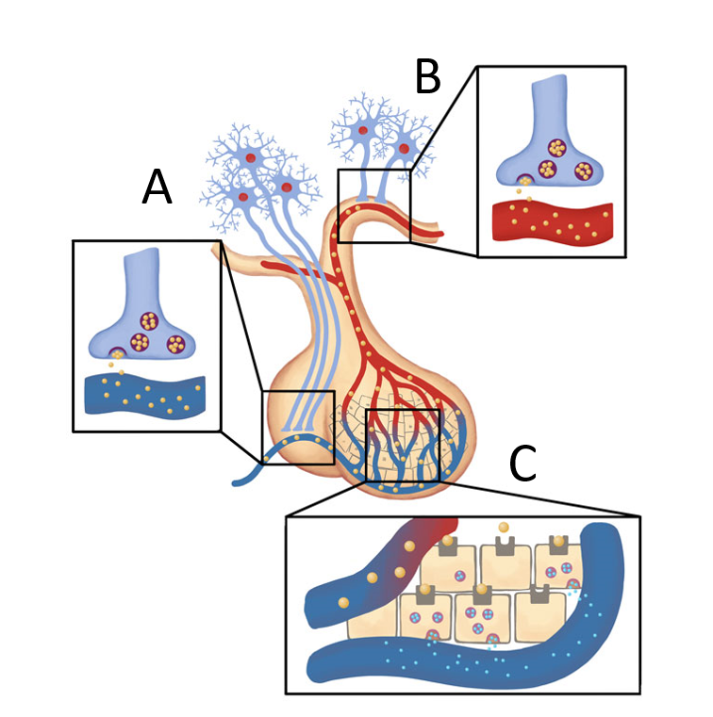
Hypothalamo-Hypophyseal Portal System and TractImage by BYU-I
The area labeled “A” in the picture above shows the axon terminals of neurons in the hypothalamo-hypophyseal tract. The cell bodies of these neurons reside in the hypothalamus. They transport neurohormones down their axons where they are released into the blood at the posterior pituitary as seen in the inset for A. This means that the hormones released from the posterior pituitary are actually made by the hypothalamus. The area labeled “B” in the image shows the axon terminals of the hypothalamic neurons that release neurohormones into the hypothalamo-hypophyseal portal system. These neurohormones travel a short distance in the blood to the cells of the anterior pituitary. The area labeled “C” shows where the neurohormones leave the portal circulation to find receptors on the various types of hormone secreting cells of the anterior pituitary. The anterior pituitary cells stop or start the release of hormones into the general circulation depending on what signaling neurohormones are released from the hypothalamus. Note that the hormones released from the anterior pituitary are synthesized there and do not come from the hypothalamus.
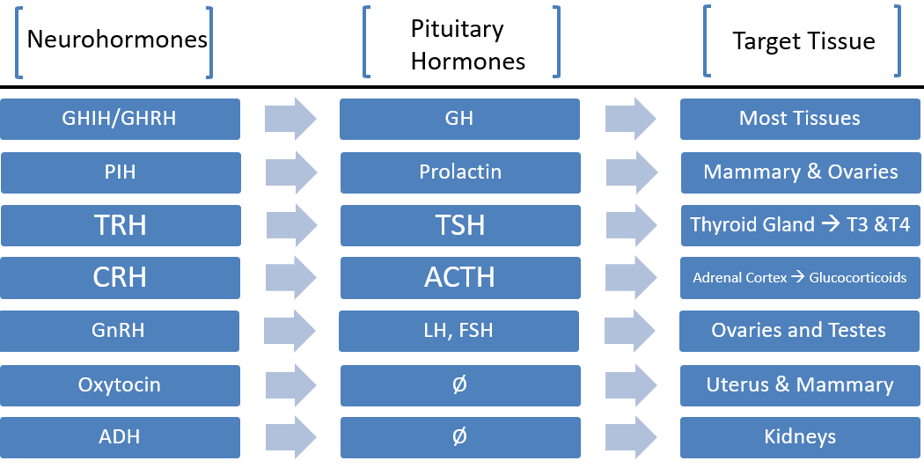
Hormones Involved in the Hypothalamic / Pituitary AxisImage by BYU-I

Hormones of the Hypothalamus
Technically, the hormones from the hypothalamus are called neurohormones because they are released into the blood from the terminal ends of central nervous system neurons. However, it is not uncommon for these neurohormones to just be referred to as hormones.
Growth hormone releasing hormone (GHRH) and growth hormone inhibitory hormone (GHIH or somatostatin) are released from the hypothalamus and act on the anterior pituitary to influence the release of growth hormone (GH). GHRH increases the release of GH while GHIH decreases the release of GH. GH is released from the anterior pituitary into the blood and acts upon most tissues to stimulate growth and regulate metabolism.
Gonadotropin releasing hormone (GnRH) is another hormone released from the hypothalamus that acts on the anterior pituitary and causes it to release follicle stimulating hormone (FSH) and luteinizing hormone (LH) into the blood. FSH and LH act on the ovaries and testes,but have different purposes in males and females. FSH is responsible for increased sperm production in males, but in females it promotes follicle development and estrogen secretion. LH is responsible for testosterone production in males, but in females it promotes ovulation and progesterone secretion.
Thyroid releasing hormone (TRH) from the hypothalamus stimulates the release of thyroid stimulating hormone (TSH) from the anterior pituitary. TSH travels to the thyroid gland where it stimulates the release of the thyroid hormones T3 and T4. T3 and T4 then travel through the blood and stimulate nearly all cells of the body to increase metabolism and growth.
Corticotropin releasing hormone (CRH) is also released from the hypothalamus and causes the increased release of adrenocorticotropic hormone (ACTH) from the anterior pituitary. ACTH then travels through the blood to the adrenal cortex where it stimulates the release of cortisol. Cortisol acts on most tissues in the body to increase protein and lipid breakdown, increase glucose production, increase blood sugar levels, and acts as an anti-immune and anti-inflammatory effector.
Prolactin inhibitory hormone (PIH or dopamine) is released from the hypothalamus and acts on the anterior pituitary to stop the release of prolactin (PRL) into the blood. Diminished PIH results in increased PRL release. It is important to note that TRH can actually increase prolactin release as well. Once in the blood, prolactin acts on the mammary glands and ovaries to cause milk production.
In a discussion of hypothalamic hormones, we should recall that the two hormones oxytocin and antidiuretic hormone (ADH) are released into the general circulation from long axons of the hypothalamus which form the posterior pituitary gland. Oxytocin acts on the mammary glands, uterus, and brain to stimulate the release of milk, uterine contractions, and enhance social and moral feelings, respectively. ADH causes increased water retention in the kidneys and vasoconstriction of the blood vessels.
All of these hormones tend to be tightly regulated by negative feedback loops. These feedback loops are critical to understand because they can inform us of what certain blood tests mean during diagnostic procedures. We will go more into these feedback regulations as we continue our discussion about some of these hormones individually.

Three Levels of Endocrine Disorders
Before we discuss specific examples of endocrine disorders, we should define the three different levels of endocrine disorders that we see in the body:
- Primary endocrine disorders take place in the actual gland that is responsible for releasing the hormone in question. For example: a tumor in the thyroid gland that causes an excessive amount of T3/T4 production would be a primary disorder.
- Secondary endocrine disorders are characterized by normally functioning regulating signals from the hypothalamus and normally functioning target tissue, but the actions of the gland in the middle of the axis are dysfunctional. For example: GHRH secreting cells of the hypothalamus are normal (the regulating signals) and body tissues of all types are normal (the target tissues), but the cells that secrete GH (the anterior pituitary) are dysfunctional because of an adenoma. This would be a secondary endocrine disorder and would likely lead to gigantism as excessive GH from the adenoma operates on normal body tissues.
- Tertiary endocrine disorders occur when the regulating signals of the third hormone secreting gland in an axis is dysfunctional (the hypothalamus) and the middle gland (pituitary) and target tissues are healthy. An example of this is when CRH secreting cells of the hypothalamus are producing either too much or too little CRH. As a result, the normal anterior ACTH producing cells don’t receive appropriate regulation from the hypothalamus and the normal adrenal cortex cells don’t receive appropriate ACTH signaling from the anterior pituitary. Ultimately, while the problem is a tertiary issue involving dysfunctional cells in the hypothalamus, the manifestations or symptoms come from the fact that the primary gland does not receive appropriate regulating signals and does not function as it should.

Read this online at https://books.byui.edu/bio_381_pathophysiol/511__hypothalamic_pi

