# GI Tract Anatomy

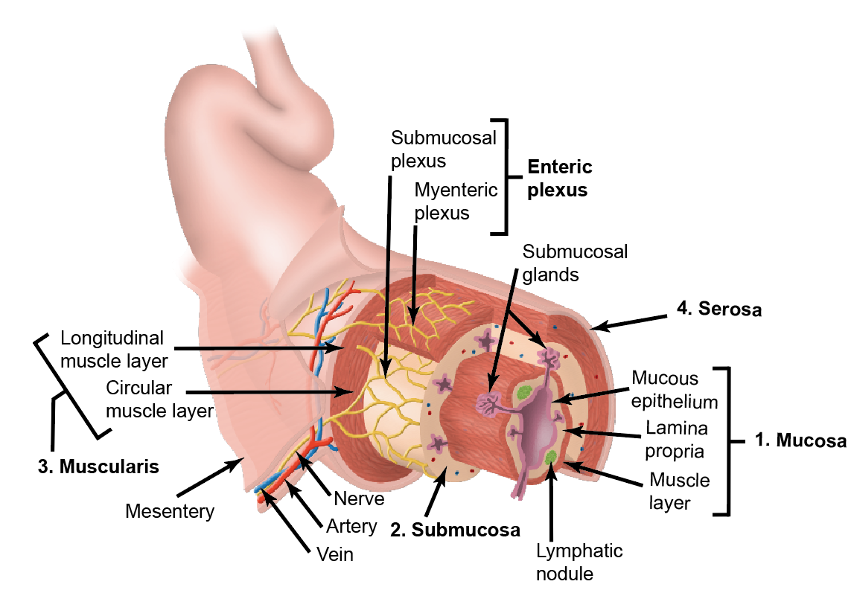

Recall that from deep to superficial, the layers of the **gastrointestinal (GI)** tract are as follows:

1. Mucosa: comprised of the mucous epithelium, lamina propria, and muscularis mucosa
2. Submucosa: contains blood vessels and lymphatic vessels
3. Muscularis externa: contains nerves that control smooth muscle movement and two layers of muscle that perform peristalsis and segmentation.
4. Serosa or adventitia: the main difference between serosa and adventitia is that the serosa covers the organs in the body cavities whereas adventitia attaches the organ to the surrounding tissues.

Recall that the enteric plexus is a mesh-like system of neurons that governs the function of the gastrointestinal tract. It is influenced by the autonomic nervous system, but it can act independently. There are many neurotransmitters that operate as part of the enteric nervous system. Interestingly, serotonin is the most abundant.

Read this online at <https://books.byui.edu/bio_381_pathophysiol/811__gi_tract_anatom>