# Osteoarthritis (OA)

**Osteoarthritis (OA)** is the most common type of arthritis. It is considered to be one of the most disabling conditions in industrialized nations. OA is largely the result of mechanical stress and the dysregulation of cartilage nutrition and repair. OA is characterized by the degeneration of articular cartilage, a type of hyaline cartilage that acts to reduce friction at the ends of bones where they come together in a joint. It can affect any joint, but it is primarily found in joints of the hands, knees, hips, and spine. Articular cartilage can handle tremendous compression loads, however bony misalignment, repetitive motion, immobility, older age, obesity, and joint trauma put a person at a much higher risk for OA. The chondrocytes of hyaline cartilage get rid of waste products and receive their nutrition through a process of losing fluid with compression of the tissue and then pulling new, nutrition rich fluid into the matrix when the compression load is removed. When mechanical forces are excessive or applied at an abnormal angle or through an unstable joint, then damage to the chondrocytes and collagen rich matrix occurs. Articular cartilage can repair itself, but it is a slow process as it has no direct blood supply.

Damaged chondrocytes release cytokines that can stimulate the release of proteases that work on the cartilage matrix. This further facilitates the cartilage destruction. Cartilage tissue breakdown soon outpaces repair and cartilage fragments are released into the joint fluid and space. These fragments are called **fibrillations** and have been nicknamed “joint mice.” Gradually, the hyaline cartilage is removed from the bony surface and bones begin to rub directly against each other. This rubbing causes the bony ends to get smooth in a process called **eburnation**. As this “bone on bone” grinding occurs, subchondral fluid-filled cysts may arise. There is an increased rate of bone matrix breakdown on the weight bearing surfaces of the bones and this stimulates nearby osteoblasts to engage in bone material synthesis. The new bony material expands at the edges of the joint and creates structures referred to as **osteophytes**. Osteophytes are irregular structures of bone deposition that can have sharp edges extending into the joint cavity and damage the lining of the joint capsule. All of this joint damage creates an inflammatory response that leads to swelling, pain, and stiffness.

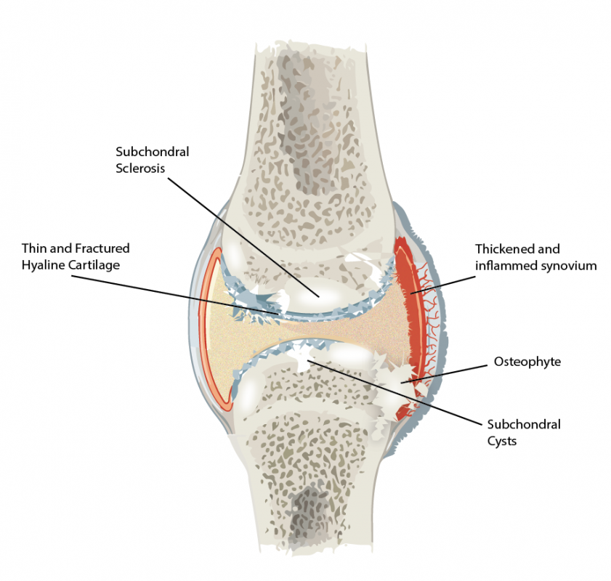

**Indications of Osteoarthritis**

Adapted from: Title: File:907 Synovial Joints.jpg; Author: OpenStax College; Site: https://commons.wikimedia.org/wiki/File:907_Synovial_Joints.jpg;; License: This file is licensed under the Creative Commons Attribution 3.0 Unportedlicense.

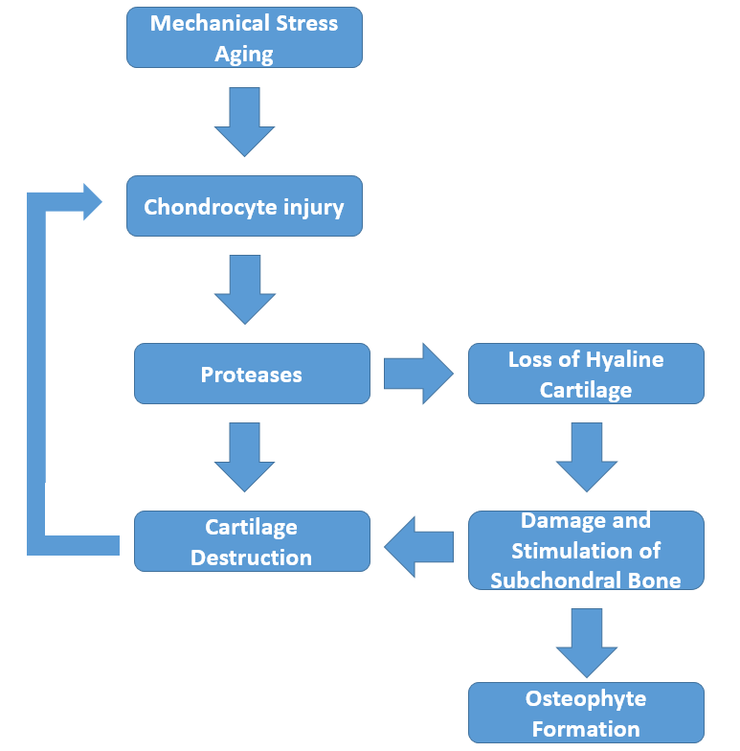

**Progression of Osteoarthritis**

Image by Lanning B. S17

The main symptom of OA is pain and stiffness. Early on in disease onset, the pain is typically decreased with activity and rest. However, as the disease continues, stiffness in the morning may become more common and pain continues to increase with joint use and activity. Some individuals will report that their symptoms get worse in cold temperatures, high humidity, or with a drop in barometric pressure. Eventually, pain and stiffness become relatively constant and can severely limit function.

In smaller joints like the fingers, chronic inflammation and joint tissue damage can lead to a visible enlargement of the joint area. These enlargements are called **Heberden’s nodes** if they are on the distal interphalangeal joints and **Bouchard’s nodes** if they are on the proximal interphalangeal joints.

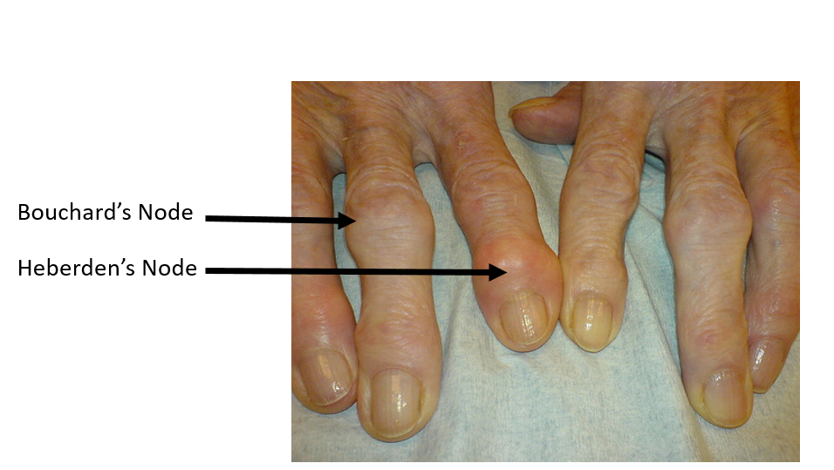

File:Heberden-Arthrose.JPG; Drahreg01; https://commons.wikimedia.org/wiki/File:Heberden-Arthrose.JPG; This file is licensed under the Creative Commons Attribution-Share Alike 3.0 Unported license.

OA may arise as a secondary condition of other diseases. It is quite common in individuals with diabetes, Ehlers-Danlos syndrome, hemochromatosis, and Marfan syndrome. It affects women more often than men and for unknown reasons, women seem to have it more severely.

Treatment of OA involves a combination of lifestyle changes, weight loss when necessary, analgesics, and anti-inflammatory medication. Administration of COX1 and COX2 inhibitors is common. Braces and orthotics to help align bones may be used. Topical ointments generally laced with NSAIDs are often applied. In more severe cases, joint injections with glucocorticoids may be performed to provide temporary relief. Injections of hyaluronic acid or components found in hyaluronic acid have been tried as a treatment, but the results are controversial and not at all certain. Surgery that involves joint replacement is performed when nothing else adequately relieves the pain and suffering. Artificial joints work well to relieve the constant pain, but these surgeries are difficult to recover from and often do not restore the full function of the joint. However, many patients with severe OA find joint replacement surgery to be quite beneficial.

Read this online at <https://books.byui.edu/bio_381_pathophysiol/1014__osteoarthritis>