# Pressure-Volume Loops and the Work of Breathing

Breathing requires a substantial amount of energy expenditure, which can be equated as work, but the work involved in breathing is a very difficult thing to measure. Placing values on things like elasticity, air flow resistance, or the force generated by the respiratory muscles is a complex process. To simplify the process, the work involved in breathing can be estimated by measuring changes that occur in lung volume and pressure during inspiration and expiration. These changes can be graphed to create a **pressure-volume curve** which can then be used to estimate work output and give us an idea of energy expenditure during breathing. The pressure-volume curve is essential in helping to properly diagnose compromises in lung function, so let’s see if we can explain the graph!

To make a pressure-volume curve we start with a lung, but one that is no longer in the body… so yeah, let that thought settle in, in this case we use a rabbit lung. At any rate, once the lung is obtained all the air is removed out of it (collapsed). The lung is then slowly filled with air and the change in lung size (volume) is measured and recorded on the Y-axis. The X-axis records the “airway pressure” or pressure build up in the airways of the lung as the air is pumped in. In a normal lung, the pressure-volume curve will resemble the green tracing below. The open arrows represent inflation (or inspiration) and the closed arrows represent deflation (or expiration).

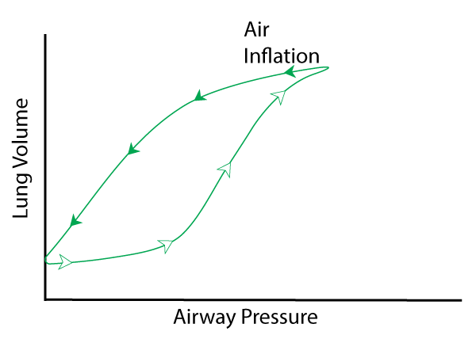

Image by JS S22

### Inspiration

Notice that the loop takes a fair amount of pressure to get a small volume change during the first part of inflation (flattened slope) but then the slope becomes more steep allowing for a large change in volume with very little change in pressure. This is believed to be because of the way that alveoli work. As explained previously, Laplace’s Law states:

**P = 2T/r**

Where “P” is the pressure generated in the alveoli as the spheres try to close or get smaller. It is this pressure that must be overcome to allow air to enter the alveolus during inspiration. The smaller the radius of the alveolus, the more pressure there will be to overcome as the air is inspired. The graph above shows air introduction from a fully collapsed lung and so the alveoli at first are very small, even collapsed themselves requiring more pressure to force them open (flattened slope). As air is introduced, pressure in the airways builds up and eventually forces the alveoli to open. At the point the alveoli open, the inspiratory loop changes suddenly to a much steeper slope, called the point of rapid **alveolar recruitment**. Thus, during the beginning flat part of the loop we describe the lung as more elastic but less complaint. During the vertical part of inspiration loop, we describe the lung as less elastic but more compliant. At the top of the green inspiratory loop line (near the end of inspiration), the slope flattens out again indicating a need for a higher pressure to change the volume. This upper inflection point represents the alveoli reaching their fully inflated state so that further volume change requires more extreme stretching of respiratory tissues and structures. The lung would once again be described as less compliant.

### Expiration

The expiratory curve shape is also dictated by surface tension and Laplace’s Law. Since water molecules are attracted to each other at the air moisture interface of the alveoli, and since the alveoli are spherical, this attraction forms a type of “tension curve” around the alveoli which works to close the alveoli. As previously mentioned, at the end of inspiration, the alveoli spheres are at their largest size, making the “r” value (alveolar radius) in Laplace’s Law large. Since “r” is the denominator, it results in a small “P” which indicates that less pressure is needed to push air out. However, if we look close at the green expiratory curve, we see that there is an upper deflection point where the slope becomes suddenly more vertical. This inflection point is the place where most alveoli are simultaneously reaching a smaller “r” value which favors more rapid closure of the alveoli. The resultant pressure pushes air out quickly. This inflection point is called **alveolar decruitment**.

### Surface Tension

To further tease out the importance of surface tension for inspiration and expiration experiments were performed on lungs controlling for surface tension effects. To isolate the effect of surface tension the lung is subjected to a post-lavage air inflation experiment and to remove the effects of surface tenson lungs are subjected to a saline inflation experiment.

#### Post-Lavage Air Inflation

The post lavage air inflation experiment is performed by washing the inside of the lung with a solution that removes surfactant. The lung is then inflated and deflated again as before. Without surfactant, surface tension is much higher (remember that surfactant lowers surface tension). The extra high surface tension (according to Laplace’s Law) increases “T” and creates higher pressures that must be overcome before the alveoli can be forced open. This causes the inspiratory inflection point to shift to the right, suggesting that a much higher pressure is required to inflate the lung. Clearly, a lung without surfactant is much less compliant (more elastic) and it would take a lot of work to generate pressures high enough to ventilate the lung.

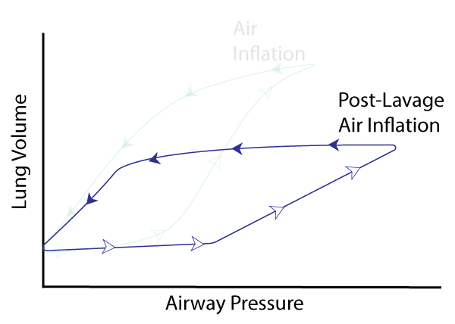

Image by JS S22

#### Saline Inflation

For this experiment, the lung is inflated with a saline solution. As the alveoli fill with fluid, the air moisture interface is removed. In other words, there is no more surface tension because there is no more “surface”.  Essentially “T” = 0 in Laplace’s Law making the law irrelevant as the lung fills.  Thus, there are no inflection points representing recruitment or decruitment. Additionally, it takes very little pressure to expand the lung to a larger volume (suggesting that without surfactant, the lung is very compliant).

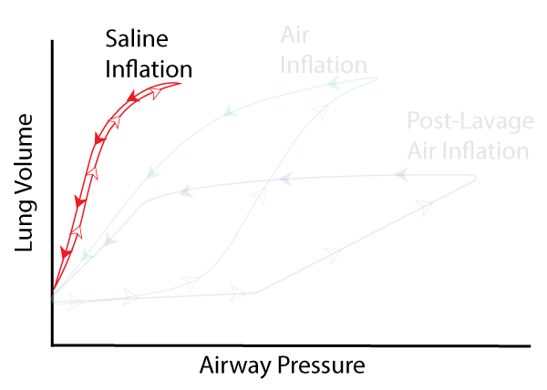

Image by JS S22

#### Elasticity

The saline inflation experiment reveals an additional truth about the lungs and that is elastic recoil. If LaPlace’s law is essentially voided out in a saline filled lung, a question might be: Why then does the lung deflate at all? The observation led to the discovery that in addition to surface tension lungs have an intrinsic property of elasticity. In other words, the lung is like a weak rubber band and will recoil when stretched. An important take home message here is that surface tension greatly increases the elasticity of the lung (i.e., effect of the rubber band), but even without surface tension, the lung has intrinsic elastic properties that make it “want” to collapse if it is allowed to. This is no doubt important as elasticity helps exhale air faster, allowing faster breathing rates. However, too much elasticity would make it hard to expand the lung to functional volumes. Too little elasticity would make expiration last a long time and decrease the potential to raise ventilatory rates to move more fresh air into the lung. To help modulate elasticity, the alveoli are coated with thin sheets of water. Then to regulate surface tension, the alveoli produce surfactant. It should now be possible to imagine disease states that increase or decrease elasticity of the lung. If we were to make pressure volume loops of these diseased lungs, we would find that more compliant lungs have a loop that tilts to the left (more toward the saline loop) and more elastic (less compliant) lungs have loops that tilt toward the surfactant absent lung (blue line).

### Clinical Pearl - Infant RDS

Respiratory Distress Syndrome (RDS) in a newborn occurs when the baby is born before the cells of the lung are developed enough to synthesize and secrete surfactant. Without surfactant, the alveoli are much more elastic and pressure-volume loops reveal a loop that tilts to the right of normal. The infants must expend a lot of energy to try and inflate the lungs. Infants struggling to overcome the decreased compliance of the lung will often show flaring nostrils and skin that sucks in between the ribs with every inspiration. These babies have faster breathing rates as well. These babies are truly working hard to get air in and even so, will often have a blue tint, especially in the face.

Treatments include administration of surfactant like substances to help increase lung compliance. The infants may also be put on a breathing assistant machines or ventilators where positive pressure will be used to help the baby expand the lung during inspiration.

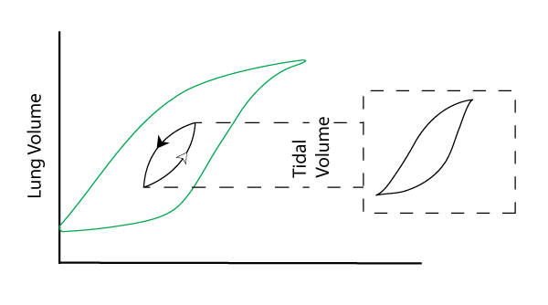

Image by JS S22

While the experiments discussed in the previous graph reveal pressure – volume loops in excised isolated lungs that could be inflated ad collapsed fully, “real-life” lungs should never be completly inflated or deflated.  The regular breathing done in a real live person achieves volumes called “Tidal Volumes”. Regular breathing involves inhaling and exhaling a volume of air that is considerably less than our isolated lung experiment. The image above shows an ellipse superimposed on our excised lung loop. Tidal volume loops are often drawn as a nearly perfect ellipse and you will see this frequently in the literature, but technically speaking, the ellipse is likely to have some subtle recruitment and decruitment inflection points such as shown on the right. This is especially true if the breathing rate increases which tends to amplify these points.

### Pressure-Volume loops and work

Consider the following derivation of the concept of “work”.  Work is defined as the amount of energy expended to apply a force to move an object a certain distance.  You may see it defined as:

Work = Force * Distance

Now consider the following:

Pressure = Force / Area

So, Force = Pressure * Area

Therefore, Work = Pressure * Area * Distance

Volume = Area * Distance

And so…

**Work = Pressure * Volume**

What this means is that if we multiply Pressure * Volume in our pressure – volume loop, we can visualize the amount of work done to ventilate by observing the “area under the curve”.

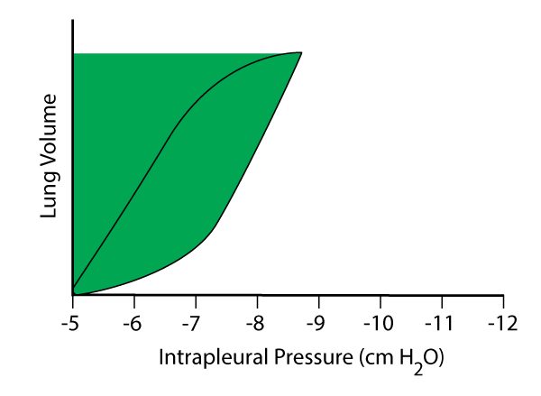

Image by JS S22

The graph above is tracking tidal volume and the X-axis has been changed. The change represents intrapleural pressure instead of the air way pressure. Instead of artificially “blowing up” or inflating the lungs as done previously, actual breathing in the body is done by creating more and more negative pressure in our intrapleural space to “suck” the lungs out towards the expanding rib cage which increases lung volume. Thus, intrapleural pressure is measure as a negative standardized value. During a normal tidal wave inspiration, intrapleural pressure starts somewhere around -5 (cm H2O) and becomes more negative to be close to -8 (cm H2O) at the end of inspiration. The amount of work that is done to expand the lung volume is equal to force times volume or the area shaded in green.

There are really three areas that work can be considered separately to create the total work done.

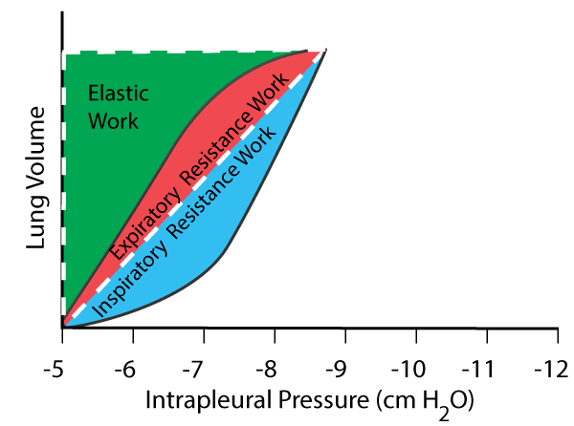

Image by JS S22

Together, the area that is colored red and green represent a triangle (circumscribed by a dashed line). This area is the elastic work done by the lung. Elastic work refers to the work done to stretch the elastic tissue. The Blue area represents the work against resistance to inflate the lung. As stated previously, airway resistance arises through the difficulties encountered to move air through the passageways of the lungs and into collapsed or very small alveoli. Since inspiration requires the addition of muscle to overcome resistance, the blue area will “bulge” out beyond the dashed triangle. The red area represents the work against airway resistance to move air out of the lung and since this is mostly a passive process during rest, the area is contained within the dashed triangle.

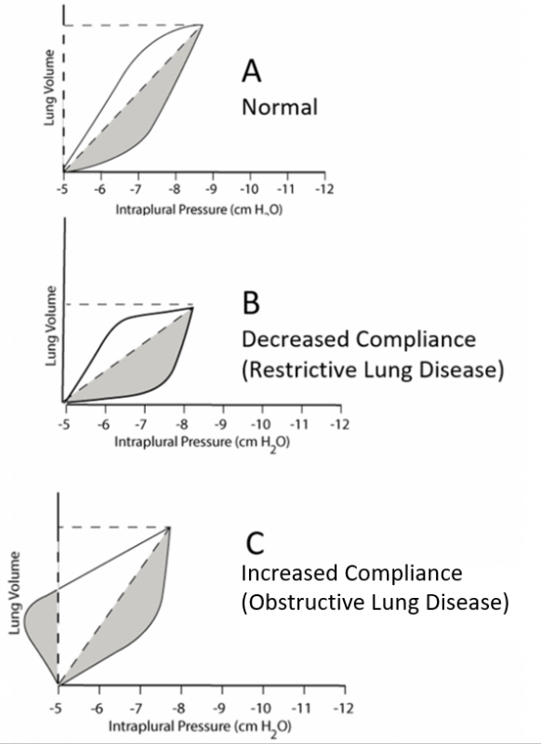

Image by JS S22

### Using Work to Interpret Lung Diseases

In the image above, we see three depictions of different lung states. Image **“A”** represents a normal pressure volume loop. The gray area represents the work done to overcome the airway resistance of the lung during inspiration. The triangle area circumscribed by the dashed line represents the work done to overcome the lungs elastic resistance. Image **“B”** shows a lung that has decreased compliance. The hypotenuse of the elastic work triangle is tilted to the right (revealing a decrease in the overall slope of the curve). Since the slope represents the amount of pressure that is required to get a volume change, the lung in **“B”** requires more work to reach the same tidal volume as **“A”**. This more resistant lung can also have an increased airway resistance which can be noticed as a larger bulge in the inspiration stage. Thus, a lung with a restrictive lung disease requires a lot more work to ventilate.

Sometimes, the elastic forces generated during inspiration are not enough to passively move all the air out of the lungs instead requiring “extra” work for exhalation. A lung with increased compliance will have a slope tilted more left and will have less stored energy as elastic work (smaller triangle) and may require a person to use extra energy to engage muscles to move the rib cage during the expiratory stage. A graph of this would look like image **“C”** above. Since elastic recoil was not enough to exhale the air, muscles were recruited to help. As this energy was expended to push the air out, the rib cage closed in on the lung more quickly and the pleural space volume decreased. Boyles law tells us that as volume decreases, pressure rises, which in this case means a less negative value. So, this effort of the body to exhale caused the pleural space to reach a value less negative than -5 cm H2O and may even rise past 0 to a positive integer. This extra work of exhaling beyond what elastic recoil can do alone is shown as the area under the curve (gray area) to the left of the starting line for the normal loop.

### Work vs Breathing Rate

In these final graphs, we see that elastic work tends to decrease as respiratory frequency increases. This is because an increased respiratory rate overcomes some of the friction of tissue molecules sliding over each other and because viscosity of lung tissue decreases as temperature rises through frequent cycles of inspiration and expiration.

On the other hand, air flow resistance increases with a faster respiratory rate. This happens when increased breathing causes air to move faster and bounce around and become turbulent. It becomes more difficult to move air efficiently through the many small passageways and alveoli of the lung.

The sum of the two types of resistances that require work to breath is labeled at the top as “total”.  The graph shows that in a normal lung the most efficient breathing rate is about 12-13 breaths per minute (requires the least amount of total work). Indeed, if you relax and count your natural resting breath, it will probably be close to this. Notice the graphs to the right of the normal depiction. The middle graph shows that elastic work increases when the lung is more “stiff” (resistive lung disease). This is also seen in the black and white graph above that reveals a larger triangle area when the lung is less compliant. Notice that when the elastic work increases, the new “most efficient” breathing rate is higher. Often when this happens, a person begins to decrease their tidal volume as they get tired from breathing so fast. The decreased tidal volume may stimulate “air hunger” and a desire to take a deeper breath, but a deeper breath will require more total work. Notice how the total work would change to a higher value if the black dashed line moved to the left to reflect a slower breathing frequency.  This extra work can make a person even more tired and in severe cases, the work of breathing can cause respiratory failure if the person cannot maintain the energy output.

In the black and white graph before, we see an obstructive lung disease in Graph **“C”**. Obstructive lung diseases tend to cause lungs to be more compliant and they do not store enough elastic energy to recoil all the air out. Expiration requires extra effort to overcome the airway resistance to get air out and the total airway resistance work increases. The graph below indicates that if this airway resistance work is increased, the most efficient breathing rate gets slower. The slow breaths may not ventilate enough air and so after some time, a person may feel the need to breath faster, but as indicated in the graph, breathing faster will move the dashed line to the right and require more total work to breath. Again, this can tire a patient out because of the increased work of breathing.

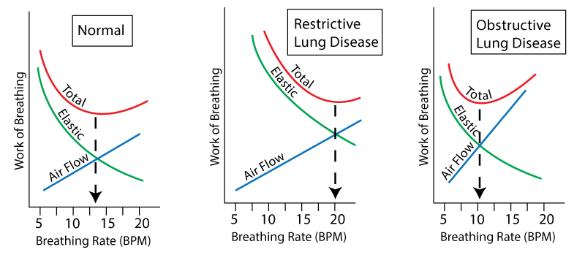

Image by JS S22

Read this online at <https://books.byui.edu/bio_461_principles_o/pressure_volume_loop>