# Pain Transmission

### 11.1.3 – Pain Transmission

The second step of nociception is **transmission**. Like other somatic sensory receptors, the cell bodies of nociceptors are located in the **dorsal root ganglion (DRG)**. Sensory neurons, including nociceptors, are categorized according to their axons. The first two types conduct sensations that are sometimes referred to as “discriminative.” Examples of discriminative sensations include textures, fine touch, vibration, two point discrimination, and proprioception. The other two are largely nociceptors that conduct sensations that can be referred to as “non-discriminatory” or “crude touch.” Examples of such sensations include generalized pressure, tickle, itch, pain, and temperature. The four types of sensory neurons are:

1. **A-alpha fibers** are thickly myelinated and the largest in diameter. They have rapid conduction speeds (80-120 m/s) and transmit signals related to proprioception (e.g. Golgi tendon reflex) and vibration.
2. **A-beta fibers** are moderately myelinated but smaller in diameter and slightly slower in conduction speed (35-75 m/s) compared to A-alpha fibers. They transmit information from the mechanoreceptors in our skin and provide our sense of detailed touch and joint position (muscle spindles). Some nociceptors activate A-beta fibers, but the majority of nociception is transmitted via A-delta fibers.
3. **A-delta fibers** are lightly myelinated and transmit pain signals at approximately 10-30 m/s in response to intense mechanical and thermal stimuli. Their activation results in the sensation of intense pain of a shorter duration. They carry the immediate, acute, sharp, and more localized type of pain.
4. **C-fibers** are unmyelinated and have the slowest action potential transmission speeds (0.5-2.5 m/s). They are associated with a duller, longer lasting “secondary” pain. This pain feels deep, achy and throbbing.

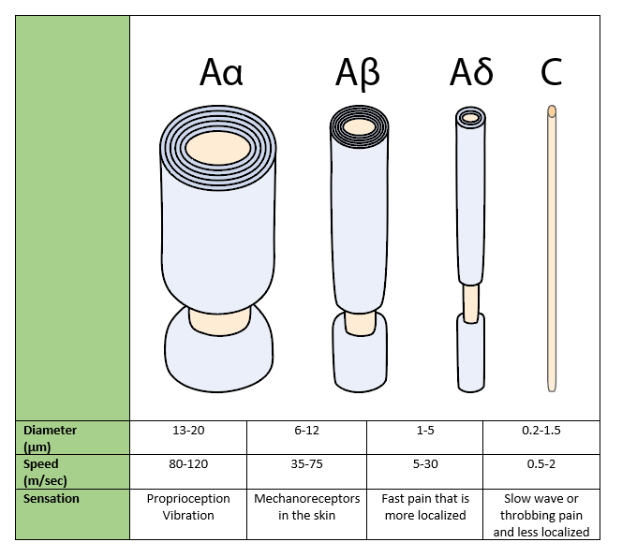

**Sensory Neuron Categorization**

Image by JS BYU-I F17

Sensory pathways are composed of **first-order(primary** or **peripheral)**, **second-order(secondary)**, and **third-order(tertiary)** neurons that ultimately transmit pain signals to the somatosensory cortex. The primary neurons are located outside the central nervous system and synapse with the secondary neurons in the spinal cord. These secondary neurons in turn synapse with the tertiary neurons in the brain. When the pain signal reaches the cortex, the individual becomes consciously aware of the pain. Substance P, norepinephrine, and glutamate are some of the excitatory neurotransmitters that may be released from primary neurons at the synapse with secondary neurons in the spinal cord. Secondary neurons project to the thalamus and also have collateral axons that innervate the **reticular activating system (RAS)** of the brainstem. The RAS helps regulate the attention and alertness we give to the pain.

#### DCML and ALS Pathways

Upon entry to the spinal cord, the central nervous system can pick up and conduct sensory signals to a variety of targets. Some signals are passed within the spinal cord to cause a motor reflex (like the flexor withdrawal reflex to quickly remove an extremity from a painful stimulus) or an autonomic nervous system response (like sympathetic changes to heart rate and blood pressure that follow pain).

Sensory signals are also passed to one of two major ascending pathways to the brain. The first is called the **dorsal column medial lemniscus (DCML)** pathway. Sensory neurons of the periphery that feed this pathway are of the larger, myelinated, and faster variety (A-alpha and A-beta). These fibers have their cell bodies in the dorsal root ganglia and the axons of these neurons enter the **dorsal horn** of the gray matter and project to the nucleus cuneatus of the medulla where they synapse with second order neurons. The second order neurons cross over to the opposite side of the medulla via the medial lemniscus and project to the thalamus where they synapse with third order neurons. The third order neurons project from the thalamus and synapse in the cerebral cortex where the stimulus is interpreted and perceived.

The second possibility for sensory signals to reach the cortex of the brain is the **anterior lateral spinothalamic (ALS)** pathway that involves smaller neurons with less or no myelination (A-delta and C-fibers). The primary fibers of this neural pathway also have their cell bodies in the dorsal root ganglia and enter the spinal cord where they immediately synapse in the dorsal horn of the gray matter with second order neurons. These second order neurons cross over to the opposite side of the spinal cord and then ascend in the anterior/lateral columns of the spinal cord until they synapse with third order neurons within the thalamus. Third order neurons then project to the cerebral cortex for interpretation and perception.

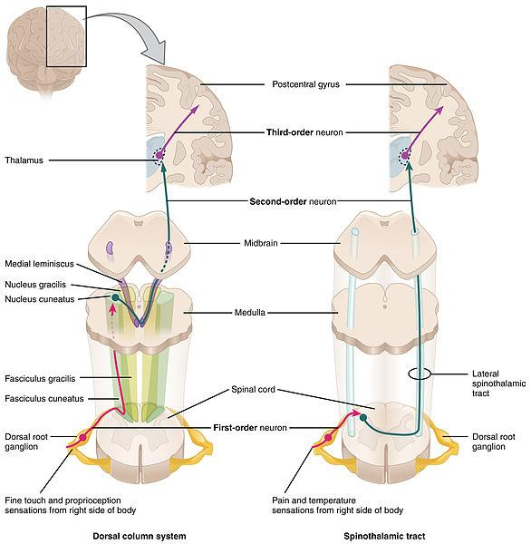

**The primary, secondary, and tertiary neurons of the ascending sensory DCML and ALS pathways**

File:1417 Ascending Pathways of Spinal Cord.jpg; OpenStax College; https://commons.wikimedia.org/wiki/File:1417_Ascending_Pathways_of_Spinal_Cord.jpg; This file is licensed under the Creative Commons Attribution 3.0 Unported license.

Read this online at <https://books.byui.edu/bio_381_pathophysiol/1113__pain_transmiss>