# Headaches

Headaches can be classified in two major categories:

1. **Primary headaches:** No structural or metabolic abnormalities are responsible for the headache. The most common types of primary headaches include migraine, tension, cluster, and chronic daily headaches.
2. **Secondary headaches:** Due to structural or metabolic abnormalities: Secondary headaches are most commonly a result of meningitis, intracranial pressure, brain tumor, glaucoma, and arteritis.

#### Migraine Headache

Watch the video [Migraines – Pathophysiology and Treatment](https://video.byui.edu/media/t/1_l8pk3zl9)

**Migraine headaches** involve head pain that is normally unilateral (one side of head), but they can be bilateral (both sides of head). The pain can be quite debilitating and normally lasts 4-72 hours. Migraines are often accompanied by increased sensitivity to light and sound as well as nausea and vomiting. Migraines are more common in women and tend to run in families.

There are two major types of migraines: those preceded by an “aura” and those without. An **aura** refers to some temporary neurological symptom or physical sensation that precedes the migraine by an hour or two. The most common auras involve vision, but can also include other senses. Visual auras can include zig zag lines, flashes of light that look like stars or dots, or even a blind spot. In more rare cases, a visual change might include distorted vision or even temporary loss of vision. Other auras might include ringing in the ears, strange odors for no reason, difficulty speaking, unilateral body fatigue, tingling in an area of the skin, or simply experiencing a “funny feeling” that is hard to describe. Less commonly, individuals may also report feeling thirsty, sleepy, or craving sweets. Approximately 15-20% of individuals experience auras prior to headache. Migraines without an aura are much more common and can sometimes (40-60%) be accompanied by anxiety, depression, food cravings, diarrhea or constipation, drowsiness or hyperactivity, or irritability one-two days prior to the headache pain. Typically these prodrome conditions are not considered an aura as they precede the migraine headache by days.

Possible triggers of a migraine include increased stress, changes in sleep patterns, and fluctuation of estrogen during menstrual periods. Dietary sources such as monosodium glutamate, aged cheese, and chocolate may also increase the risk for migraines. Avoiding these triggers and maintaining regular sleep patterns can help prevent migraines. Retiring to a dark room during a migraine attack can help relieve symptoms.

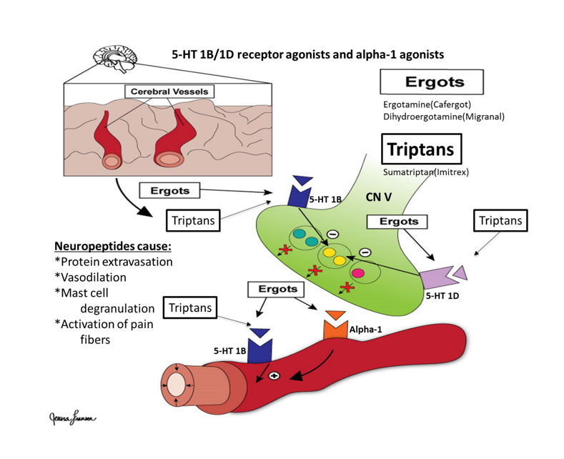

Image by JL BYU-I student F18

During a migraine, the **trigeminal cranial nerve V** becomes activated. Once activated, the nerve releases neuropeptides and neurotransmitters such as substance P, CGRP, and **vasoactive intestinal peptide (VIP)**. These neuropeptides cause mast cell degranulation, protein extravasation, vasodilation, and activation of nociceptors (especially in the tissues of the vasculature and meninges).

Drugs used to treat migraines focus on causing vasoconstriction and decreasing the release of nociceptor-stimulating substances from the trigeminal nerve. The triptan drugs, including sumatriptan are used to treat the symptoms of an acute migraine attack by blocking the release of neuropeptides from cranial nerve V. These drugs are agonists of 5-HT1B/1D receptors, which are expressed on the trigeminal nerve and induce hyperpolarization. They also cause cerebral vessel vasoconstriction by binding to 5-HT1B receptors expressed on cerebrovascular smooth muscle. Ergotamine derivatives such as ergotamine (Cafergot) and dihydroergotamine (Migranal) have a similar mechanism of action as triptans, but they also activate alpha-1 adrenergic receptors expressed on cerebrovascular smooth muscle to induce vasoconstriction. CGRP antagonists that block the action of CGRP are also a medication option for migraine prevention and acute migraine attacks.

#### Cluster Headaches

**Cluster headaches** are more common in men and most often occur around the eye and near the temple. There is often increased eye watering, nasal congestion, and swelling around the eye. Cluster headaches are often mistaken for dental problems or sinus infections due to their location being so close to the sinuses and upper jaw. These headaches occur in clustered attacks that have pain-free periods in between. The attacks can come at regular times each day or they can be random and impossible to predict. The clusters of attacks can last for days, weeks, months, or sometimes years. The pain is unilateral and typically lasts 15-180 minutes (typically less than an hour).

The cause of cluster headaches is unknown. Researchers point to neurovascular or endocrine triggers with the possibility of some hypothalamic dysfunction. The hypothalamus controls biological clocks and circadian rhythm and these headaches seem to be influenced by such timing mechanisms. Also, it has been observed that hormones like cortisol, prolactin, and testosterone have disrupted physiological levels during active headaches.

Cluster headaches come on rapidly and reach peak pain in minutes. Consequently they are too fast for oral medication to have much effect. Treatment may involve oxygen inhalation (to enhance vasoconstriction) and subcutaneous sumatriptan. Prophylactic medication includes oral triptans, vasoconstrictors, corticosteroids, and some forms of anticonvulsants. It is also important to avoid triggers. Triggers include smoking, bright lights, heat, and nitrites.

#### Tension Headaches

**Tension headaches** are the most common type of headache. These headaches are often described as a dull, aching, and diffuse pain that occurs bilaterally over the “hatband” region around the head. Tension headaches do not generally cause severe debilitation but can be tolerated as a person performs activities of daily living. These headaches can be infrequent or common (nearly daily). Nausea and vomiting are not common symptoms.

The cause of tension headaches is not known. Popular theories include sustained tension in the muscles of the head and neck, stress, anxiety, and depression. Overuse of caffeine is also associated with increased frequency of tension headaches.

Tension headaches can often be treated non-pharmacologically with biofeedback relaxation techniques, massage, acupuncture, meditation, and exercise. Pharmacological treatments include NSAIDs and acetaminophen. Individuals using these drugs generally use over the counter varieties. Chronic use of these drugs can result in rebound headaches. Rebound headaches are the emergence, or even worsening of headache pain as the effects of medication wear off. The entire range of migraine medications may be tried in cases where tension headaches simply do not respond to anything else.

Read this online at <https://books.byui.edu/bio_381_pathophysiol/1119__headaches>