# Disorders of the Glomerulus

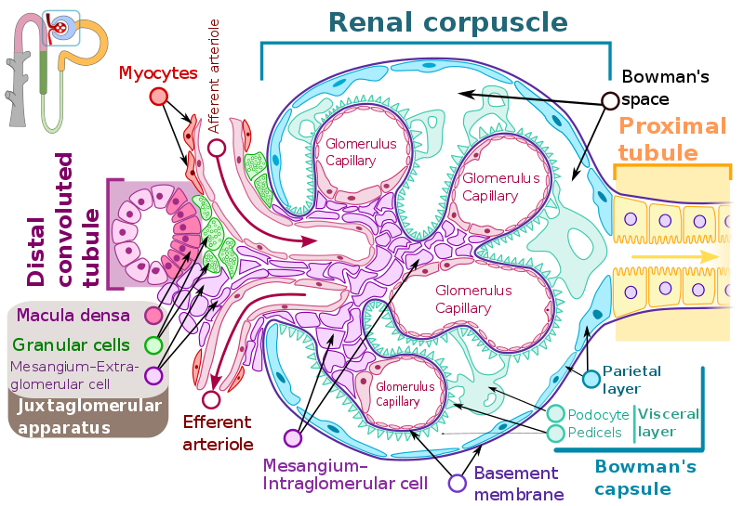

File:Renal corpuscle-en.svg; Shypoetess; https://commons.wikimedia.org/wiki/File:Renal_corpuscle-en.svg; This file is licensed under the Creative Commons Attribution-Share Alike 4.0 International license.

Glomerular capillaries experience a hydrostatic pressure of about 55 mmHg. This is higher pressure than most capillaries of the body as it is the main pressure driving filtration, which is the movement of fluid out of the capillary and into the nephron via Bowman’s capsule. The pressure in the glomerular capillaries is high enough to rupture the fragile endothelial barrier, but this doesn’t happen because the endothelial barrier is supported by a basement membrane and podocytes that lie against the basement membrane and surround the capillaries. The podocytes make up the visceral layer of Bowman’s capsule while regular simple squamous epithelial cells make up the parietal layer of Bowman’s capsule. The basement membrane is found between the endothelial cells of the glomerular capillaries and the podocytes.

The glomerular capillary endothelium, basement membrane, and podocytes constitute the glomerular filtration barrier which selectively allows water, ions, and some molecules to pass. The endothelium of the glomerular capillaries have small pores called fenestrae that average about 70nm in diameter. The podocytes have membrane extensions that interdigitate and make small slits called filtration slits. These slits vary in size but average between 30 and 40 nm in diameter. Blood cells and platelets run thousands of nanometers in diameter so these will not fit through any of these pores or slits. Electrolytes, sugars, amino acids, and other plasma proteins are small enough to easily be filtered. Albumin and other plasma proteins are also small enough to fit through the fenestrae and even the filtration slits. However, albumin and many of the blood proteins have an overall electrical charge that is negative. The endothelial cells have many glycoproteins that are attached to the cell membranes and these glycoproteins are also negatively charged. The basement membrane that lies outside the glomerular endothelium is also full of negatively charged glycoproteins. Finally, there are negatively charged glycoproteins on the membrane surface of the podocyte epithelial cells. There are also negatively charged molecules in the filtration slits. These negatively charged molecules repel plasma proteins and thus most proteins are not filtered. However, some proteins do make it through and into Bowman’s capsule. The cells of the nephron aggressively reabsorb these plasma proteins so that they are not lost in the urine. Urine that contains a lot of protein (especially albumin) usually suggests something has compromised the glomerular filtration membrane. Sometimes, the filtration membrane can be compromised so much that it is possible to find blood cells in the urine.

Mesangial cells are either extraglomerular or intraglomerular. The extraglomerular mesangial cells are between the efferent and afferent arterioles. Mesangial cells also have contractile properties and can contract or relax to help regulate the flow of blood through the glomerular capillaries. Found among the extraglomerular mesangial cells, are granular cells (also called juxtaglomerular cells). These granular cells are adjacent to the macula densa cells which are part of the epithelium of the distal convoluted tubule. Due to their proximity, these cells communicate with each other to regulate the release of renin. Renin is synthesized by the granular cells and is released in times of low filtrate production and low blood pressure. Together, the macula densa cells and granular cells are called the juxtaglomerular apparatus.

#### Nephrotic and Nephritic Syndromes

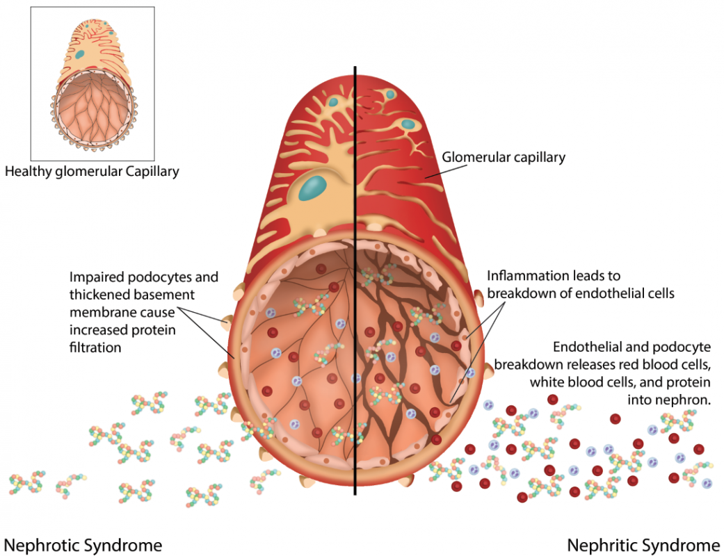

Image by Becky T. BYU-I W20

The term **glomerulonephritis (GN)** refers to inflammation of the glomerulus. This inflammation will generally result in one of two “syndromes” – nephrotic or nephritic.

**Nephrotic syndrome** occurs when there is injury and damage to the podocytes and even the basement membrane, but the endothelial cells are relatively intact. When this occurs, the negative charges found surrounding the endothelial fenestrae are diminished and results in elevated filtration of plasma proteins. At first, only the smallest and most abundant proteins will escape and something called selective proteinuria occurs (selective refers to the finding of mostly albumin found in the urine). As injury and damage to the basement membrane and podocytes increase, even more negative charges disappear and larger sized proteins find their way into the filtrate and urine. These larger sized proteins are categorically called globulins and may refer to many of the alpha, beta or gamma globulins in the plasma. We call this type of proteinuria non-selective proteinuria because all plasma proteins are capable of being filtered and found in the urine.

Interestingly, protein build up in the urine can cause an obvious “froth” to be observed. This can be especially apparent in a catheter bag that is agitated. Proteins, with their many charged regions, can act like a detergent that is able to decrease the surface tension of water. As the surface tension decreases, it becomes easier for air to enter the water and create bubbles (froth).

The liver under maximum effort can synthesize about 3.5g/day of protein released into the plasma. When protein loss in the urine exceeds 3.5g/day, several new symptoms start to arise. Since albumin is responsible for the majority of the blood colloid osmotic pressure (BCOP) in capillaries, a significant loss of albumin (decreased BCOP) can lead to increased movement of fluid into the interstitial space resulting in osmotic edema. As more and more water leaves the vascular system and enters the interstitial spaces, we see a drop in blood volume. This results in stimulation of the R.A.A.S. This will result in sodium and water retention and an increase in blood pressure. Recent research has also shown that plasminogen which may also escape a damaged glomerulus will stimulate apical sodium channels in the nephron. This also increases sodium retention and blood pressure. The increased blood pressure may only be raising it to a normal or slightly elevated value as the low blood volume caused by edema was lowering blood pressure.

When plasma proteins are lost excessively, the liver is hyper-stimulated to compensate by increasing plasma protein synthesis. Under such conditions, it appears that the liver ends up producing more lipoproteins. This leads to a poor lipid profile called hyperlipidemia. Hyperlipidemia greatly increases the patient’s risk of cardiovascular disease.

Another protein that can be lost in the urine is antithrombin III (AT-III). AT-III has important anticoagulant properties. It also localizes near the endothelial surface where the cell membranes contain heparin-like molecules that attract it. Given its attraction to the endothelial surface, it is in close proximity to the fenestrae and more likely to be excessively filtered in nephrotic patients. If the liver cannot keep up with the loss of AT-III then hypercoagulation occurs and DVT becomes a higher risk for the patient.

Finally, if there is enough damage that even large proteins are getting through, we may see lipids accumulating in the nephron filtrate as well. The cuboidal cells along the nephron will take in the lipid and become quite lipid laden. Such cells will die and shed into the filtrate. As these cells are carried along, the lipid forms small casts or droplets that end up in the urine. A microscopic analysis of the urine may spot these lipid particles and they are named “fat oval bodies”.

#### Minimal Change Disease

Minimal change disease is the most common cause of nephrotic syndrome in children. It is characterized by a gradual and random loss of podocytes. Loss of protein can be extensive leading to edema. This condition is most commonly seen in children but may occasionally be seen in adults. For a long time, pathologists noticed no real changes when studying kidney biopsies of individuals suffering from minimal change disease (this lack of evidence gave the condition its name). Under immunofluorescence, however, immunoglobulins and complement deposits can be found. The cause of these complexes is not really known and so this condition is still considered idiopathic. The immunoglobulin complexes in this condition appear to target the podocytes in a way that they are damaged. This causes increased permeability of the filtration membrane and proteins are lost. The first line of treatment is corticosteroids which suppress the immune system and decrease inflammatory responses. Other immunosuppressants have also been used. Most individuals have a good prognosis with the syndrome dropping into remission within a month.

#### Diabetic Nephropathy

Diabetic nephropathy is the most common cause of nephrotic syndrome in adults. Diabetic nephropathy is a complex condition that results from many overlapping pathological pathways tied to diabetes. Diabetes is characterized by chronic high blood sugar which causes many cellular proteins to become dysfunctional and activates pro-inflammatory processes. Diabetic nephropathy is one of many ways the kidney is detrimentally affected by chronic high blood glucose and is described in short below.

Chronic hyperglycemia results in excessive filtered glucose that begins to accumulate in the basement membrane separating endothelial cells and the podocytes. This creates an osmotic pressure that draws water to the basement membrane altering matrix components and causing it to thicken. Podocytes respond to the changes in the basement membrane by altering their morphology in a way that foot processes recede and the filtration slits widen. With the altered basement membrane and podocyte morphology, albumin and other small proteins are filtered in excess and excreted in the urine. Eventually, these alterations in the filtration barrier due to excess glucose filtration and accumulation in the basement membrane will result in hardening (or sclerosis) in and around the glomerulus. Without intervention, obliteration of the glomerulus occurs, likely inducing an inflammatory response that leads to nephritic syndrome and ultimately very low GFR that induces end stage renal disease.

**Nephritic Syndrome** results from damage to all three layers of the filtration barrier and formed elements (blood cells and platelets), as well as protein can be found in the urine. Some of the classic manifestations of nephritic syndrome include:

* **Hematuria:** Blood in the urine. In addition to blood cells being excreted in the urine, commonly causing a ‘cola colored’ urine, microscopic analysis of the urine will reveal dysmorphic (misshapen and fractured) RBCs due to the shearing and compression experienced as they were pushed through the compromised filtration membrane and narrow parts of the nephron.
* **RBC casts:** These are stacks of RBCs observed through microscopic analysis of the urine. Certain areas of the nephron are difficult for RBCs to pass though. As a result, they get smashed together prior to reaching the bladder.
* **Proteinuria:** While nephritic syndrome features protein in the urine, not as much protein is excreted as you would see with nephrotic syndrome. Even with the filtration barrier completely damaged, proteinuria in nephritic syndrome is less because the RBC casts and severe inflammation within the glomerulus actually decreases GFR. Since the kidney fails to filter as much, less protein is lost per day in the urine such that the liver can more easily keep up with replenishment. Therefore, severe edema is not as common in nephritic syndrome.
* **Oliguria:** This is a significant drop in urine output due to the decreased GFR.
* **Hypertension:** High blood pressure occurs because of the excessive release of renin and activation of the RAAS pathway. Due to the low GFR, macula densa cells release increased amounts of paracrine signals to stimulate the release of renin by the juxtaglomerular cells.
* **Azotemia:** This is a large amount of nitrogen containing compounds in the blood. This would include protein, urea, uric acid, and creatinine. This is different from uremia which is an increase of just urea in the blood. Azotemia can occur with severe nephritic syndrome because GFR has decreased so much that the nitrogen containing compounds are not being filtered as effectively.

Nephrotic and Nephritic syndromes are simply clinical manifestations of possible disease processes. They are not diseases in and of themselves. There are many diseases that can affect different components of the glomerulus to different degrees. The important thing to remember is what nephrotic and nephritic manifestations look like and what parts of the glomerulus are involved. It is certainly possible to progress from a mild nephrotic syndrome to a raging nephritic syndrome over time. It is possible to remain with a mild nephrotic syndrome for a long time. It is possible to have a very fast onset of nephritic syndrome.

Here is a table to help you compare the two syndromes

|  |  |  |
| --- | --- | --- |
| **Characteristics/ Manifestations** | **Nephrotic** | **Nephritic** |
| **Proteinuria** | Large amounts of protein in urine | Not as much protein in urine, urine may even be normal |
| **Generalized Edema** | A lot of edema over the whole body | Not as much edema may even be normal |
| **Hypoalbuminemia** | Can be quite an excessive loss | May be normal or minimal loss |
| **Hyperlipidemia** | Major symptom | Not as severe |
| **Hematuria** | Not usually | A major symptom |
| **Hypertension** | Low, normal or slightly high | High |
| **Increased risk of infections** | May lose complement proteins making it harder to fight infections | More likely to retain complement proteins |
| **Blood Clotting (Hypercoagulation)** | AT-III may be lost in the urine. Also, the liver may be stimulated to increase protein production and clotting factors can increase. This can lead to an increase of DVT risk. | Blood clotting problems are not as much a problem as GFR is reduced and filtering of blood proteins is not as extreme. |
| **Inflammation** | Minimal | A major symptom |

**Glomerulonephritis (GN)** is a term that describes many kidney diseases. These diseases are characterized by inflammation of the glomeruli and small blood vessels in the kidney. As the inflammatory processes damage the glomerulus, nephrotic manifestations may occur first followed by nephritic symptoms later. Infections, deposition of autoimmune complexes, and even antibodies that target specific glomerular antigens have all been found to induce inflammation and subsequent damage that can result in nephritic manifestation. Eventually, nephritic syndrome will result in end stage renal disease that requires dialysis or kidney transplant. **Goodpasture syndrome** is a particularly aggressive form of GN and is caused by antibodies that specifically target components of the basement membrane of glomerular capillaries. These antibodies also cross react with basement membrane components of lung alveolar basement membrane. As a result, Goodpasture syndrome leads to a relatively rapid onset of pulmonary hemorrhage and nephritic symptoms. This is considered a type II hypersensitivity and can be quite fatal if treatment is not started quickly.

Read this online at <https://books.byui.edu/bio_381_pathophysiol/1212__disorders_of_t>