Kidney Function Tests
Watch the video BUN and Creatinine
Blood urea nitrogen or BUN is the nitrogen content of urea in the blood. Normal BUN values range between 8-20 mg/dl. Urea primarily comes from amino acid metabolism where the nitrogen-containing amino group is removed in a process called deamination, which primarily occurs in the liver. The deaminated amino acid can then be used for anabolic or catabolic reactions, depending on the energy state of the cell. The deaminated amino group is ammonia (NH₃) and is toxic to the body, so enzymes in the liver add a carbon dioxide molecule onto it to form the much less toxic urea in a process known as the urea cycle. Urea can then be excreted out of the body by the kidneys. 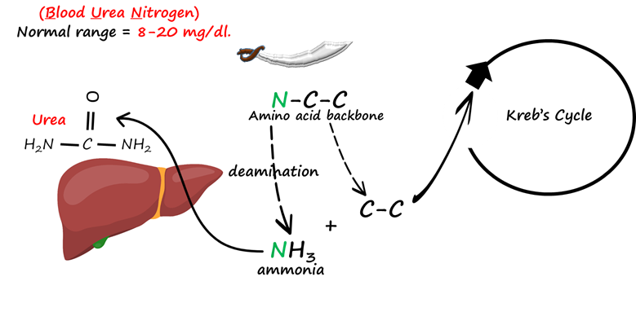
Image by Lanning B. BYU-I F17
Phosphocreatine is a creatine molecule with an attached phosphate group that is stored inside muscle cells and brain cells. During acute periods of ATP demand (e.g. anaerobic exercise), an enzyme called creatine kinase transfers the phosphate from phosphocreatine to ADP, thus providing the needed chemical energy . This reaction also yields creatine. When there is excess ATP, creatine kinase can remove a phosphate from ATP and convert creatine to phosphocreatine.
Each day roughly 1% of creatine and 2.5% of phosphocreatine break down into creatinine which is released from muscle cells into the blood. Creatinine levels vary according to an individual’s muscle mass. Females average plasma creatinine levels of less than 1 mg/dl. Males normally have levels of 1 mg/dl or higher depending on relative muscle mass.
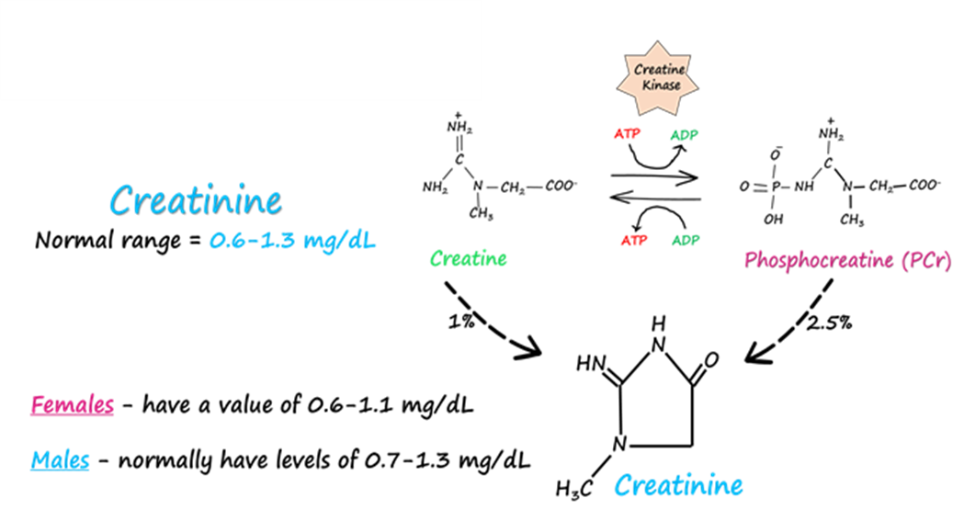
Image by Lanning B. BYU-I F17
Urea and creatinine are handled by the kidney in different ways. Urea is filtered and reabsorbed while creatinine is primarily filtered and minorly secreted (15-20%). Circumstances that increase blood urea and creatinine include acute kidney injury (AKI) and chronic kidney disease (CKD). Both conditions reduce GFR (more on this later) resulting in elevated urea and creatinine in the blood due to the inability to filter and excrete them.
Since urea comes from the breakdown of proteins, anything that increases protein breakdown will increase BUN. Exogenous corticosteroid administration can cause protein wasting. Elevated corticosteroid levels in conditions like Cushing Syndrome will lead to more protein breakdown as well. A diet high in protein can increase BUN. Two drugs, cimetidine and trimethoprim can increase serum levels of creatinine. Cimetidine is an H2 receptor blocker used to treat heartburn, and trimethoprim is an antibiotic. Remember that creatinine is both filtered and secreted by the nephron. Cimetidine and trimethoprim reduce creatinine tubular secretion and therefore increase serum creatinine levels.
The primary condition that decreases BUN is liver failure. Blood urea levels drop as the liver is unable to produce urea which results in elevated ammonia in the blood and leads to brain toxicity and damage, a condition known as hepatic encephalopathy. Serum creatinine is decreased in individuals with low muscle mass or a low protein diet.
Serum creatinine levels are often used to calculate GFR and can also be used to estimate percent kidney function. The following equation may be used.
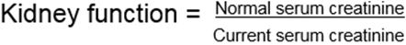
For example, using the above equation, a serum creatinine level of 2 mg/dl would tell us that the kidney function is about 50% (recall that normal serum creatinine is close to 1 mg/dl).

Read this online at https://books.byui.edu/bio_381_pathophysiol/1221__kidney_functio

