Painting Safely

Introduction
This chapter covers safe practices while painting in a confined space. You will learn what employers and workers must do so that the work can be done more safely. Employers have a responsibility to provide a safe workplace. You will also learn that proper ventilation, appropriate equipment, and training save lives.

Real-Life Example
Please be advised. The scenes you are about to read about deal with deaths at construction sites and might be disturbing for some people. This example is based on a true story.
Two night shift employees were moving lighting and spray painting equipment inside a barge to continue a painting operation.
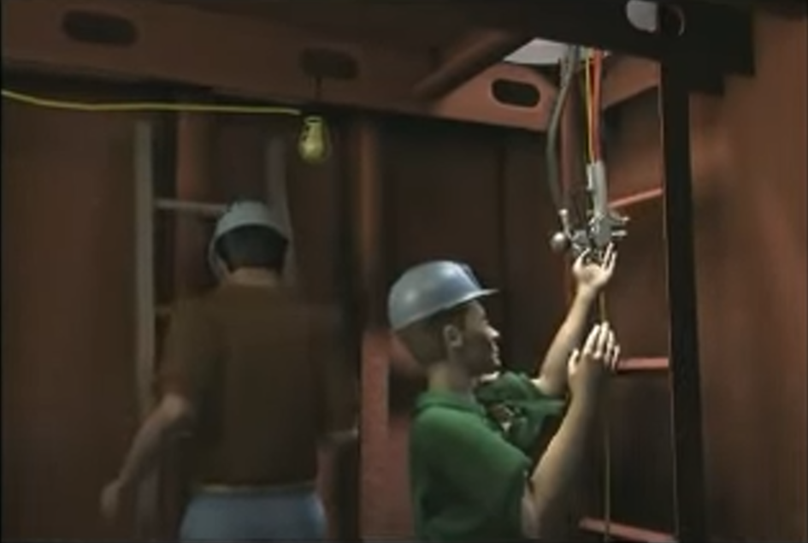
Employees on the previous shift had been painting in the confined space continually for ten hours. The paint mixture being used was flammable. The lighting equipment was not explosion-proof. There was no ventilation and only one open-access hole. Painters and laborers constantly enter the confined space without any air monitoring.
As the two night shift employees set up the equipment a spark ignited the flammable paint vapors and caused a flash fire. Both employees were killed.
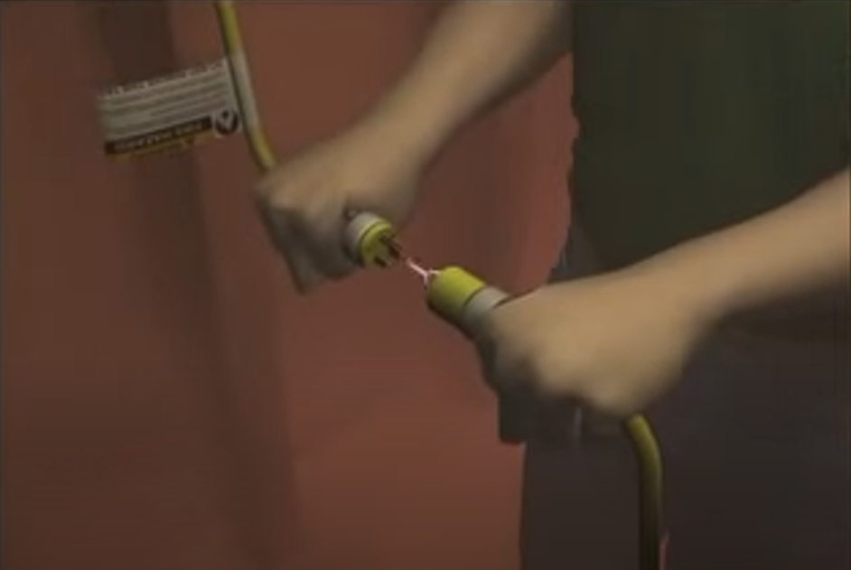
What went wrong? Sufficient ventilation would have kept the concentration of flammable vapors below ten percent of the lower explosive limit. A shipyard competent person should have visually inspected and tested the confined space for oxygen content and lower explosive limits prior to entry by employees and found the flammable atmosphere. There should be no plugs or electrical connections within 50 feet of hazardous atmospheres and painting operations. Explosion-proof lighting and equipment must be used when spraying flammable liquids. The employer did not make sure that employees entering confined spaces were properly trained to recognize hazards.
Although not contributing to the fatality, electrical cords and open access holes presented two additional safety hazards. Electrical cords and painting hoses should not be in the way of workers using the ladder, clear interference with ladder access as much as possible. Open access holes in decks should be adequately guarded to prevent employees from accidentally falling down.

Supplemental Resources
This page was created from the video, Painting in Confined Space Causes Fire.
Read this online at https://books.byui.edu/construction_221_con/painting_safely

