# Electron Configurations

The key factor determining the chemical properties of each element is the configuration of its electrons. Likewise, the energy associated with atoms and molecules is a function of their electrons. Think of the atom; it has a positively charged nucleus with negatively charged electrons orbiting the nucleus. Just like the opposite poles of a magnet, oppositely charged particles attract each other. Because of these attractive forces, it requires energy to pull them apart. In an atom, electrons can be moved further away from the nucleus but only if energy of some form is applied (usually light). Likewise, when electrons move closer to the nucleus, energy can be released. To illustrate, consider the idea of fluorescent glow sticks. If your glow stick starts to fade, you can shine light on it to “charge” the stick, and then, when the lights are turned off, your stick will glow or fluoresce. How does this work? Light, which is a type of electromagnetic radiation has energy that can be used to push electrons into orbitals further from the nucleus. When the light is turned off, the electrons “fall” back down into a lower orbital, releasing energy (**fluorescence**) which causes the stick to glow in the dark. Likewise, in the atmosphere when an electron is hit by a photon of light it absorbs (**absorbance**) the energy and moves to a higher state (electron starts moving faster; called **excitation**). Electrons then jump around the atom as they gain or lose (**relaxation**) energy releasing or gaining energy as packets of energy called photons.

Note. Electromagnetic energy is a type of traveling energy, in the form of wavelengths such as gamma rays, x-rays, ultraviolet and visible light, infrared, microwave and radio waves. Each type of electromagnetic energy is defined by its wavelength with small wavelengths carrying more energy.

As was mentioned above, the electrons of the atom are in **orbitals.** From our discussion above, we learned that the energy associated with the electrons in an atom is a function of its position or distance from the nucleus. Therefore, electrons in orbitals close to the nucleus possess less energy than electrons in orbitals that are further away from the nucleus. Another important property of orbitals is that each orbital can hold a maximum of 2 electrons. Based on the amount of energy in each orbital, they are arranged into what are referred to as **electron shells** or **energy shells (first postulated by Niels Bohr; 1885 – 1962),** which contain one or more orbitals. The shell model is a very useful tool to help visualize and predict how one atom might react with another atom in a given situation (next section), but like most models in biology, when it comes to “real life” the model does not actually predict how electrons are distributed around the nucleus. In reality, electrons behave less like orbiting planets and more like waves. Thus, if you want to get really technical, the orbital model is a better predictive model that tries to “predict” where an electron is most likely to be by following its orbital “wave” path. This predictive model breaks orbital paths down into four subshells designated by the letters **s**, **p**, **d** and **f**. All of the electrons in a given electron shell have the same amount of energy and are designated by a number and the symbol “n”. Thus, 1n would represent the first energy or electron shell closest to the nucleus . To summarize, electron shells (1n, 2n, 3n, etc.) are representative of the amount of energy that electrons have, with increasing shell numbers having increased energy, and those energy shells containing subshells (s, p, d, f). Each subshell represents the path of the orbitals that are contain in it, with each orbital holding up to 2 electrons.

To accommodate the electrons in the largest of the naturally occurring elements, seven electron shells (7n) are required. The first shell can only accommodate one orbital, designated as the s orbital; thus, the maximum number of electrons in the first electron shell is two. The second shell contains four orbitals (one s and one p subshell) and can, therefore, accommodate eight electrons each. Shell 3n has s (1 orbital), p (three orbitals) and d (five orbitals) subshells allowing for 18 electrons. Shell 4n has s, p, d and f (seven orbitals) subshells and can accommodate 32 electrons.

It has also been observed that atoms appear to be more stable when they have eight electrons in their outer shell (not including the first shell), this is known as the **octet rule.** The outer shell is also called the **valence** shell. One other important fact is that as electrons are added to electron shells, they occupy the innermost shells first before filling the outer shells. It’s like parking spaces at Walmart; those closest to the store fill first, and once they are filled, shoppers have no choice but to park in spaces further away. For example, hydrogen has one electron which is located in the first (innermost) electron shell. This can be explained as an **electron configuration** and is designated as 1s1 (1 representing the electron shell, and s the subshell). The superscript 1 indicates one electron within the 1s orbital. Helium has two electrons, both in the first energy shell so is designated as 1s2. All of the space in the first energy shell is now filled. Lithium has three electrons; two of them are in the first shell, and the third electron is in the second electron shell: 1s22s1. Remember the 2n shell has 1 s and 1 p subshell orbitals, so the electrons fill the first s and then the one extra electron will fill the s of the 2nd shell.  subshell orbitals, so the electrons fill the first s and then the one extra electron will fill the s of the 2nd shell.

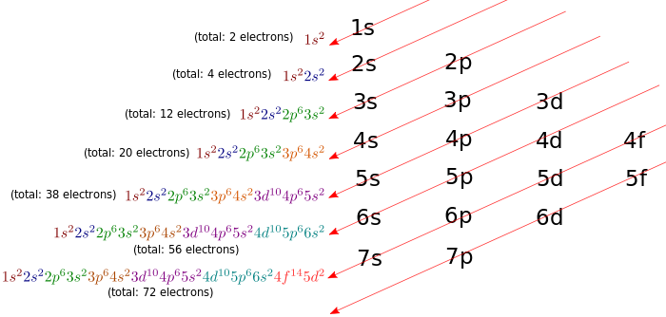

 By CK-12 Foundation

[CC BY 3.0](https://creativecommons.org/licenses/by/3.0/)

The reason that this is important to know is because **the chemical properties of an element are determined by the number of electrons in its outer electron shell**. We define the “outer electron shell” as the last shell that has electrons in it (valence), so for hydrogen, its outer electron shell would be the first shell, and for lithium, its outer shell would be the second shell. Each of these elements has one electron in its outer shell, which means that they will have similar chemical properties.

Let’s try an example. Oxygen has an atomic number of 8, which means it has 8 protons and 8 electrons. How many electrons are there in the outer electron shell of oxygen? The first two electrons will go into the first shell, leaving six to go into the second shell. Therefore, the outer electron shell for oxygen is the second shell, and it has six electrons in it (1s22s22p4).

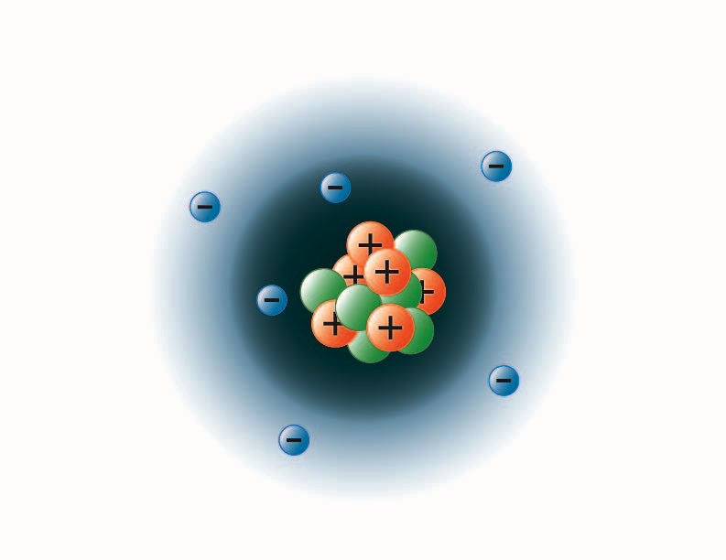

**Carbon Atom:** Image created by BYU-I student Hannah Crowder Fall 2013

The image above represents the electron configuration for carbon. Carbon has an atomic number of 6, hence 6 electrons. The first two electrons fill the first shell (dark blue), and the next four are in the second shell (light blue).

Read this online at <https://books.byui.edu/bio_180/12___electron_config>