# Covalent Bonds

Another way that atoms can fill their outer electron shells is to share electrons. For example, hydrogen has an atomic number of 1 and, therefore, has 1 electron in its outer electron shell. To fill this shell, hydrogen needs one more electron (recall that the first electron shell will hold a maximum of two electrons). One way of filling this shell would be for two hydrogen atoms to unite to form a molecule by sharing electrons with each other. This type of bond, formed by sharing electrons, is called a **covalent bond**. Covalent bonding is highly dependent on a property called **electronegativity** ,  which is a measure of the tendency of an atom to attract a bonding pair of electrons. Units for electronegativity are measured using the Pauling scale (strongest 4.0 to weakest 0.7). An atom with a higher electronegativity value will more strongly attract electrons to covalent bond with. The chemical shorthand for a covalent bond is simply a dash. Therefore, the molecule represented in Figure 6 could be expressed as H-H, with the dash representing the shared electrons. Note that the equal sharing of electrons does not cause either atom to have unequal numbers of electrons and protons; hence, there is no net – or + charge. Equal sharing occurs when the atoms have the same, or close to the same, electronegativity because they have the same attraction for electrons. Also, unlike ionic bonds, which form crystals, covalent bonds create an intimate relationship between the two atoms. That is, these two atoms are linked directly to each other. You could think of ionic bonds as a group date or hanging out and a covalent bond as marriage. The image below represents a covalent bond between two hydrogen atoms.

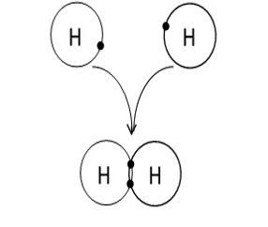

**Hydrogen Covalent Bond:** Image created by MG Fall 2013

Covalent bonds can also be formed by the sharing of more than one pair of electrons. For example, oxygen has an atomic number of 8 with 6 electrons in its outer electron shell. Two oxygen atoms will combine to form oxygen gas, O2, by sharing two pairs of electrons, thus completing the outer shell of both oxygen atoms. We refer to this as a **double covalent bond** and represent it by two dashes, O=O, with each dash again representing a pair of shared electrons. Once bonds move from single to double, they lose the ability to rotate around the bond. It should be noted that triple covalent bonds are also possible by sharing three pairs of electrons. However, in the compounds we will be studying, none have **triple covalent bonds.**

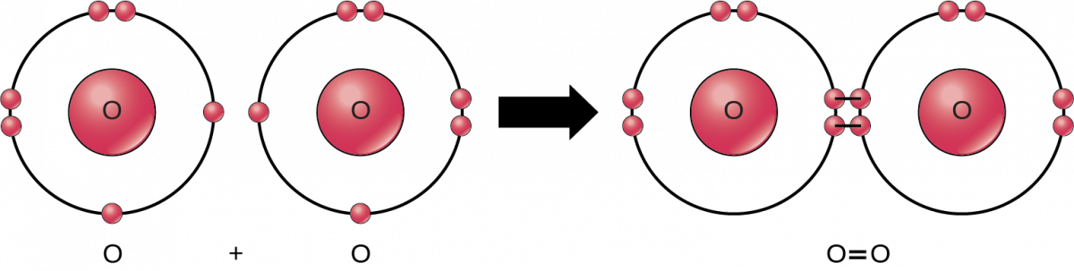

Depending on the atoms involved in the covalent bonds, the electrons can either be shared equally, or the electrons may spend more time with one partner than the other, resulting in unequal sharing of electrons. Two molecules are shown in the figure below. Methane is the image on the left and is a gas that is composed of one carbon and four hydrogen atoms. In this molecule, the electrons are equally shared between the carbon and each hydrogen (their electronegativities are very close), forming **non-polar covalent bonds** . Because all the bonds in the molecule are non-polar, this molecule is a non-polar molecule. The other image on the right is water. In this molecule, the negatively charged electrons are more strongly attracted to the oxygen (because of its increased electronegativity) and, hence, spend more time with the oxygen than with the hydrogen. This creates a molecule with bonds that have a slight negative charge at one end (the oxygen end) and a slight positive charge at the other end (the hydrogen end). Since the molecule is made up of bonds that have oppositely charged ends, we refer to these types of bonds as a **polar covalent bond** . Because all the bonds in the molecule are polar, water is a polar molecule. Note that the total charge on the molecule is 0, but the ends are partially charged. Polar covalent bonds and ionic bonds are similar, in that electrons are pulled away from one atom and pushed towards the other. The difference is that with ionic bonds, the electrons are completely removed from one atom, forming the cation, and captured by the other atom, forming the anion.

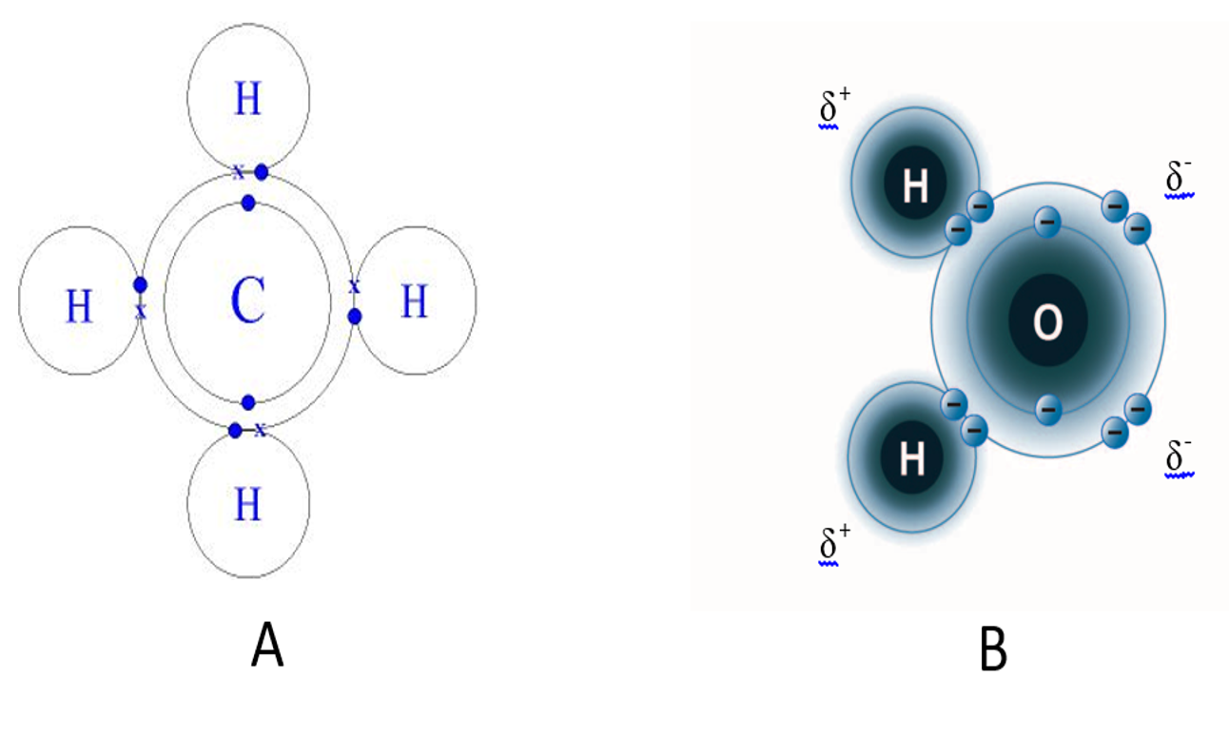

A: Methane gas – Non-polar covalent bond; B: Water molecule – Polar Covalent Bond.  
Image created by BYU-I student Hannah Crowder Fall 2013

Read this online at <https://books.byui.edu/bio_180/132_covalent_bonds>