# Hydrogen Bonds

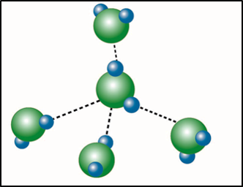

**Hydrogen Bond:** Image created by BYU-I student Hannah Crowder Fall 2013.

One other interaction of importance in biological systems is called the **hydrogen bond**. This is not a bond that forms molecules or ionic crystals; rather, it is an interaction between molecules containing polar covalent bonds. Because of this, it is referred to as an **intermolecular force** or an attraction between two molecules. Hydrogen bonds can only occur between molecules containing polar covalent bonds and are a result of attractions between the oppositely charged ends of these molecules called **electrostatic** attraction. Note that hydrogen bonds and ionic bonds are similar. The difference is that ionic bonds are created by attractions between oppositely charged ions, while hydrogen bonds are attractions between oppositely charged ends of polar covalent molecules. Although hydrogen bonds are very weak compared to the other bonds we have discussed, they play important roles in many of the compounds we will be studying in this class. For example, most of the important characteristics of water are due to its ability to form hydrogen bonds with itself and other polar molecules. Likewise, the complex structures of proteins and nucleic acids rely heavily on hydrogen bonding.

Another weak bond, like hydrogen bonding, occurs from an interaction called a **Van Der Waal**. This interaction can occur between any two or more molecules (polar and nonpolar) and is dependent on very small fluctuations in electron densities surrounding an atom. The interactions are extremely weak and require the molecules to be very close to one another.

Read this online at <https://books.byui.edu/bio_180/21_hydrogen_bonds>