# Mitosis

The mitotic phase of the cell cycle is divided into five subphases: prophase, prometaphase, metaphase, anaphase, and telophase. Mitosis represents that part of the cell cycle where the replicated chromosomes are separated into two identical nuclei. The purpose it to transfer the parent’s cells genome into two daughter cells. The chromosomes were replicated (copied) in the S phase of interphase. Mitosis can be further broken up into a beginning phase (**karyokinesis** ; prophase, prometaphase, metaphase, anaphase, and telophase) and a later phase (**cytokinesis** ).

**Prophase** . Prophase occurs after the G2 phase and is marked by the disappearance of the nucleolus, nucleus, and organelles such as the Golgi apparatus and the endoplasmic reticulum. The Golgi apparatus and the endoplasmic reticulum disappear by fragmenting and dispersion to the edges or periphery of the cell. The nucleus disappears because the nuclear envelope starts to dissociate into much smaller vesicles and the DNA (chromatin) fibers condense into discrete chromosomes. During prophase centrosomes can also be seen on opposite sides of the cell with extended microtubules between them. The microtubules are formed from tubulin monomers and occur at center of the cells with various tubules attached to chromosomes, and then motor proteins help push the centrosomes to opposite sides of the cell. Interestingly, plants do not appear to use centrosomes and microtubular spindles.

**Prometaphase** . The migration of the centrosomes along the microtubular complex to opposite poles causes a tension that aligns the chromosomes in the center of the cell. The center region is called the equatorial plane or the metaphase plate. Tension is generated because of structures called kinetochores. During prometaphase, kinetochore structures on microtubules search for and attach to kinetochore structures on chromosomes. Kinetochores are polar protein binding structures. These structures will form mitotic spindles. The attachment of two kinetochore protein structures induces a motor activity that uses ATP to crawl along tubules, pulling the microtubule toward each centrosome.

**Metaphase** . The pulling by the motor proteins on the spindles is most evident in metaphase. The pulling causes the chromosomes to align along the equatorial plate. Although not fully understood, cells have the ability to ensure that the kinetochores are properly attached and that the chromosomes are correctly aligned. This is referred to as the metaphase checkpoint and if deemed correct the cell will proceed to the next phase called anaphase, if not, division will stop. Check points are used throughout the cell cycle to stop the cell cycle if mistakes were made or if external conditions are not favorable for growth. Other checkpoints occur at the end of G1 and at the G2/M transition. The G1 checkpoint is based on environmental conditions, G2/M checkpoint is based on DNA conditions.

**Anaphase** . During anaphase the microtubules shorten so much that the sister chromatids start to pull apart. The chromatids can only come apart if the proteins that are linking them together (cohesion proteins) are cleaved. The pulling will also cause the cell to elongate as the sister chromatids are pulled to opposite sides of the cell in preparation to reform within a new nucleus.

**Telophase** . In telophase, the cell becomes maximally elongated and nuclear envelops begin to reform on each end. The nucleolus reappears and the chromosomes start to decondense. For a brief moment the cell has two nuclei, but the center will soon cleave, leaving two identical daughter cells during cytokinesis.

**Cytokinesis** . During cytokinesis the cells will cleave in half, forming two identical daughter cells. The cleavage site, located in the center of the cell, is called the cleavage furrow. Vesicles derived from the Golgi apparatus migrate to the middle of the cell and help in the cleavage by forming a contractile ring composed of actin filaments. The actin filaments will pull the cell inward, forming the cleavage furrow. Cytokinesis in plant cells, because of the cell wall, is a more complex process involving enzymes, structural proteins, and glucose molecules need to make a new cell wall and cleavage furrows are not present.

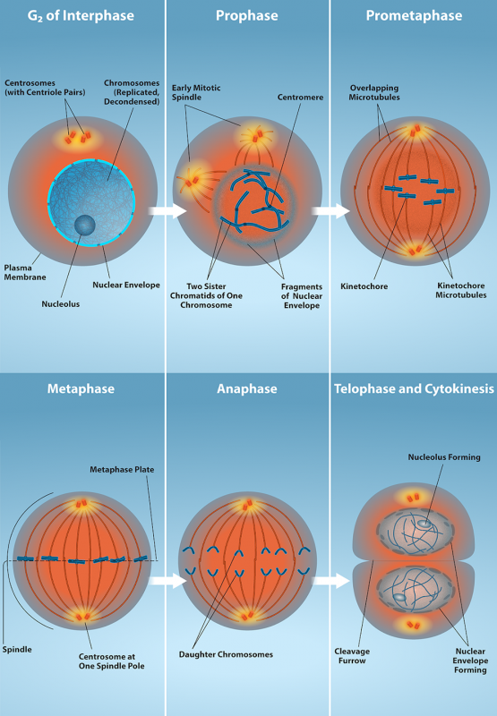

Read this online at <https://books.byui.edu/bio_180/122_mitosis>