# Diffusion of Solutes

Because the hydrophobic core of cell membranes creates a barrier, preventing hydrophilic substances, such as ions, water, and large polar molecules, from moving across the membrane, the membrane makes use of proteins to facilitate movement of most solutes and water. Processes that move substances (solutes) across membranes can be grouped into two general categories based on whether the process requires an input of cellular energy or not. If no energy input is required for the transport, then we say particles move via a **passive transport process**. On the other hand, if the process requires cellular energy, usually in the form of ATP, then it is an **active transport process**.

#### Simple Diffusion

Diffusion is a process that results from the fact that molecules are constantly in a state of random movement. All molecules, including solids, liquids and gases are in continuous motion. This motion causes collisions between neighboring molecules, thus altering directions and creating a state of “random” motion. This random motion can be further altered by temperature, with increases in temperature stimulating a more rapid random movement. If there is an initial, unequal distribution of the molecules (i.e., more concentrated in one area than another), the constant random movement and collisions cause them to eventually become equally distributed. This process of gradual movement from where they are more concentrated to where they are less concentrated is called diffusion. We refer to the concentration difference as the **concentration gradient**.

Therefore, substances diffuse down their concentration gradients (from high to low concentration). Once the molecules are evenly distributed, we say that we have reached a state of **diffusion equilibrium,** and even though the molecules are still moving, there is no longer any net change in concentration. You can observe this phenomenon by carefully placing a drop of food coloring into a glass of water. The dye gradually moves through the liquid until it is evenly dispersed in the water. If the material in question can pass through the cell membrane without the aid of a membrane protein, we refer to the process as **simple diffusion**. Solutes that cross the membrane by simple diffusion tend to be hydrophobic. Examples of substances that cross the membrane by simple diffusion are the gasses CO2 and O2.

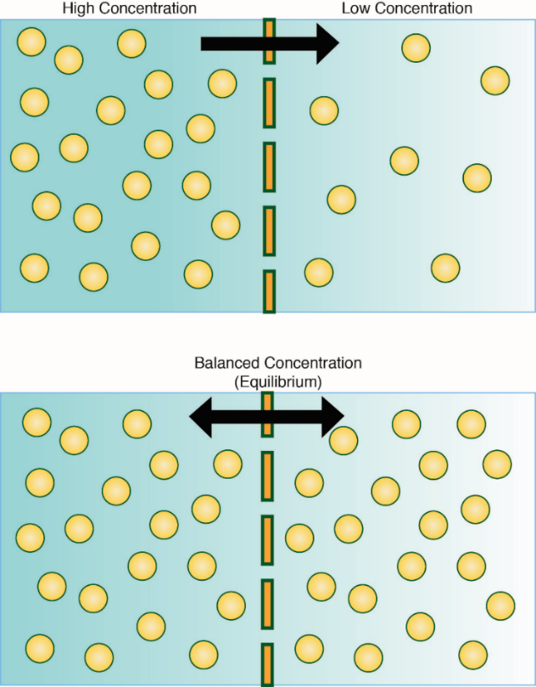

**Simple Diffusion: Process of Moving from High to Low Concentration to Reach Equilibrium.**

Image created by BYU-Idaho student, Hannah Crowder 2013.

The top panel shows the diffusion of solute from left (high concentration) to the right (low concentration) until an equilibrium is established. Once a diffusion equilibrium exists, there will no longer be any net movement of solute (lower panel).

#### Factors That Affect the Rate of Diffusion

The speed at which a molecule moves across a membrane depends in part on the mass, or molecular weight, of the molecule. The higher the mass, the slower the molecule will diffuse (rate is proportional to 1/MW1/2). Another factor that affects the rate of diffusion across the membrane is the solubility of the substance. Nonpolar substances, such as oxygen, carbon dioxide, steroids, and fatty acids will diffuse rapidly, while polar substances, having a much lower solubility in the membrane phospholipids, move through slowly, or not at all. Ions, such as Na+ and Cl-, tend to diffuse across a membrane rather rapidly. The diffusion rate across a membrane is proportional to the area of the membrane and to the difference in concentration of the diffusing substance on the two sides of the membrane. This relationship can be demonstrated by Fick’s first law of diffusion, which states that:

J = -DA(∆C/∆X)

J = net rate of diffusion in moles or grams per unit time

D = diffusion coefficient of the diffusing solute in the membrane (this coefficient takes into account the size of the substance as well as its solubility in the membrane)

A = surface area of the membrane

∆C = concentration difference across the membrane

∆X = thickness of the membrane. Diffusion is quite rapid over short distances but gets slower the further it goes. The time it takes for something to diffuse is proportional to the square of the distance. Therefore, if it takes one second to diffuse one centimeter, it will take 100 seconds to diffuse 10 cm and 10,000 seconds to diffuse 100 cm. So, to go 100 times further takes 10,000 times longer. Diffusion is quite sufficient to cross the thin cell membrane, but to travel long distances by diffusion would be very slow. Therefore, organisms have developed other mechanisms, like circulatory systems, for moving substances long distances.

Read this online at <https://books.byui.edu/bio_180/1112__diffusion_of_s>