Bulk Transport

To this point, we have been talking about the movement of relatively small solutes across the cell membranes (i.e. ions and small organic molecules). There are instances, however, when it is necessary to move much larger materials across the membrane, like when a macrophage engulfs a bacterium or when larger amounts of a given material are released from a cell, such as the release of a hormone. These processes also require ATP and are, therefore, examples of active transport, but they move materials in a very different way.

Endocytosis
Endocytosis is the bulk transport of materials into the cell. There are several types of endocytosis, and we will briefly explore each one. First, let's discuss phagocytosis (see figure below), which means cell eating. In this process, the cell sends extensions of its plasma membrane, called pseudopodia, out and around the particle to be phagocytized. As these pseudopodia surround the particle, they eventually fuse, creating a vesicle containing the particle. This phagosome can then unite with a lysosome inside the cell, and the engulfed material can be digested for use within the cell.
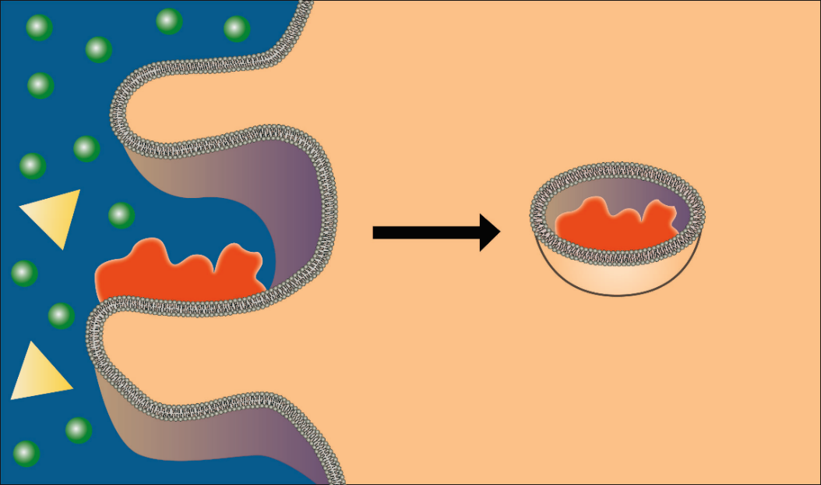
Phagocytosis. In phagocytosis (shown above), the cell membrane forms processes that
surround and engulf a particle to be brought into the cell.
Image created by BYU-Idaho student, Hannah Crowder, 2013.

A second type of endocytosis is pinocytosis, which meanscell drinking. In this process, rather than send out pseudopodia, the cell membrane simply invaginates (forms a pocket) and engulfs anything in the fluid that is taken into the cell (see figure below). The cells are not interested in the water in the vesicles but any solutes that might be brought in. As you can imagine, this is not a very efficient way of bringing materials into the cell because it is nonspecific and brings whatever is in the fluid into the cell. It provides cells with a nonselective mechanism for sampling the extracellular environment. Thus, phagocytosis engulfs larger particles like bacteria or other microorganisms, and pinocytosis engulfs smaller particles/molecules such as endo/exotoxins released from bacteria or other molecules used for cell signaling.

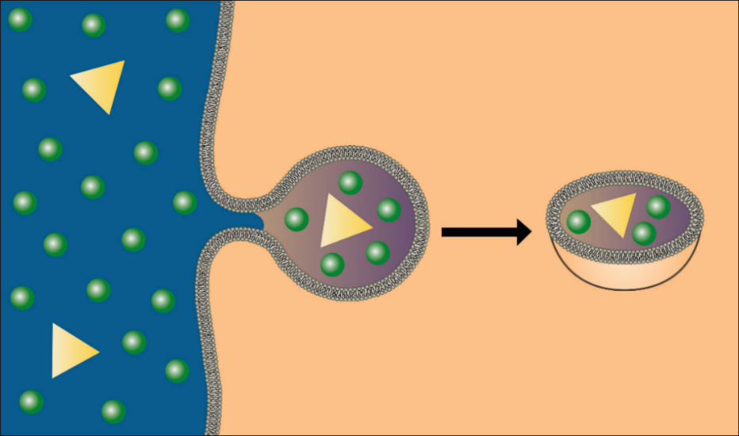
Pinocytosis. In pinocytosis, the membrane forms an invagination (pocket) that pinches off,
bringing into the cell the fluid in the pocket along with any solutes in the fluid.
Image created by BYU-Idaho student, Hannah Crowder, 2013.

A much more efficient mechanism for bringing specific solutes into the cell is receptor‐mediated endocytosis. As the name implies, this mechanism employs specific receptors that bind to the material (ligand) to be brought into the cell. Once the material binds, the receptor‐ligand complex migrates to a specific area of the membrane, a clathrin‐coated pit, which is then brought into the cell by a process like pinocytosis (see figure below). The advantage of receptor‐mediated endocytosis is that it can engulf large amounts of a specific solute.

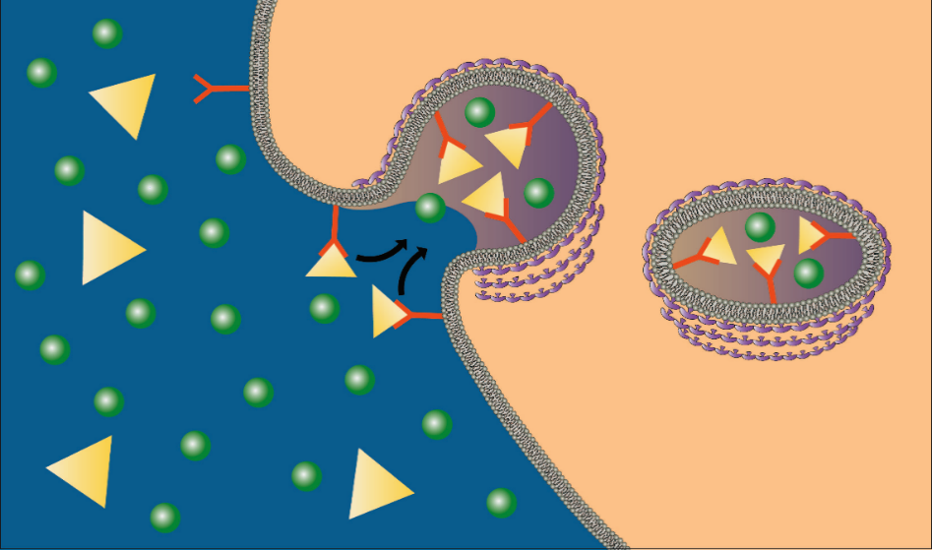
Receptor-Mediated Endocytosis.
Image created by BYU-Idaho student, Hannah Crowder, 2013.

Exocytosis
Thus far, we have been discussing bulk transport, bringing material into the cell. There is also a need to export material from the cell into the extracellular fluid. This process is called exocytosis. The mechanism is essentially the reverse of endocytosis. Secretory vesicles filled with the material to be released migrate to the plasma membrane where the membrane of the vesicle fuses with and becomes a part of the plasma membrane (see figure below). The material that was in the vesicle suddenly finds itself outside of the cell. The usual signal that initiates this process is the entry of calcium ions into the cell. Recall that calcium is an extracellular ion, so there is a large diffusion gradient for calcium to move into the cell. The opening of gated calcium channels, allowing calcium to diffuse into the cell, initiates the exocytosis process.

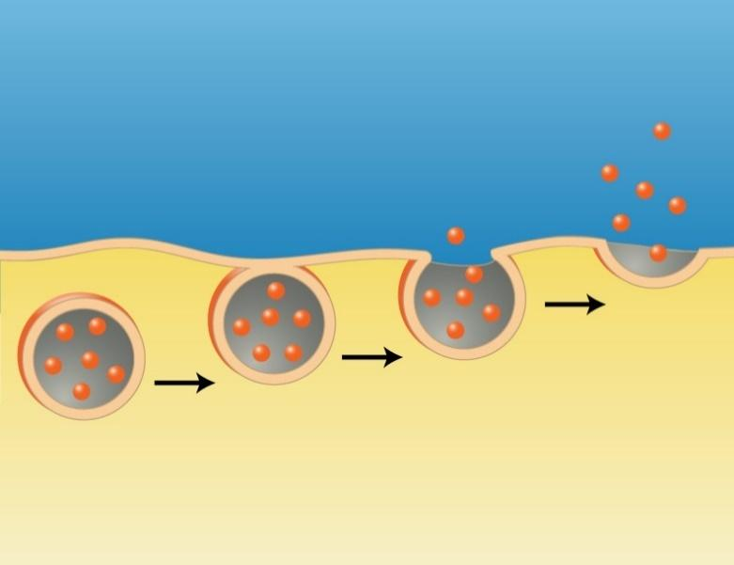
Exocytosis
. Image created by BYU-Idaho student, Hannah Crowder, 2013.

In exocytosis, secretory vesicles migrate to the cell membrane where the vesicular membranes fuse with the plasma membrane, releasing the vesicles’ contents into the extracellular fluid.

Read this online at https://books.byui.edu/bio_180/1124___bulk_transpor

