# Hydrocarbons

[TEXT HERE](https://books.byui.edu/)

When carbon forms bonds with just hydrogen we call the structure a hydrocarbon. The simplest hydrocarbon is composed of four single bonded hydrogen atoms surrounding a center carbon and is called methane (CH4 ). Since the non-polar covalent bonds found in hydrocarbons store lots of energy, hydrocarbons are often used as fuel, an example being the propane (C3H8) in your barbeque grill. Butane (C4H10), found in campstove fuels and lighter fluids, and Octane (C8H18), found in high octane gasoline are also common examples of energy rich hydrocarbons.  Methane, propane, and octane are all composed entirely of single bonds that create a **tetrahedral** geometry that is shared by many carbon containing molecules.   A tetrahedron is a four sided triangle formed by the four sp3 hybrid bonding orbitals in carbon spreading out as far apart from one another as possible in a 3-dimensional space.  The bond angle between each bond orbital is **109.5°**.  When a hydrocarbon chain is formed from multiple carbons and hydrogens the resulting pattern resembles a seesaw pattern with two hydrogen arms on each carbon pointing to each side.  Each single bond within the tetrhedral arrangment can rotate freely allowing the molecule to adopt different shapes as show for the relatively sinple butane structure below.

(FIGURE: Need a image of stick and ball model of butane illustrating see saw pattern and then perhaps three smaller images of butane in varous conformations.)

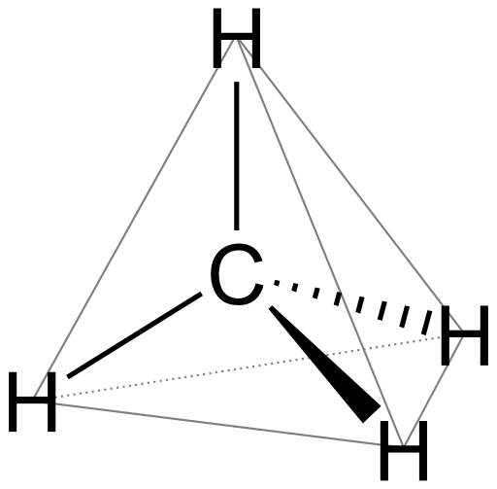

#### Hydrocarbon variations

With just Carbon and Hydrogen you can build a vast library of different hydrocarbons.  Important variables include chain length, branching, ring formation, and the placement of 1 or more double bonds.  Varying **chain length** simply means varying the number of carbons used to form the primary carbon chain of the molecule.  Propane, Butane, and Octane are all examples of varied chain length.  **Branching** involves adding one or more carbons to one of the interior carbons of the chain.  Butane and tertiary butane are examples of having the same number of carbons but different branching patterns.  **Ring formation** involves linking the two ends a hydrocarbon chain with eachother to form a ring structure.  You need at least four carbons to make a ring with the most common number being five-or six membered rings.   Rings greater than 6 atoms are possible, but not common.

The final variation is the presence and placement of **double bonds** in a hydrocarbon chain. To form two bonds with another carbon, both carbon atoms have to reorganize their electrons out of four sp3 hybrid orbitals and reform into a single p orbital and 3 equal sp2 hybrid orbitals.  Doing this changes the carbon bond geometry from a tetrahedral pattern to a new trigonal planar geometry.     In this pattern the two carbons and any atom directly connected to them all lie flat in the same plane with each other and the angle beween each bond is 120°.  The carbons in double bonds cannot rotate.   In biology we often see rings or carbon chains that alternate between single and double bonds in what is called a **conjugated ring** or chain.  Conjugated rings are common in biology such as purine and pyramidine rings of DNA.  Such rings are note for being flat or planar and often refered to as **Aromatic** rings since they are common to many scented molecules.

(images.  Multiple images are needed including branched and unbranched chains, boat and chair hexameric rings. and the

#### Hydrocarbon Names and Formulas

Most linear hydrocarbons are named by their number of carbons using greek prefixes like Penta-(5), hexa-(6), and so on.  If they are composed of all single bonds then the common suffix "-ane" is aded.  Simple branched chains share the same suffix.  They name the parent chain and list the branch at the start with a number to show where it is attached.  The most common branch names are methyl (1C) or ethyl (2C).  As an example 2-methyl butane has a 4 carbon parent chain and a 1C branch on the second carbon of the main chain.  The molecular formula of a linear and branched hydrocarbons is always CnHn+2 , where n is the number of carbons in the chain.

Simple ring hydrocarbons add the prefix "cyclo-", as in cyclo-hexane.  If a double bond is present in the chain, then the suffix is chaned to -ene and a number is added to show where the double bond starts as in 2-Butene.  Both rings and double bonds remove 2 hydrogens from the molecular formula.  if a single ring or double bond is present the forumula is CnH2n.  If a second ring or double bond is present then you would subtract 2 from the number of hydrogens and repeat that subtraction for each additional ring or double bond.

#### 

#### 

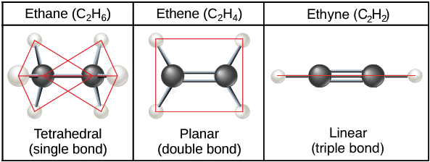

Access for free at <https://openstax.org/books/biology-2e/pages/1-introduction>  [CC BY 4.0.](https://creativecommons.org/licenses/by/4.0/)

Read this online at <https://books.byui.edu/bio_180/311__hydrocarbons>