# Receptor Interactions

Receptors that respond to ligands are found in three general locations:

* On the plasma membrane
* In the cytosol of the cell
* In the nucleus.

Most plasma membrane receptors are **G-protein-coupled receptors** (discussed below). Other types include **receptor tyrosine kinases** and **receptor serine/threonine kinases.** Activation of these receptors leads to an intracellular cascade that produces second messengers like cAMP, cGMP, or inositol triphosphate (IP3). These second messengers activate other enzymes such as those that phosphorylate or dephosphorylate proteins. Adding a phosphate to an enzyme is like flipping a light switch, when the phosphate is attached to the enzyme it can become active and when the phosphate is removed it becomes inactive. The opposite can also be true where adding a phosphate can inactivate an enzyme and removing the phosphate would then activate the enzyme. Additionally, the second messenger may increase intracellular calcium. Calcium can also act as a messenger that turns on events in the cell.

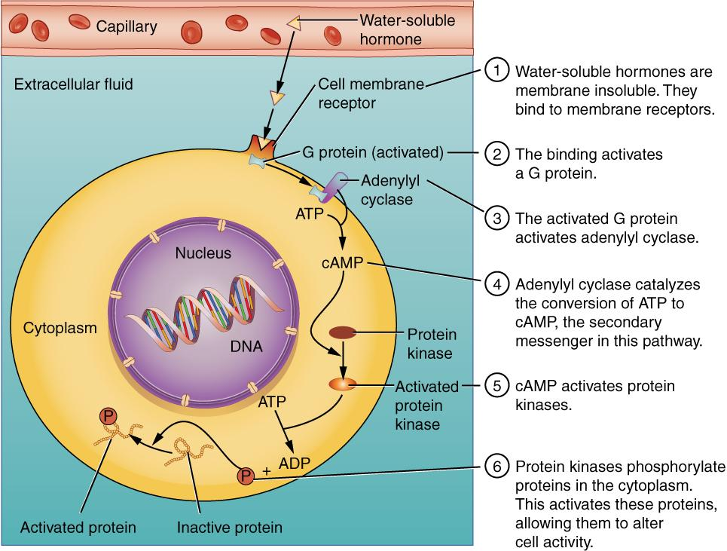

**Water-Soluble (Hydrophilic or Amino Acid Derived) Hormone Receptors: G-protein-coupled receptors. Synthesized by cell receptors on cell surface. Examples include Insulin, Growth Hormone, and Epinephrine.**

Author: OpenStax College; License: [CC BY 3.0 (http://creativecommons.org/licenses/by/3.0)], via Wikimedia Commons; Link: https://books.byui.edu/-YEuY

**Intracellular and nuclear receptors** interact with DNA and affect mRNA synthesis. Nuclear receptors, or receptors on the nucleus of the cell, when activated stimulate transcription of various genes, resulting in the production of new proteins. The new proteins result in a change in the cell. Having different kinds of receptors such as membrane receptors and intracellular receptors accommodates both **hydrophilic** and **hydrophobic** ligands. Hydrophilic ligands easily dissolve in water, but do not easily enter the cell due to the phospholipid bilayer of the cell membrane and therefore act via membrane bound receptors, while nonpolar or hydrophobic ligands can easily cross the plasma membrane bind to cytosolic and nuclear receptors.  In addition, membrane receptors typically induce short term and rapid responses, while intracellular receptors tend to produce slower but prolonged responses.

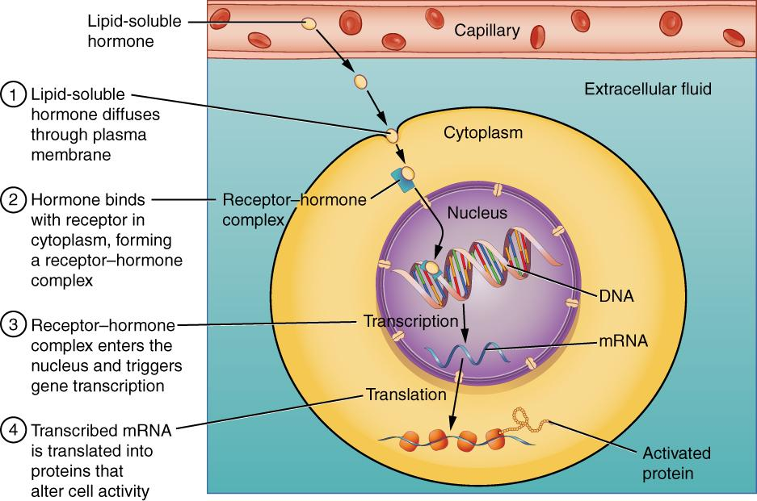

**Lipid-Soluble (Hydrophobic or Cholesterol-derived) Steroid Hormone Receptors: Cytosolic and Nuclear Receptors. Synthesized inside the nucleus of the cell. Examples are Testosterone and Estrogen.**

Author: By OpenStax College; License: [CC BY 3.0 (http://creativecommons.org/licenses/by/3.0)], via Wikimedia Commons; Link: https://books.byui.edu/-Hua

It is truly the receptor, not the ligand that ultimately determines the cellular response. Most receptors are highly selective to their ligand, that is, even similar ligands don't bind to the receptor with the same affinity. The receptor recognizes subtle differences in ligand structure which allows the receptor to distinguish between ligands. This concept has allowed pharmaceutical companies to design drugs (analogs) that can interact with specific receptors to provide medicinal intervention. Drugs that bind to and stimulate a receptor are called **agonists**, while those that bind to a receptor and block its effects are called **antagonists**.

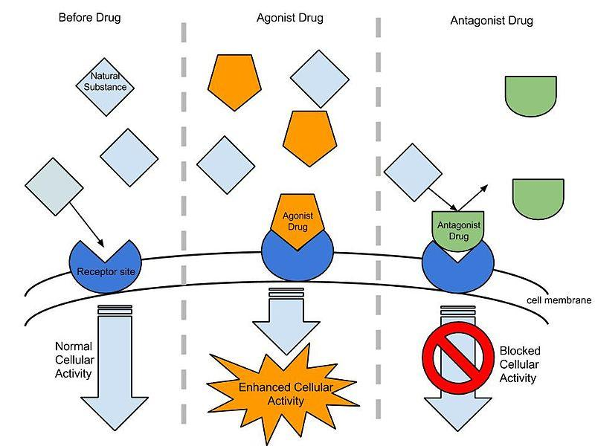

**Agonist and Antagonist Ligands. Agonists fit hormone receptors and activate them. Antagonists occupy hormone receptors and do not activate them but block them from activation.**

Author: By Dolleyj (Own work) [CC BY-SA 3.0 (https://creativecommons.org/licenses/by-sa/3.0)], via Wikimedia Commons Link: https://books.byui.edu/-zknP

The specificity of receptors allows endocrine ligands to be released at any site and circulate throughout the system, but only affect the cells that contain the receptor for the ligand.

Receptor numbers are constantly being changed within a given cell, thus, depending on the number of receptors present, a cell may become less or more responsive to a given ligand. These receptor numbers can be regulated by ligands in a positive (**up-regulation**, more) or negative (**down-regulation**, less) manner.

Read this online at <https://books.byui.edu/bio_180/1132_receptor_intera>