# Isomers

How atoms are placed within organic molecules (three-dimensional structure/chemical bonds) determines the overall function of the molecule. Interestingly, some molecules can have the exact same number and types of atoms (i.e., molecular formula) but those atoms can be arranged differently.  Like using a the same Lego set to build different structures.  Molecules that have the same molecular formula but different structures are called **isomers**.  The structural arrangements found in two different isomers can have dramatic effects on both the properties and function of each molecule. For example oleic acid acid is a primary component of olive oil, a liquid at room temperature.  Its isomer, Elaidic acid has the same molecular formula and differs only in its "rotation" around a single carbon and yet it occurs a solid at room temperature and has several negative health impacts.

For example, the drug Thalidamide was used in the 1950's to treat morning sickness in pregnant women.  It has two nearly identical isomers.   One isomer is an effective sedative responsible for its therapuetic properties.  The other isomer is a powerful teratogen that caused shortened limbs and neurologic defects in exposed children until it was pulled from the market in 1961.   [Story of Thalidomide](https://www.ncbi.nlm.nih.gov/pmc/articles/PMC3573415/#:~:text=Thalidomide%20was%20withdrawn%20from%20most,the%20end%20of%20the%20decade.)

Isomers can be divided into two broad categories; structural isomers and stereoisomers. Stereoisomers can be further subdivided into geometric isomers, enantiomers and diastereomers.  The diagram below shows relationship between these various isomer types with some simple definitions.  In this lesson you will learn the concepts and chemistry that will allow you to compare two structues, identify them as isomers, and distinguish which category of isomers they fall into.  Along the way you will also become familiar with reading, comparing, and even drawing simple chemical structures.   Both outcomes will be important in your continued study of chemistry and biology.

[Figure:  Cleant this figure up.  Add namese of isomer groups.  Put simple definition below names.  Add rotation label to bottom row.]

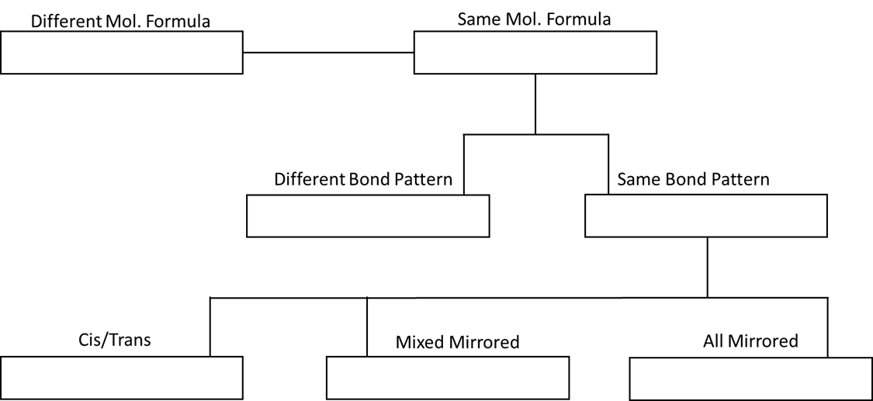

### **Structural Isomers**

Structural isomers, also called constitutional isomers, have the same molecular formula but different arrangements of atoms.  We will typically refer to them as having a different bond pattern.  Usually structural isomers are created by breaking an atom or group of atoms (called a functional group) off of one carbon and swapping it with a group from another carbon along the main carbon chain.  The concept is more easily illustrated than explained.  Consider the constitutional isomers Butane and Isobutane shown in the figure X panel A.  The top carbon in each isomer (C1) has the same bonding pattern, 3 Hydrogens and one Carbon.  Moving down to the second carbon we see that they have different bonding patterns.  Butane is bound to 2 carbons and 2 hyrdrogens while Iso butane is bound to 3 carbons and one hydrogen.  If you will look closely you will see that a CH3 group from C3 in butane was swapped with a Hydrogen group at C2 to create the isobutane structure.  An additonal example of structural isomers are provided next to butane/isobutane.  See if you can identify the groups that have been swapped to create the pair of isomers.

[Figure Notes - Panel A should show a Fisher diagram of butane and isobutane. it may be helpful to have C4 of buane rotated to position on right of C3.  Second panel should show fisher projection of glucose and fructose.  It would be cool to have a pull down window on figure that shows molecules with the swapped groups circled.]]

### **Stereoisomers**

Unlike Structural isomers, Stereoisomers have both the same molecular formula and the same bond pattern, but differ in their bond arrangement or "rotation" around one or more special carbons called steriogenic centers.  There are two are opposite of constihave the same number of atoms and bonds, but they differ in how their atoms are oriented around one or mor carbons. Often, they look very similar, but if you were to try and stack them on top of each other they would not fit, a phenomenon that is called non-super imposable structures.

### **Geometric isomers**

Geometric isomers also have the same molecular formula and the same pattern of covalent bonding but differ in how atoms are spaced around a double covalent bond, especially in a carbon-to-carbon double bond. For example, consider the molecule butene (C4H8). In the molecule butene the two methyl groups (CH3) can be located on same side as the double bond (**cis configuration**) or opposite sides (**trans configuration**). The cis arrangement makes the molecule bend since the two methyl groups act to “repel” each other, whereas in the trans configuration the molecule will be more linear as the two methyl groups “balance” each other.

### **Enantiomers**

When two molecules’ atoms are arranged in the exact opposite way, so that they actually look the same in the mirror, we call them enantiomers. To be an enantiomer the atoms swap positions around a central carbon called an **asymmetric carbon**. At this point you may be thinking: “How on earth did anyone in the right mind figure this stuff out when they can’t even see them!?” Well, in the case of enantiomers scientists used the properties of light. Apparently, when you shine light at structures that are invisible to the naked eye, light rotates, and rotating light is something that can be seen. Thus, even though a molecule has the same molecular formula, swapping positions with different groups of atoms to create a mirror image can drastically affect how light rotates through it. The term mirror image refers to the result of the swapping groups of atoms (**functional groups; see below**) around a center carbon and can be captured in one concept called **chirality**. For example, a metal rod would not be considered chiral because its appearance in a mirror would look the same. However, consider the threads on a screw. Rotating the threads to the right would appear as if you were rotating the screw to the left in the mirror, this effect could be described as chiral.

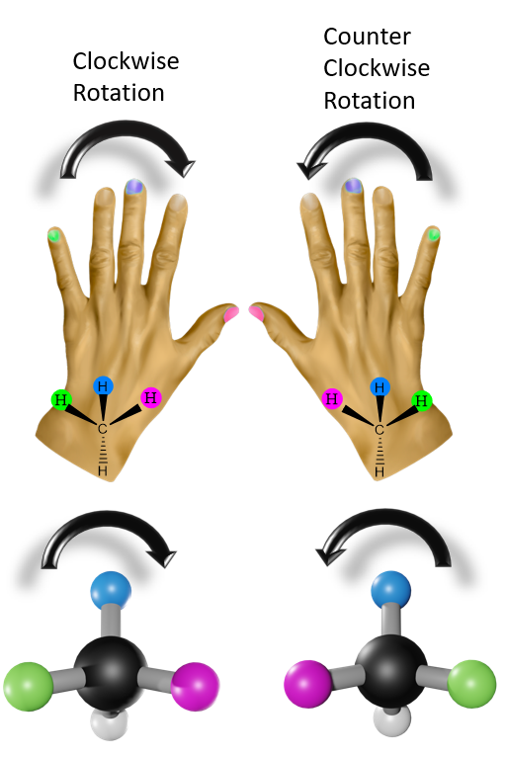

In chemistry, a chiral molecule can exist in two forms, described as non-superimposable mirror images, and these two forms are called enantiomers. Non-superimposable mean that if you tried to stack images of the two molecules on top of each other they would not line up. Consider your hands, they are mirror images of each other but they do not stack on top of each other. Pairs of enantiomers will rotate light either clockwise (to the right) or counterclockwise (to the left). Initially, clockwise rotations (right) were described as dextrorotary (d) and counterclockwise rotation (left) as levorotary (l). This nomenclature evolved to the capitol D and capitol L system. Once a structure has been identified, determining which way light will rotate is determined using the Cahn-Ingold-Prelog (CIP) system which uses R (clockwise) and S (counterclockwise) nomenclature. The CIP system assigns priority based on atomic numbers to help determine the rotation (I > Br > Cl > S > P > F > O > N > C > H).

### **Diastereomers**

The final group of stereoisomers are diastereomers which are very similar to enantiomers except that they contain more than one asymmetric carbon. This property makes it impossible for them to form mirror images.

Read this online at <https://books.byui.edu/bio_180/312_isomers>