# Triglycerides

**Triglycerides** (also called triacylglycerol) constitute the major form of fat stored in plants and animals. Triglycerides are composed of two molecular building blocks: glycerol and fatty acids. Glycerol is a 3-carbon sugar alcohol. A triglyceride is formed by attaching a fatty acid to the hydroxyl group (-OH) of each of these 3 carbons of glycerol through a process called **esterification**. This reaction is a dehydration synthesis reaction (water is removed) and the resulting bond is called an **ester linkage** (see figure below).

Bonding of Three Glycerol and Fatty Acids by Dehydration Synthesis Reaction to Form Triglyceride.

Image created by JS at BYU-Idaho 2014

To understand the properties of a triglyceride, you must first understand the properties of fatty acids. **Fatty acids** are hydrocarbon chains with a carboxyl group (-COOH) at one end. The hydrocarbon chain consists of carbon-carbon and carbon-hydrogen bonds, which are non-polar covalent bonds and therefore **hydrophobic**. The carboxyl group at the beginning of the hydrocarbon chain is considered a weak acid because it can donate a proton at physiologic pH.  Hence the name “fatty acid”.

Fatty acid chains can vary in length, as well as the number and type of carbon-carbon double bonds contained within the hydrocarbon chain. Fatty acid chains with no carbon-carbon double bonds are referred to as **saturated**. This means that every carbon-carbon bond in the chain is a single bond, which allows two hydrogen atoms to link to every carbon in the chain, except for the last carbon which is bonded to three hydrogen atoms. However, if a double bond occurs between two carbons in the hydrocarbon chain, then the carbon atoms connected by a double bond will each bond with one less hydrogen atom in order to maintain four bonds per carbon atom. As such, the hydrocarbon chain is no longer "saturated" with hydrogen atoms at every carbon. Therefore, an **unsaturated** fatty acid will contain one or more double bonds (see the image below).

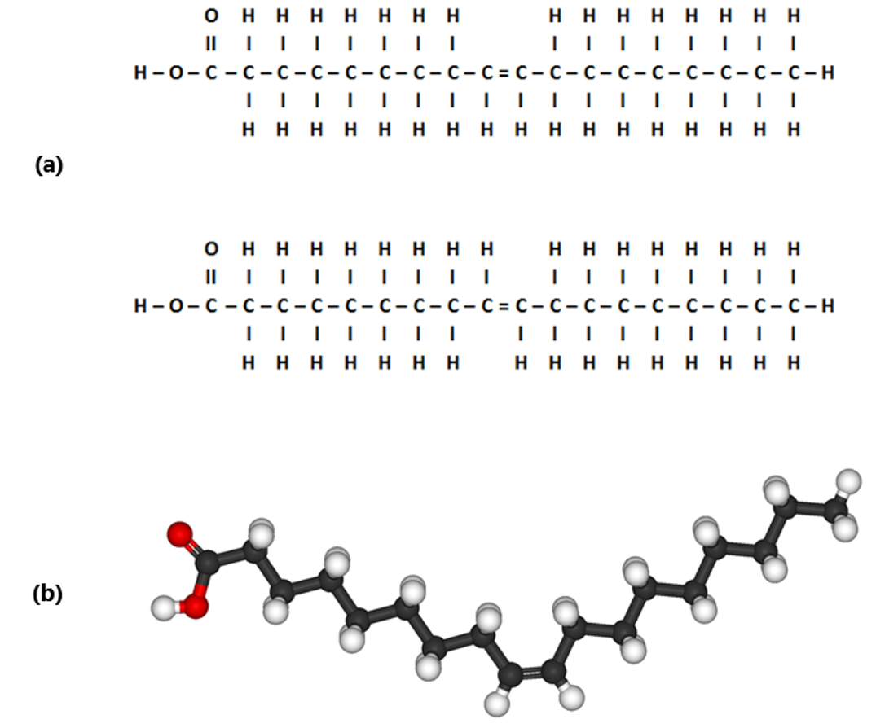

(a) Cis & Trans Double Bond in Monounsaturated Fatty Acid; (b) Cis Double Bond in Unsaturated Fatty Acid.

Image created by JS at BYU-Idaho 2014: Modified File: Oleic-acid-3D-ball-&-stick.png; Author: Benjah-bmm27; Site: https://commons.wikimedia.org/wiki/File:Oleic-acid-3D-ball-%26-stick.png; License: Public Domain

Carbon-carbon double bonds significantly affect the behavior of the fatty acid. These double bonds can occur in one of two states: cis (same) or trans (across). The figure above shows a line drawing of two monounsaturated fatty acids. Note that the first molecule in illustration (a) has the hydrogen atoms extending from the carbon chain on the same side of the double bond. This is called a cis double bond. Note that the second molecule in illustration (a) is nearly identical except that the hydrogen atoms extend from the carbons at the double bond on opposite sides. This is called a trans double bond. Illustration (b) shows a 3D representation of the cis double bond in the unsaturated fatty acid chain. Notice how cis bonds bend or put a kink in the carbon chain.

**Trans Double Bonds in Unsaturated Fatty Acid.** Title: File: Tridecylic-acid-3D-balls.png; Author: Jynto and Ben Mills; Site: https://commons.wikimedia.org/wiki/File:Tridecylic-acid-3D-balls.png; License: public domain

A fatty acid with one double bond is referred to as a **monounsaturated fat,** and fatty acids with two or more double bonds are **polyunsaturated fats**. All lipid containing foods have a specific mixture of saturated and unsaturated fatty acids. Because saturated fatty acids tend to be straight, they can pack together more tightly. The more tightly packed molecules of fat are more dense and more likely to be solid at room temperature. In contrast, unsaturated fats with cis bonds allow for a kinked or angled geometry that makes it more difficult to pack together, causing them to be a liquid at room temperature. Most naturally occurring unsaturated fats are cis fats.

Unsaturated fats with "Trans" bonds contain a geometry that resembles the straight line of a saturated fat.  This geometry allows for trans unsaturated fats to pack together tightly enough that they will be found as a solid at room temperature. Products like Crisco and Margarine often have substantial quantities of "trans fats".  Cis fats are the most common type found in nature, although there are some naturally occurring trans fats. Although trans fats are rare in nature they have appeared in the American diet as a product of oil processing.  Food manufacturers take naturally occurring oils and use high pressures, high temperatures and hydrogen gas to artificially "hydrogenate" unsaturated fats, making them a creamy solid.  A byproduct of this process is the formation fats with rearranged double bonds (trans fats).  This type of fat is usually listed as "partially hydrogenated oil" in the food ingredients list. Food companies are interested in the "hydrogenation" of oils so that they might get fat that has the texture, flavor and chemistry necessary for many of the food products we enjoy (i.e. many pastries, puddings, sauces, creamers, and confectioneries). Unfortunately, this switch of hydrogen arrangement has been shown to increase the risk of coronary heart disease by altering LDL and HDL levels (discussed further below).

Read this online at <https://books.byui.edu/bio_180/411___triglycerides>