# Protein Structure

By now, you should be starting to realize the importance of proteins; they are critical to the proper functioning of various life systems. What is it about proteins that allow them to perform all of these different tasks? The answer to this question can be summed up in three words: shape, shape, and shape. As mentioned earlier, form (shape) equals function. As you can imagine from the many functions of proteins, they have very complex shapes. If we think of proteins as cars, we all quickly understand that the wheels on the bottom of the car and a steering wheel to guide the car are very important standard equipment. Similarly, if our protein doesn't have the right parts in the right places with each component properly connected together, the protein will function about as well as a car that has been put through an auto crusher. In studying the shape of proteins, biochemists have dissected and broken them down into four levels of complexity or structure. Keeping with the car analogy, if we really wanted to dissect a car and determine how it works, we could take it apart all the way down to the nuts and bolts and then reassemble it again. Biochemists do the same thing to proteins to try and understand how proteins work. The first level would be analogous to the “parts” level. As we move from thefirst to the fourth level of structure, the preceding level adds to the next. For example, you cannot have secondary structure without a primary structure.

#### Primary Structure (First Level)

The primary structure of the protein is the sequence of the amino acids in its polypeptide chain. If proteins were popcorn stringers made to decorate a Christmas tree, the primary structure of a protein is the sequence in which various shapes and varieties of popcorn are strung together. The primary structure of a protein is maintained by covalent peptide bonds connecting the amino acids together. Insulin, the first protein to be sequenced, contains the following 110 amino acid primary sequence: malwmrllpl lallalwgpd paaafvnqhl cgshlvealy lvcgergffy tpktrreaed lqvgqvelgg gpgagslqpl alegslqkrg iveqcctsic slyqlenycn.  Each letter is specific for 1 of the 20 amino acids.

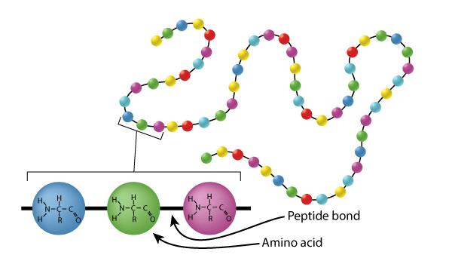

Primary Protein Structure: Insulin Polypeptide Chain linked by Covalent Peptide Bonds.

Image by BYU-Idaho student Nate Shoemaker Spring 2016

The image above represents the primary structure of a protein (a chain of amino acids). As you might expect, the sequence of the amino acids in the polypeptide chain is crucial for the proper functioning of the protein. Importantly, how does the cell know the right order in which to connect the amino acids? The original code is found in the DNA (deoxyribonucleic acid) housed in the nucleus of the cell. When a specific protein needs to be made, a segment of DNA called a gene is first copied in a process called transcription. This copy is called messenger RNA (mRNA). The mRNA strand exits the nucleus and attaches to a ribosome, a specialized organelle within the cell that interprets the code contained in the mRNA, recruits the appropriate amino acid, and catalyzes the formation of the peptide bond that links amino acids together. The process is called translation and results in a growing polypeptide chain (see figure below).

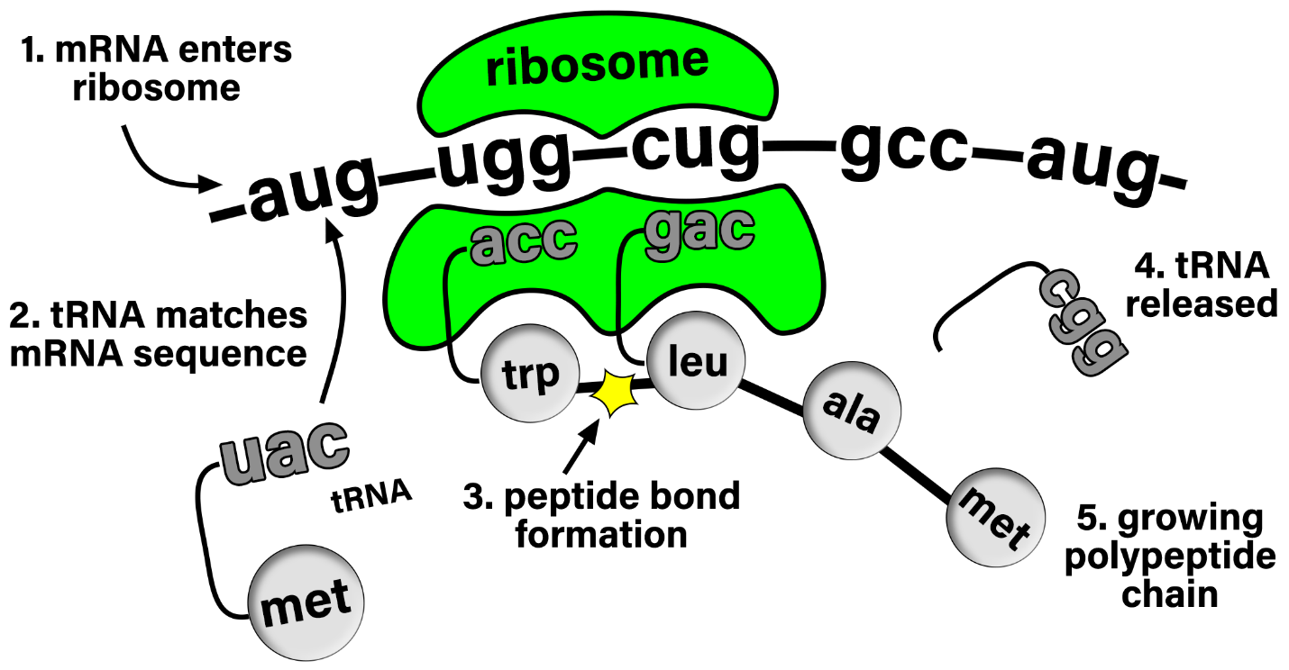

**Protein Translation. The mRNA feeds through the ribosome which helps match the appropriate tRNA carrying its respective amino acid. The ribosome then catalyzes the formation of a peptide bond between amino acids to create a polypeptide chain.**

Image by BYU-Idaho professor Spring 2021

If there is a mutation in the DNA then the amino acid sequence may be altered and the function of the protein can be affected. Many known genetic diseases in humans, such as cystic fibrosis, sickle cell anemia, albinism, etc., are due to mutations that result in alterations in the primary structures of proteins, which then, in turn, cause alterations in the other levels of protein folding: secondary, tertiary, and possibly quaternary structure.

#### Secondary Structure

The secondary structure of proteins involves twisting or folding polypeptides into highly regular sub-structures. Whereas the primary structure of a protein is pretty much two-dimensional, the secondary structure of proteins begins the very important three-dimensional configuration of proteins.

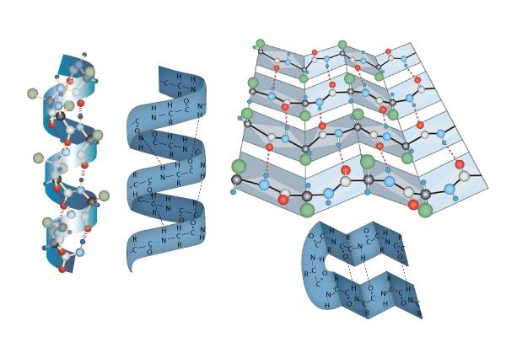

Secondary Protein Structure: Alpha Helix and Beta Pleated Sheet linked by Hydrogen Bonds.

Image drawn by BYU-Idaho student Nate Shoemaker Spring 2016

The two types of secondary structure are the **alpha helix** (think "slinky" as shown in the left picture just above) and the **beta pleated sheet,** or simply pleated sheet (shown to the right in the image above; think about one of those folded cardboard windshield guards that can be placed on the inside of your car's windshield on a hot day so the inside of your car doesn't end up with a temperature approximately that of the interior of our sun). The secondary structure of proteins is a result of the sequence of amino acids in the primary structure and is maintained by **hydrogen bonds**. These hydrogen bods occur along the protein backbone, independent of R-group side chains. Some proteins, like collagen, are almost entirely alpha helix, while others, like silk, are a mostly pleated sheet. Other proteins can have short segments of alpha helix and/or pleated sheet in their structure.

#### Tertiary Structure

The tertiary structure of a protein is the overall folding of the polypeptide chain and represents a protein’s final 3-dimensional shape. In contrast to secondary structure, tertiary structure can be stabilized by multiple types of bonds (covalent, ionic, hydrogen) and hydrophobic/hydrophilic interactions as dictated by the amino acid R-group side chains.

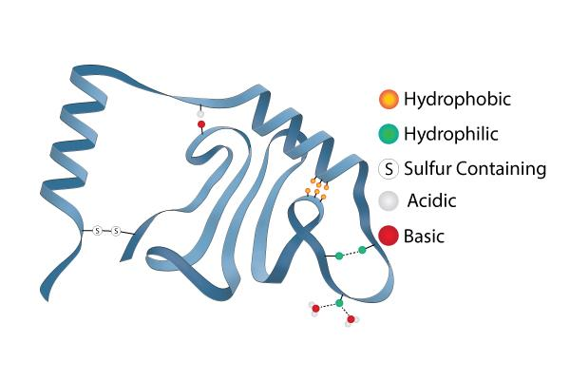

**Tertiary Protein Structure: Hydrophilic & Hydrophobic R Groups bound by Hydrogen Bonds, Ionic Bonds Impacted by pH, and Covalent Disulfide Bonds.** Image drawn by BYU-Idaho student Nate Shoemaker 2016

For example, R-groups that act as weak acids and bases can donate or accept protons. This can create positive and negative charges on the amino acids that will create ionic attraction. Certainly, pH can affect how these attractions between acidic and basic R groups occur. This helps explain why radical changes in pH can cause the structures of proteins to fall apart and ruin the protein’s ability to function. One very important and very strong tertiary structure bond is a covalent bond that occurs between R groups on cysteine residues. These R-groups contain sulfur, which can interact with other sulfurs to form a disulfide bridge. The loss of a protein’s 3-dimensional shape is called denaturing the protein.

#### Quaternary Structure

Sometimes multiple protein subunits work together to perform a specific function. Quaternary structure describes the number and arrangement of multiple polypeptide chains coming together to form a functional multi-protein complex. Not all proteins assume a quaternary structure. Only proteins composed of more than one polypeptide chain have quaternary structure. As an example, the protein in the picture below has four polypeptide chains that work together to form one functional protein called hemoglobin.

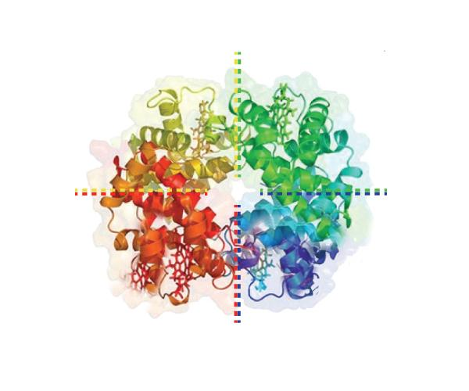

Quaternary Protein Structure: Four Polypeptide Chains Forming One Protein.

Image developed by BYU-Idaho student Nate Shoemaker Spring 2016

Hemoglobin is found in the red blood cells of humans and has the job of carrying oxygen throughout the body. There are two alpha and two beta chains that make up hemoglobin. You may have heard of sickle cell anemia. This genetic disease is caused by a mutation that results in a change to just one amino acid in the primary structure of the beta chains. This small change is enough to cause a significant alteration to the quaternary structure of hemoglobin, resulting in an abnormal sickle shape. This alteration affects hemoglobin's ability to function correctly, resulting in multiple pathological symptoms.

This next image below is just a summary that shows all the levels of protein structure in one image. You can see how each level leads to a more complex development of a very specific three-dimensional protein.

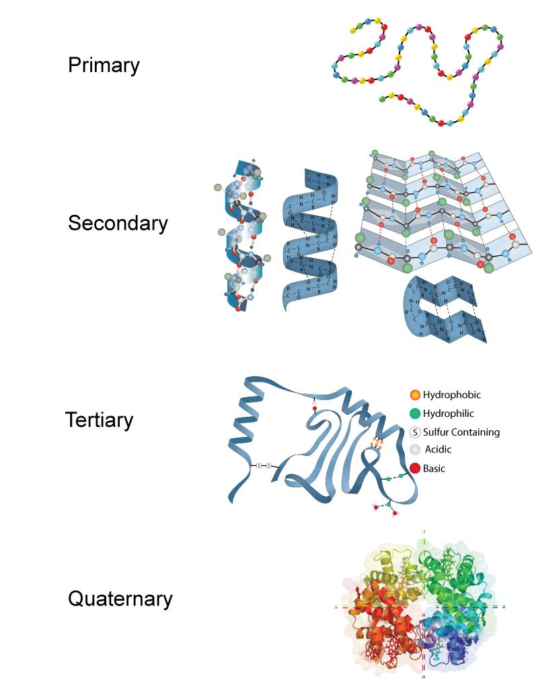

**Four Levels of Protein Structures.** Image developed by BYU-Idaho student Nate Shoemaker Spring 2016

Read this online at <https://books.byui.edu/bio_180/434___protein_struct>