# Electron Transport Chain (Oxidative Phosphorylation)

The Electron Transport Chain is responsible for the synthesis of most of the ATP in the cell. In order to understand how the electron transport chain works, it is critical that you have a good understanding of what the mitochondria are and how it is organized.

**Mitochondria, a double membrane organelle inside the cell.** Image derived from File: Überseemuseum Bremen 2009 237.JPG; Author: Sterilgutassistentin.Site:[https://books.byui.edu/-cgKk](https://commons.wikimedia.org/wiki/File:%C3%9Cberseemuseum_Bremen_2009_237.JPG);License: GNU General Public License as published by the Free Software Foundation

The Mitochondria have an inner and an outer membrane. The inner membrane folds in and out on itself and these folds are called Cristae. Cristae increase the total surface area of the inner membrane. The center of the mitochondrion is called the matrix and is analogous to the cytoplasm of a cell. The Electron Transport Chain reactions take place on the inner membrane.  
  
The term, electron transport refers to the proteins on the inner membrane of the mitochondria that will take hydrogen atoms and electrons from NADH and FADH2 and then ultimately use the energy in the electrons to make ATP. Recall that NAD+ and FAD picked up high energy electrons and hydrogens from C-H bonds in glycolysis (from the cytoplasm) and the citric acid cycle (in the matrix of the mitochondria).  
  
In the inner membrane of the mitochondrion is a series of protein complexes that will receive the electrons and pass them from one complex to another. NADH passes 2 high energy electrons onto a protein complex (**Complex I**) in the inner membrane of the mitochondria. This complex is called NADH dehydrogenase. NADH dehydrogenase does two things. First, it accepts a pair of high energy electrons from NADH. Second, it uses some of the energy from these electrons to undergo a conformational change. This conformational change is associated with the movement of 4H+ ions from the mitochondrial matrix to the intermembranous space (the space between the inner and outer membranes of the mitochondria). Next, these two new electrons on Complex I are moved to Coenzyme Q (**CoQ**). Coenzyme Q is also called ubiquinone. CoQ will pass these electrons straight to complex III. *Note: the flow of electrons is either 1,3,4 for NADH or 2,3,4 for FADH2 and complex II doesn’t pump protons. For these reasons, we get more energy from NADH than FADH2.

FADH2 also passes a pair of high energy electrons to a protein complex (**Complex II**), also called Succinate dehydrogenase. Complex II accepts the electrons but does not go through any conformational change that is associated with the movement of H+ ions. However, Complex II does pass the electrons to **CoQ** just like Complex I did. **CoQ** is a mobile shuttle that moves easily through the membrane and is able to relocate and react with **Complex III**. Complex III has a long name (Coenzyme Q-Cytochrome c Oxidoreductase). Complex III also goes by the name Cytochrome bc1 Complex. Complex III will undergo a conformational change that is associated with the movement of 4H+ ions from the mitochondrial matrix to the intermembranous space. The two electrons are then moved from Complex III to Cytochrome C (**Cyt c**). **Cyt c** another mobile shuttle that is a soluble protein in the intermembranous space that moves easily along the membrane and reacts with **Complex IV**. Complex IV, also called Cytochrome c Oxidase, uses some of the electron energy to undergo a conformational change that is associated with the movement of 2 H+ ions from the mitochondrial matrix to the intermembranous space. Oxygen receives the 2 electrons from Complex IV and reacts with H+ available in the surrounding fluid to make H2O or water.

A review of figure 11 below reveals that one NADH results in the movement of 10 H+ ions from the mitochondrial matrix to the intermembranous space. One FADH2 results in the active transport of 6 H+ ions. The important message in all of this is that electron energy is used to transport H+ ions to the intermembranous space and this sets up an electrochemical gradient that favors the movement of H+ ions back into the matrix. This is allowed to happen through another protein complex called **ATP synthase**. The diffusion of H+ ions through ATP synthase is called "**chemiosmosis.**"

ATP synthase is made up of two main components referred to FO and F1 regions. Protons flow through the FO regions (carousel) and cause rotation of the F1 region (stalk). The F1 region is made of α, β, γ, and δ subunits. The rotation of F1 causes the subunits to come in contact and change between three conformations. In conformation one, ADP and Pi can bind with high affinity. In conformation two, ADP and Pi increase binding that they are essentially “smashed” together to that ATP can be formed. In conformation three ATP is released. This process is called **Oxidative Phosphorylation**.

For each pair of electrons that move from Complex I to Complex IV, about 2.5 ATP can be produced. For each pair of electrons that move from Complex II to Complex IV, about 1.5 ATP can be produced. Therefore, if we round up, it is often stated that each NADH yields 3 ATP while each FADH2 will yield 2 ATP.

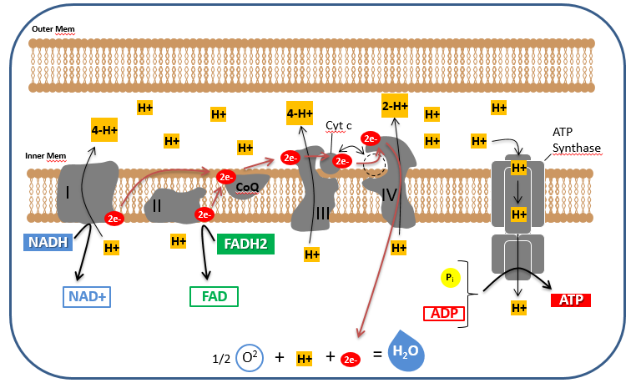

**Electron Transport Chain.** Image created by JS at BYU Idaho F2013.

The image above illustrates the Electron Transport Chain. The protein complexes on the inner mitochondrial membrane use high energy electrons from NADH and FAD2 to move H+ ions to the intermembranous space. The H+ concentration gradient is then used to make ATP through the enzyme complex called ATP Synthase. Oxygen is the final electron acceptor and becomes water.  
  
A quick recap of what has happened so far might go like this: Electrons and hydrogen ions were harvested from the C-H bonds of glucose. These high energy electrons with hydrogen are carried from the reactions of glycolysis and the citric acid cycle to the electron transport chain on the inner membrane of the mitochondria. The electron transport chain takes these high energy electrons and gradually "uses" the energy to pump hydrogen ions into the intermembranous space. As the energy in the electrons is used, the electrons don't have enough energy to form a C-H bond anymore, but they can form an O-H bond. Thus, oxygen comes along and accepts the electrons and hydrogen to form water. The cycle is complete, and water can once again be used by a plant somewhere to participate in the photosynthetic reactions that will excite O-H bond electrons again. The hydrogen ions that have been pumped into the intermembranous space are allowed to flow down their electrochemical gradient through ATP synthase. ATP is generated as a result and ATP is used to run the many molecular processes in cells.

Glucose is not the only molecule with C-H bond energy to use in metabolic reactions. Lipids and Proteins are also metabolized by cells.

#### Metabolism Summary Part 3: Electron Transport Chain

We will continue with our summary of the metabolic process using the Electron Transport Chain process magnified from the “Metabolism Summary” image. (Green numbers from summary correlate with green numbers on the image below.)

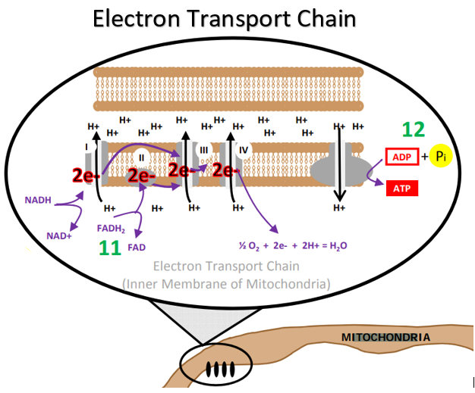

**Electron Transport Chain, from the “Big Picture” of Metabolism:**

**Glycolysis, Citric Acid (Krebs) Cycle, Electron Transport Chain, Beta Oxidation and Lipolysis.**

Image created at BYU-Idaho by JS 2010

**11**  NADH is carrying a proton and 2 high energy electrons that need to be “dropped off”.   FADH2 is also carrying high energy electrons and a couple of protons. These electron “carriers” are able to donate these electrons to an enzyme complex found in the inner mitochondrial membrane. Think of the “**electron transport chain**” as a bucket brigade. A series of proteins pass 2 electrons from one to another. Sometimes when the electrons are passed, a little bit of the energy from the electrons is used to induce a conformational change in some of the protein structures. This conformational change results in the transport of protons from the inside of the mitochondria to the intermembranous space (the space between the inner and outer mitochondrial membranes). Also, some of the energy released as the electrons move through the electron transport chain is given off as heat. NADH donates to the electrons to the electron transport chain at complex I and FADH2 donates electrons at complex II. There are more protons pumped from electrons moving down the transport chain from complex I than from complex II. For this reason, NADH yields more ATP ultimately than FADH2. Whether from NADH or FADH2, any donated electrons will move down the transport chain to the last electron acceptor and cannot go back to previous components of the chain.

Oxygen accepts the electrons from the last protein complex (complex IV) of the chain. As oxygen accepts the electrons, the oxygen becomes reactive and capable of forming a covalent bond with two protons and water is formed (H2O). Oxygen is the final electron acceptor.

Notice that NADH becomes NAD+ at the beginning of the electron transport chain. Also, FADH2 becomes FAD. This recycles these electron carriers such that they can be used again in earlier metabolic reactions. This has been mentioned, but it is worth mentioning again. Without NAD+, reactions that use NAD+ cannot occur.

**12**  In step 11, we learned that as high energy electrons passed down the chain of protein acceptors, energy was used to move H+ ions into the intermembranous space. This generates a proton gradient. This means that there will be a higher concentration of protons in the intermembranous space than there is inside the mitochondrial matrix.  This proton gradient represents “potential energy” because the protons will try to flow down their gradient if a passageway opens and allows such movement.

Step 12 represents the idea sometimes referred to as **chemiosmosis**. This is a term that refers to the fact that protons tend to flow down their gradient through a selective protein channel. This protein channel, called ATP-Synthase is a very intricate and specialized molecular machine. This protein literally turns as the protons come through it and this kinetic energy is used to bring ADP and inorganic phosphate together so that ATP is created. The synthesis of ATP through chemiosmosis is referred to as **Oxidative Phosphorylation**.

While glycolysis gives us 2 ATP per glucose molecule, the electron transport chain gives us approximately 34 ATP per glucose molecule. We say “approximately” because it is difficult to say exactly how many ATP we get. This is because some ATP is used to shuttle molecules in and out of the mitochondria and there is likely some “leaking” that occurs when protons from the intermembranous space accidentally escape by some other way than through the ATP synthase enzyme complex. However, it is generally accepted that aerobic metabolism yield between 18 and 19 times more ATP than anaerobic metabolism. From a thermodynamic perspective 686 kcal of energy are released and 432 kcal of that energy are captured in ATP. Showing an efficiency of 63% energy while the rest (37%) is lost as heat.

|  |  |  |
| --- | --- | --- |
| **Molecule** | **Conversion Rate to ATP** | **ATP Yield through Electron Transport** |
| 2 NADH from Glycolysis  2 NADH from Pyruvate Oxidation  6 NADH from Citric Acid Cycle | 3 ATP / NADH | 6 ATP  6 ATP  18 ATP |
| 2 FADH from Citric Acid Cycle | 2 ATP /FADH | 4 ATP |
| **Net Total from Electron Transport** | **34 ATP** |
| Net Total from Glycolysis + Citric Acid Cycle (Remember 2 ATP used to start glycolysis) | 4 - 2 + 2 = 4 ATP |
| **Total ATP from the complete aerobic metabolism of one glucose molecule** | **~38 ATP (minus some loss)** |

Read this online at <https://books.byui.edu/bio_180/91___electron_transp>