# Energy Cycle, ATP, and Electron Carriers

Survival of living organisms depends on the ability to harvest energy from their surroundings and then convert that energy to forms that can carry out cellular processes. Energy can be found in our physical world in many different forms, some of which include electrical energy, light energy, heat energy, and even the energy of motion. **Thermodynamics** is the study of the relations between heat, work, temperature, and energy. The study of thermodynamics has two governing scientific laws. The first law states that – Energy cannot be created or destroyed and the second law states that – No energy transfer is 100% efficient, instead some energy is lost to **entropy**, a form that is the least useable for organisms.

At the broadest level, energy can be organized into one of two categories, **kinetic** and **potential** energy. Objects in motion (electrons, moving cars, or air molecules) all have kinetic energy, while objects not in motion (parked car) have potential energy. Since energy is defined as the ability of an object to do work, both moving (kinetic), and nonmoving objects (potential) possess energy. It might seem a bit odd to categorize nonmoving objects as having energy, but it is precisely this concept of potential energy that allows cells to exist. In the case of biological cells, it is the potential energy stored in the chemical bonds that hold molecules together that sustain life. This type of potential energy that exists in chemical bonds is called **chemical energy**. As macromolecules are synthesized from simpler molecules, they store chemical energy in their newly formed bonds through **anabolic pathways**. Then when these same macromolecules are broken down back to their simpler forms, they release the stored chemical energy through **catabolic pathways**.

**Bioenergetics** is the study of how energy is transferred through the chemical reactions of living systems. Cells are always breaking and making bonds. Every time a bond is broken, energy is released and every time a bond is made energy is required in forming that bond. Keep in mind that whenever we see a reaction that involves the synthesis of new molecules, we call this an **Anabolic** reaction. **Catabolic** reactions occur when molecules are broken down into smaller and smaller parts. Several catabolic reactions occur in cells to break sugars, proteins, and lipids down into smaller and smaller parts until finally the C-H bonds have been processed to allow the energy in such bonds to be used in the form of ATP to do work.

The energy transfer between breaking and making bonds is quantified with a measurement called **free energy** or **Gibbs free energy** (**G**) named after Josiah Gibbs who developed the measurement. Gibbs free energy attempts to quantify the amount of useable energy that is left over after a chemical reaction. Recall, that the second law of thermodynamics states that no reaction is 100% effective, and some energy is lost through **entropy** which is unusable. Thus, Gibbs free energy gives an estimate of only the energy available after entropy for a given chemical reaction. This energy exchange is called the delta G (∆G). Therefore, to calculate ∆G the total energy of a system called enthalpy (∆H) is subtracted from entropy (∆S). Since temperature is a very big factor in energy exchange, we also include temperature (T; in degrees Kelvin) in the ∆G calculation and make assumptions that pH and pressure are constant.

ΔG=ΔH−TΔS

The units will include the measure of energy (kilojoules or kilocalories) per the amount of chemical reactants (mol). Using the ∆G calculation for a give chemical reaction reveals two kinds of reactions: **exergonic** or **endergonic**. Exergonic means that energy is being released during the reaction. Stated more specifically, the products have less energy than the reactants and the ∆G will be less than zero or negative. These reactions occur spontaneously which means that if two reactants are placed together, they will eventually make a product, even though technically, they do require energy to get started. Sometimes these reactions occur quickly and sometimes slowly, but they will eventually make the product. In contrast, endergonic reactions require the input of large amounts of energy so that the products will have more energy than the reactants and the ∆G will then be greater than zero or positive. These reactions will not occur without the addition of more energy. Combining all the terms thus far, anabolic processes that build complex molecules (glucose to glycogen) are endergonic reactions, and catabolic processes (glycogen to glucose) are exergonic.

Perhaps no other molecule in biology demonstrates the importance of endergonic and exergonic better than the molecule adenosine triphosphate (**ATP**). In terms of cellular energy, ATP could be considered currency! The molecule of ATP consists of the nucleoside adenosine bound to three phosphate groups. When ATP is combined with water the resultant hydrolysis reaction can yield -7.3 kcal/mol for the loss of one phosphate or -10.9 kcal/mol with the loss of two phosphates.

ATP + H2O → ADP + Pi ΔG° = −7.3 kcal/mol

ATP + H2O → AMP + PPi ΔG° = −10.9 kcal/mol

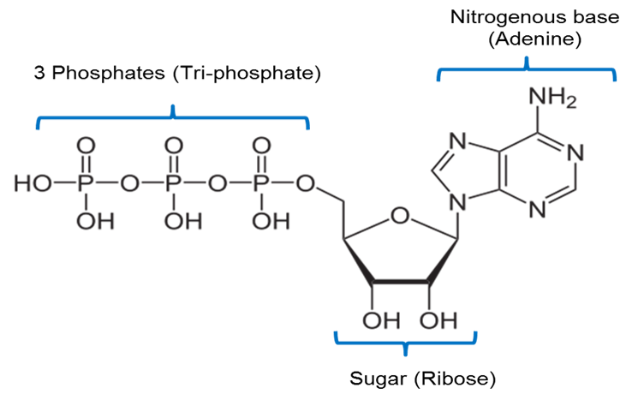

**Chemical Structure of ATP**. Image created by JS at BYU Idaho Fall 2013.

The chemical reaction is considered exergonic because the resultant products (ADP and one inorganic phosphate (Pi) have lower free energy than the initial reactants (ATP and water). The free energy can then be used for cellular work. In fact, the molecule ATP is very unstable, “spontaneously” converting to ADP and Pi and constantly releasing energy as heat unless harnessed by other proteins.

Most endergonic or exergonic reactions are reversible, releasing energy in one direction and consuming energy in the other direction. Since exergonic reactions are spontaneous, in a closed system, the ultimate direction would always favor the exergonic direction. Fortunately for living organisms, the system is open, with constant supplies of energy. Thus, all living organisms are in a constant uphill battle to try and keep the direction of reactions equal, requiring constant supplies of energy. The amount of energy needed to start reactions, both endergonic and exergonic, is known as the **activation energy**. A common source of energy for the initial “push” to start the reaction is heat energy. Heating up a system will increase the energy available and speed up the process. The higher the activation energy, the slower the reaction will occur and the more heat energy it will need to get it started. In many systems, the activation energy is too high to be overcome with heat energy alone (this is good, so things don’t just spontaneously start), instead they require the use of a **catalyst** to help facilitate the process, thereby indirectly lowering the activation energy.

Read this online at <https://books.byui.edu/bio_180/71__energy_cycle_atp>