# Glycolysis

Glycolysis literally means the breakdown of sugar (Glyc = sugar or sweet and Lysis = to cut or loosen). Glycolysis occurs in the cytoplasm of the cell. In short, glycolysis takes 1 glucose molecule of 6 carbons and makes two 3 carbon molecules called pyruvate. In the process, electrons and hydrogen atoms are captured by NAD+. Any energy liberated will be released as heat or captured as ATP or NADH.

|  |  |
| --- | --- |
| **Molecule** | **Net Yield through Glycolysis** |
| ATP  NADH  Pyruvate | 2  2  2 |

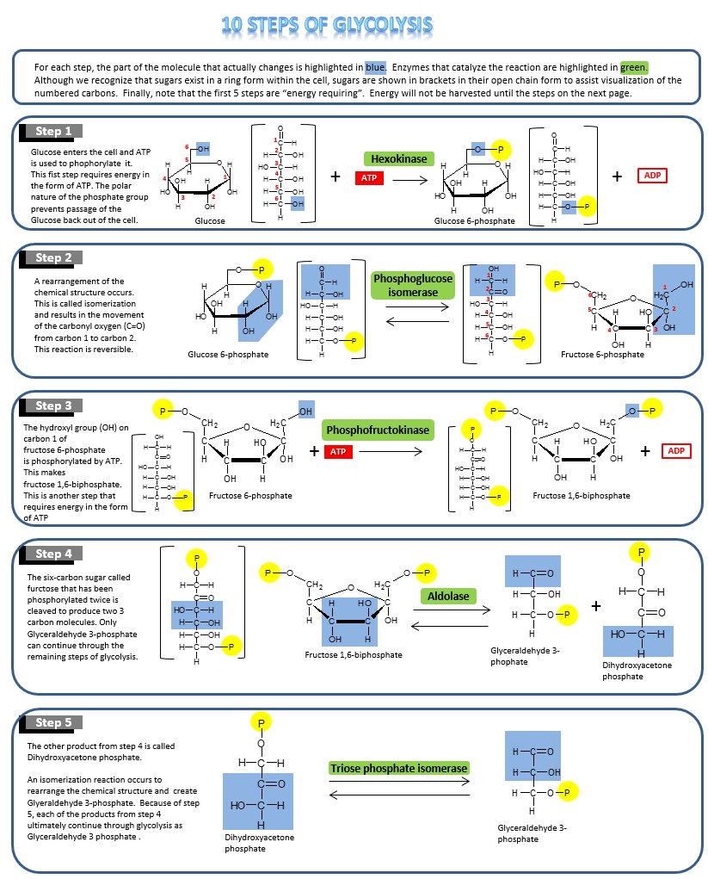

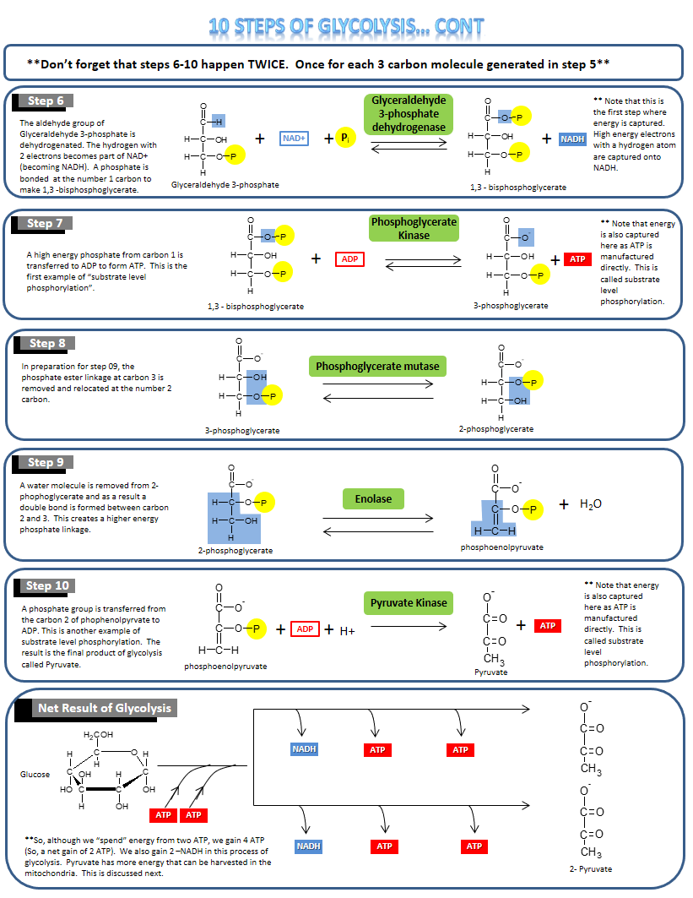

#### Anaerobic and Aerobic Use of Pyruvate

**Anaerobic**

The last step of glycolysis results in two 3-carbon molecules, called pyruvate. The fate of pyruvate depends on the availability of oxygen and whether the organism has mitochondria. If oxygen is available, then pyruvate is shuttled into the mitochondria and continues through several more biochemical reactions called the "Citric Acid Cycle." This is called **aerobic metabolism**. If oxygen is not available in sufficient quantity to the cell, then pyruvate goes through a reduction reaction that, depending on the organism, results in the production of Lactate or alcohol (**fermentation**). This is called **anaerobic metabolism**.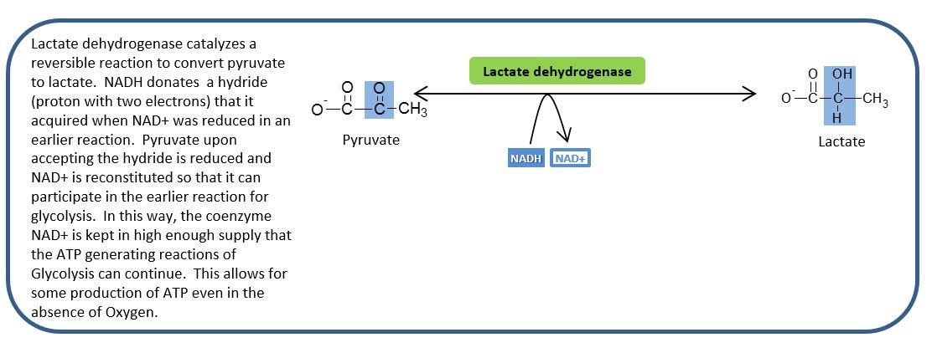

**Anaerobic Metabolism: Pyruvate Reduction to Lactase.** Image created by JS at BYU-Idaho Fall 2013.

**Aerobic**

When there is enough oxygen available to the cell, pyruvate crosses the mitochondrial membrane and is quickly converted to Acetyl CoA (a 2-cabon molecule). During this process, one molecule of CO2 is released. Acetyl CoA enters the Citric Acid Cycle where CoA is removed, and the acetate is added to a 4-carbon molecule to make a 6 carbon molecule called “Citric Acid.” As the biochemical steps of the Citric Acid Cycle continue, 2 more carbons are lost as CO2 and so ultimately all the carbons of pyruvate are lost as CO2. After 2 pyruvates complete the citric acid cycle, all the carbons of the original Glucose molecule have been released as CO2.

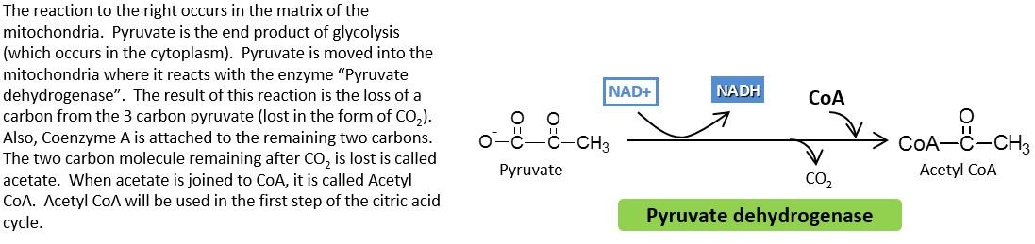

**Conversion of Pyruvate to Acetyl CoA.** Image created by JS at BYU Idaho F2013.

**The image above shows the conversion of Pyruvate to Acetyl CoA occurs in the mitochondria and results in the loss of a Carbon as CO2**

**and the creation of Acetyl CoA.**

Read this online at <https://books.byui.edu/bio_180/81__glycolysis>