# Economic Issues and Foreign Exchange



### Questions to Ponder

* What broad measures can we use to understand the relative economic health of national economies?
* What factors impact currency exchange rates?
* How can fluctuating exchange rates impact the profitability of international transactions, investments, and businesses?

## Introduction

It is critical that international business people are aware of global and national macroeconomic trends. Inflation and interest rates can affect consumer demand, supplier pricing, and the costs of doing business. In addition, policies that governments enact will almost certainly impact your business.

Furthermore, fluctuating currency exchange rates can turn a profitable international transaction into an unprofitable one. For instance, when foreign earnings are translated back to the home currency for annual report purposes, mediocre foreign performance can appear to be a strong growth if exchange rates work in your favor. Conversely, excellent performance can appear sluggish if exchange rates are not in your favor. Therefore, it is important to anticipate potential changes in economic conditions and currency exchange rates so that you can develop contingency plans to deal with changing conditions.

For which of you, intending to build a tower, sitteth not down first, and counteth the cost, whether he have sufficient to finish it? (Luke 14:28)

## Macroeconomic Measures

Companies and governments use broad macroeconomic measures to assess the relative health of national economies. Understanding the factors that drive these measures is critical for business leaders. While broad in nature, they give a good sense of the historical and current business environment specific to a country. We focus on the following four macroeconomic measures:

* **PPP GDP Per Capita** – The Gross Domestic Product (combined value of all goods and services of a country) divided by its total population and adjusted for Purchasing Power Parity (PPP), which takes into account the relative cost of living.
  + Countries with a higher PPP GDP Per Capita are wealthier.
* **GDP Percentage Growth** – The year-to-year growth of the combined value of all goods and services produced by a country.
  + Positive GDP Percentage Growth means the overall economy is growing.
* **Inflation Rate** – The rate (shown in a percentage) at which prices change over time
  + A positive inflation rate means that prices are increasing and the purchasing power of money is therefore declining.
* **Lending Interest Rate** – The amount a lender charges a borrower as a cost of borrowing money. This is shown as a percentage of the principal, or the amount loaned.
  + Higher interest rates mean it is more expensive to borrow money in a given country.

## Exchange Rate Policies

National governments take different approaches to exchange rate policies. These policies range from **free,** or **clean flow** all the way to **fixed-rate,** or **pegged policy**. A free-floating policy allows currency to fluctuate based on market supply and demand rather than government intervention. For instance, the Canadian government has not intervened with their dollar since 1988, so the Canadian exchange rate policy is largely free-floating.

On the other hand, some countries choose a **pegged**, or **fixed-ratepolicy**. These nations maintain an exchange rate tied to another country’s currency, typically US dollars or euros.

Most countries including the US Federal Reserve and the European Central Bank use a **managed,** or **dirty policy.** These governments allow their currency to fluctuate based on supply and demand, but from time to time, the central bank intervenes in the currency market to influence the value of the currency. They buy or sell quantities to try to strengthen or weaken the currency. A “dirty policy” does not mean that government intervention is corrupt; it just means that the government has a policy of influencing the exchange rate when they see fit.

China currently has a **semi-fixed policy**. The Central Bank sets a fixed rate that the government adjusts frequently, but they allow the currency to fluctuate slightly around that rate. Before China adopted this policy, the government maintained a fixed-rate policy. They fixed the exchange rate relative to the US dollar over time. They held their exchange rate constant for a long time. This led to the significant undervaluing of the Chinese currency. Since the move to the semi-fixed policy, the government has allowed the Chinese Yuan to appreciate over time. However, some governments feel that it is still undervalued.

### Question to Ponder

Why would the Chinese government want to keep the value of their currency as low as possible? Isn’t an increasing currency value a good thing?

## Factors Impacting Foreign Exchange Rates

### Forex Market Basics

Beyond the government policies already mentioned, many factors influence the value of a currency in an open market setting. Take care not to take any one of these in isolation. They have a combined effect on currency values, and in the end, much of the currency’s value is based on supply and demand. The more important factors are shown in the graphic below:

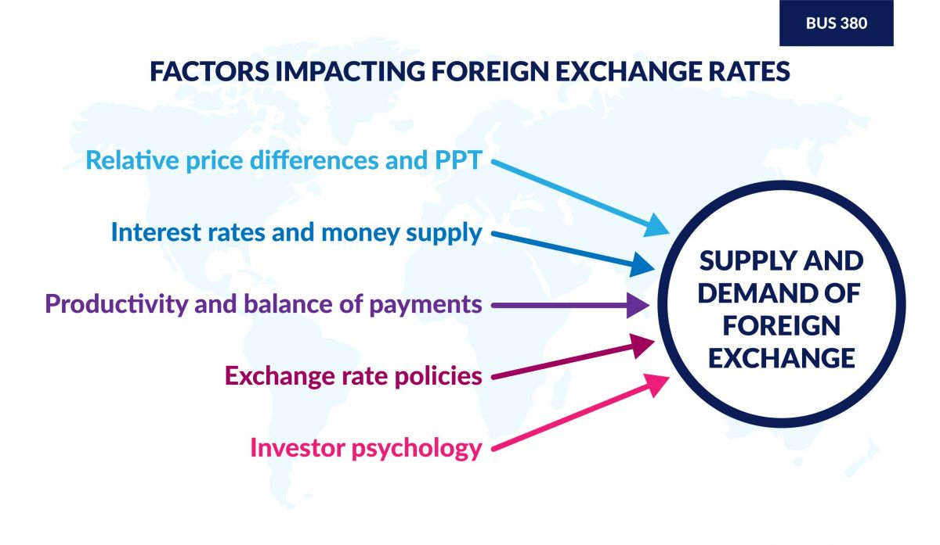

Learn the basics about the (FX) market by clicking on the and in the video below.

**Purchasing Power Parity (PPP)**

is the relative price differences between countries. Some countries have expensive prices; others have cheap ones. The effect of these differences on the exchange rate is measured by the PPP.

Below is an example of a surprisingly common way to measure PPP. This is the [Big Mac Index](https://www.economist.com/big-mac-index) put together by The Economist. Every so often, they take a look at the price of a Big Mac from McDonald’s restaurants around the world. Then, they compare it to the US Big Mac price. Finally, they deduce whether each country’s currency is overvalued or undervalued against the US dollar.

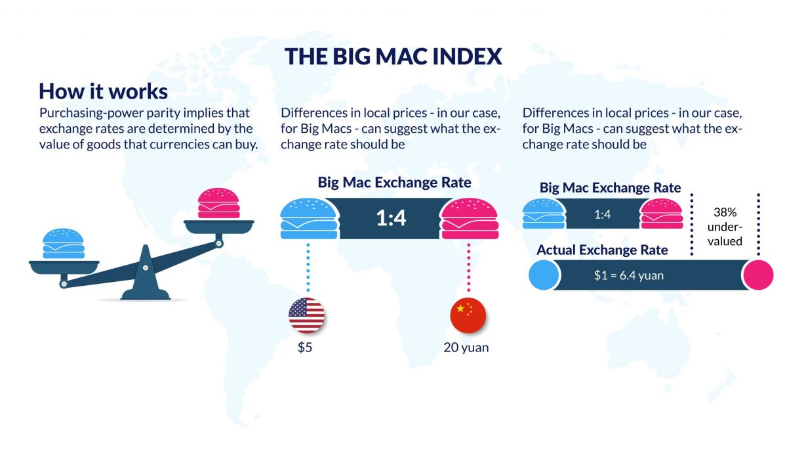

### Question to Ponder

Why would governments and businesses consider the price of a Big Mac an accurate an effective way to measure purchasing power around the globe? Why do you think it may not be a perfect measure?

The next factors that impact foreign exchange rates are **interest rates** and **the inflation of the money supply**. A **real interest rate** is the interest rate minus inflation rates. For instance, if one country’s real interest rates are high relative to other countries, it will attract foreign funds. In the short term, this could increase the value of the currency. However, sustained inflation will result in currency depreciation. For example, since the US Dollar is considered both a stable and common currency, many nations execute long-term or expensive transactions in US Dollars.

### [Fast Effects of Massive Hyperinflation!](https://www.youtube.com/watch?v=dcaa0KV2xVg)

Inflation measures the pace of rising products. Hyperinflation is a rapid, excessive, and out-of-control general price increase in an economy. This video illustrates Zimbabwe’s hyperinflation in 2007–2008.

As mentioned in the video above, it only took about one and a half years for Zimbabwe’s hyperinflation to take place, rendering the Zimbabwean dollar practically worthless. This made adopting a completely different currency necessary.

Productivity changes have a significant impact on a country’s economy. A rise in productivity brings a rise in foreign investment. **Productivity** is defined as the quantity of value added in an economy relative to the labor used to produce that value. Increases in this measure often fuel demand for the home currency, increasing its value relative to other currencies.

The **balance of payments** (discussed previously in Chapter 4) is a related and important factor tied to productivity (read the ["What is Balance of Payment (BOP)"](https://byjus.com/commerce/balance-of-payment/#:~:text=The%20balance%20of%20payment%20is%20the%20statement%20that,a%20clear%20vision%20of%20the%20flow%20of%20funds.) article for additional information). This is simply the total value of payments for goods and services into and out of a country. This factor is commonly divided into two broad categories, the Current Account and the Capital Account, as shown below: 

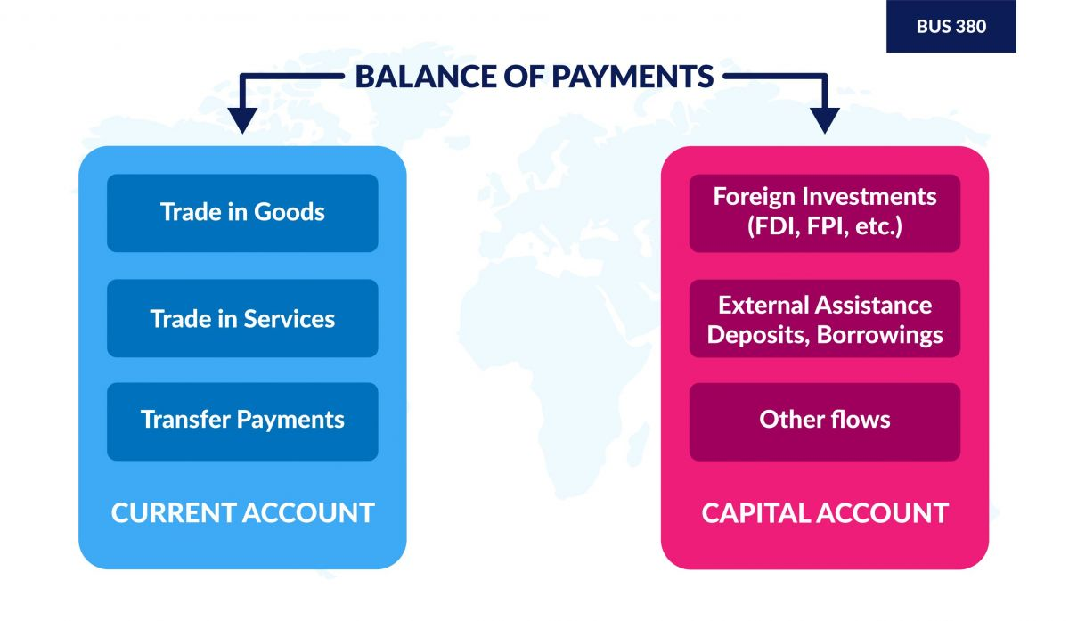

A sustained current account deficit (or trade deficit) will result in currency depreciation. This means that more trade value is leaving the country than is coming back. For many years, the United States has been in trade deficit to China because it imports far more goods and services from China than it exports to China. Sustained current account surpluses result in currency appreciation. The Chinese economy has experienced this over a number of years. Current account surplus is a key reason why the Chinese government actively manages its currency to keep it as low as possible relative to the US dollar.

Another element of the current account is **repatriated profits,** or income earned abroad. For example, if Toyota sends some of its profits from US sales back to Japan, the returned profits are the repatriated profits. The profits are key components of the current account. When more money is leaving the country on an annualized basis than is coming in, the deficit in the current account over the long term could lead to a weaker currency.

Last, but certainly not least, is **Investor Psychology**. It is the bandwagon effect – “Uh oh, it’s starting to go down. People are selling that currency; I’d better sell it also.” Or “Oh, it’s starting to gain value, maybe I’ll buy it too.” This dynamic can drive a self-fulfilling prophecy. Currencies often experience short-term movements simply because people buy or sell based on psychology, regardless of other more data-driven factors.

### The International Monetary Fund

The International Monetary Fund (IMF) is the lender of last resort for countries experiencing major balance of payment problems, particularly current account problems. The industrialized nations of earth each help fund the IMF. The IMF does not set any exchange rates; instead, it loans money to help governments get through a major currency devaluation crisis. Loans typically require long-term policy reforms. Borrowers may have to raise taxes, privatize some state-owned enterprises, or eliminate some government subsidies. In other words, borrowers need to improve macroeconomic practices in order to keep getting IMF loan installments. For example, in the 1990s, Mexico and several Asian nations experienced significant currency crashes. The IMF helped them stop the slide and propped up their currency by giving loans to these governments. The countries paid back the loans with interest. The interest payments were based on an assigned quota.

The main difference between the International Monetary Fund (IMF) and the World Bank lies in their respective purposes and functions. The IMF oversees the stability of the world's monetary system, while the World Bank's goal is to reduce poverty by offering assistance to middle-income and low-income countries.

### Worldwide Considerations

People within both the IMF and the World Bank have expressed views that religious organizations and faith-based groups can be powerful allies in stabilizing the world’s economies and reducing poverty. Christine Lagarde, managing director of the IMF in 2018, spoke about the “Appeal of Conscience” to motivate people to work toward economic prosperity because, “Those who have economic freedom can more easily pursue their aspirations—and can build a society free of ethnic, religious, and civil strife” (see ). Paul M. Bisca and Rebekka Grun, with the Brookings Institute, wrote the following about the need for collaboration between the World Bank and religious institutions: “Fighting poverty requires specialized knowledge and technical skill (‘Mind’). But it must also be fueled by passion and commitment for the poor (‘Heart’), an awareness of people’s values (‘Soul’), and hard work to translate ideas and passions into action (‘Hands’)” (see ).

## Exchange Rate Table

Many businesses and individuals refer to an **exchange rate table** as a way to compare currency trends across multiple nations. The most common form is a **cross currency rate** (see table above). Exchange rates are quoted in two ways. They can be quoted as the amount of foreign currency a US Dollar will buy or the amount of US dollars a unit of foreign currency will buy. This is not because the US dollar is the most valuable currency in the world; instead, it is considered the ”base currency” and therefore is the most commonly understood point of reference in global trade.

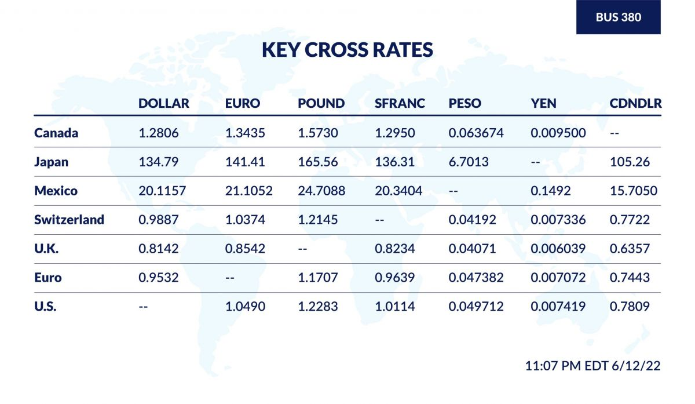

Examine the major currencies table above. The left-hand column shows the value of $1 in each of the foreign currencies. So, in June 2022, $1 was worth 134.79 Japanese yen. The bottom row shows the value of one unit of foreign currency in US dollars. For example, in June 2022, one euro was worth $1.049.You can find the [most recent version of the major currencies on the WSJ Markets](https://www.wsj.com/market-data/currencies).

## Impacts of Foreign Exchange to Businesses

It is important for companies to recognize that if they are going to make or receive payments in a foreign currency, they are carrying the **foreign exchange risk**. This means the exchange rate may change between the time a deal is struck and the payment is due. As a result, the business may pay more (or less) in dollars than expected. To combat this risk, companies may engage in **currency hedging** to protect from fluctuations of the **spot,** or **daily exchange rate**.

Large companies can practice **strategic,** or **strategy hedging.** In other words, they spread out their activities in a number of countries and different currencies to offset losses in any one region. The idea being that if a certain currency goes up, another one will likely go down, so the risk is offset. Smaller companies usually do not have widespread operations, so they are more likely to need to practice currency hedging instead of strategic hedging.

### Comprehension Check

Read each question below, decide on your answer, and select to discover if you are correct. If you answer incorrectly, review the sections above to learn the correct answer.

Which of the following is not one of the components of the balance of payments, Current Account?

1. Merchandise trade
2. Service trade
3. Income made on foreign-owned assets
4. Foreign Direct Investments

The Canadian government has not intervened in the foreign exchange market to affect the value of their currency since 1988. Since 1988, the Canadian dollar has been an example of which currency exchange system?

1. Free Float
2. Fixed
3. Spot Market
4. Managed (or dirty) float

An American buys a Big Mac Sandwich at McDonald's in Denmark. Then, she figures out that it cost more (in dollars) than it would have back in the United States. The Big Mac Index suggests that the Danish kroner is overvalued and will probably lose value in the future. This is an example of _________.

1. Interest rates
2. Purchasing Power Parity
3. Balance of payments
4. Productivity

If the euro gains value against the dollar, which of these scenarios would most likely occur?

1. A German company converting dollar profits from its US subsidiary would receive more euros
2. German imports would cost less in US dollars
3. An American tourist in Germany would find their hotel costs less in US dollars than before
4. An American company buying parts from Germany would have lower parts cost (in dollars) if they were paying in euros

Read this online at <https://books.byui.edu/international_business/economic_issues>