# International Marketing: Target Markets, Product Decisions



## Introduction

Marketers need to heed the example of our Lord, who gives to every man according to his needs.

If a son shall ask bread of any of you that is a father, will he give him a stone? or if he ask a fish, will he for a fish give him a serpent? (Luke 11:11).

The principle of understanding others’ needs and organizing your efforts to meet those needs is both an eternal principle and a foundational principle of good marketing. One key principle of marketing is market segmentation. The Apostle Paul tailored his messages to the needs of each region. Every epistle spoke to a different geographic target market. Today, missionaries seek the Spirit to direct the message according to the needs of the investigator. They practice a form of micro-segmentation. Area Presidencies focus on the specific needs of the people in their areas. While the gospel is the same truth for all, specific teachings are needed to touch the hearts and bless the lives of individuals according to their circumstances. As an international marketer, you are also invited to cater your creative efforts to the specific needs and circumstances of each target market you seek to serve.

### Questions to Ponder

* How can I look at potential target markets to segment them (organize them) in a way that helps me better understand and meet potential customers’ needs?
* How can I work together with my team members to understand the target market and develop a strategy to help us effectively enter a new international market?
* What methods are available to help me understand the competitive environment in a new international market?
* What differentiation and positioning strategies exist and how can I apply them and thrive amidst competition?
* How can we develop a product and brand strategy that adds value, differentiates our product from competitors, is not easily imitated, and is appropriately adapted to the local needs of an international market?

## Developing an International Marketing Strategy



There are two basic parts to developing a marketing strategy:

1. Identify and understand your target market.
2. Tailor your **P**roduct, **P**ricing, **P**romotion, and **P**lace (distribution strategies) to the needs of your target market.

### Identify and Understand Your Target Market

You need to first separate your market into distinct groups of consumers, because not all citizens of a host country are the same and purchasing behaviors differ between groups. Each group is called a **market segment**, and after segmenting the market you choose one or more of these segments as a target market to pursue.

There is essentially one main question to answer as you determine market segments in a new international market: Do you need to use a different method of market segmentation in the host country versus how you’ve done it at home, or is your target market a global segment that is essentially the same around the world?

#### Methods of Market Segmentation

If you determine that your marketing strategy will have to be different in each country to account for differences in your target market, you will want to carefully consider multiple ways of analyzing and determining market segments, including by product benefits, psychographics, demographics, geography, and competitive factors.

#### Based on Product Benefits

There are various building blocks of market segmentation. First of all, where possible, segmenting should be done based on product benefits sought by a particular group of people within your target market. This will help you design and market your product or service to better meet the needs of the customers within each segment. For example, customers of a bank may be divided into different segments based on the product benefits each segment feels are most important.

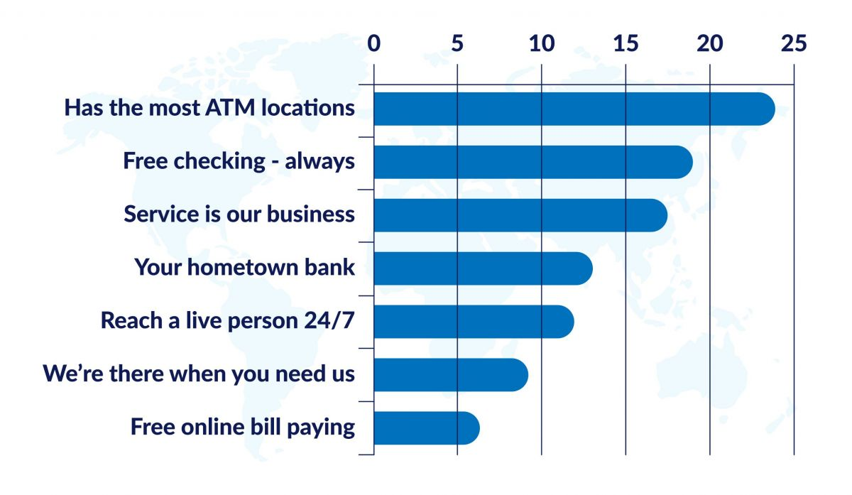

If you were to use the data above to determine your market segments, you might choose the top three most-desired benefits as your market segments:

* Convenience Oriented (customers who care most about easy access to ATM locations)
* Cost Conscious (customers who care most about free checking)
* Service Oriented (customers who care most about friendly service)

Although a company may segment their target market a certain way based on the needs of customers in their home market, the needs of their target market may change as they take their product or service to a different country. When that is the case, a wise company will determine new segments based on the different needs of the new country’s target market.

#### Based on Psychographics

Once you have identified the market segments you seek to serve, you will then want to look at the psychographics of the customers within each market segment. This means looking at the motivators (things like attitudes, activities, hobbies and activities, political views, talents and skills, personality traits and opinions) of groups of people. This can help you develop the advertising and promotion strategies that appeal to a specific segment and can also aid in the design of your product or service.

### Worldwide Considerations

Religious beliefs and practices often provide the foundation for the psychographics mentioned here. Learning a little bit about the prevalent religions in the countries and markets you are seeking to enter will give you a greater depth of understanding of why certain products or services may be more or less marketable. It can also help you navigate potentially controversial products or services, such as [fashionable hijabs](https://en.vogue.me/culture/lifestyle-and-travel/the-changing-faces-of-hijab/) for Muslim women. You may want to review some of the material in Chapter 2 of this text and/or explore the "Beliefs" and "Ethics and Community" sections for specific religions in the Patheos [Library of World Religions and Faith Traditions](https://www.patheos.com/library). Knowledge of other worldviews can better help you understand the foundations behind the psychographics of a population.

The VALS framework (based on "Values and lifestyles”) is an example of a framework that helps companies identify what matters most to their target market. There are three basic categories in the VALS framework:

* **Experiencers** are primarily motivated by self-expression.
* **Achievers** are motivated by the desire for accomplishment and achievement.
* **Thinkers** are motivated by ideals or principles.

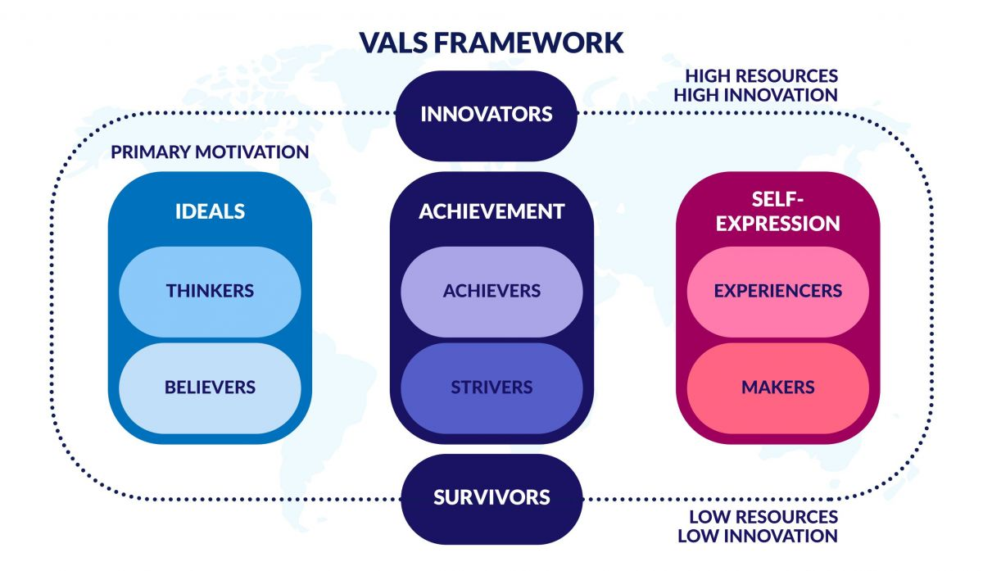

This helps explain how video game companies use the VALS framework to improve how they design and market their games.

Similar to a video game company, if the bank we discussed in the previous section wanted to use the VALS framework to further segment their market based on psychographics, they might gather together a focus group of people from each of the benefit-based market segments (Convenience, Cost, and Service) and begin digging deeper to discover the psychographic motivators that influence why the customers in each benefit segment care so much about their chosen product benefit.

#### Based on Demographics

Perhaps the most familiar and common variable in market segmentation is demographics, although this is often not a good predictor of the unmet needs of the market. For example, most university students are in their late teens and twenties, but do all of them have the same purchasing behaviors? Their purchasing behaviors may be similar for some products and services, but they are often quite diverse.

Demographics could also include age, gender, income, education level, and ethnicity. While demographics can help us see obvious and somewhat helpful differences in a market, they are not the most reliable way to segment a market. It’s best to create segments based on product and service benefits first, psychographics second, and demographics third to further describe a segment when needed. For example, a segment for a clothing brand might be defined as follows: “This segment values style over function, are motivated by self-expression, and tend to be younger but come from well-educated middle to upper-class families.” So you can see that the benefit sought is primarily followed by some psychographics and then demographics come in as additional descriptors.

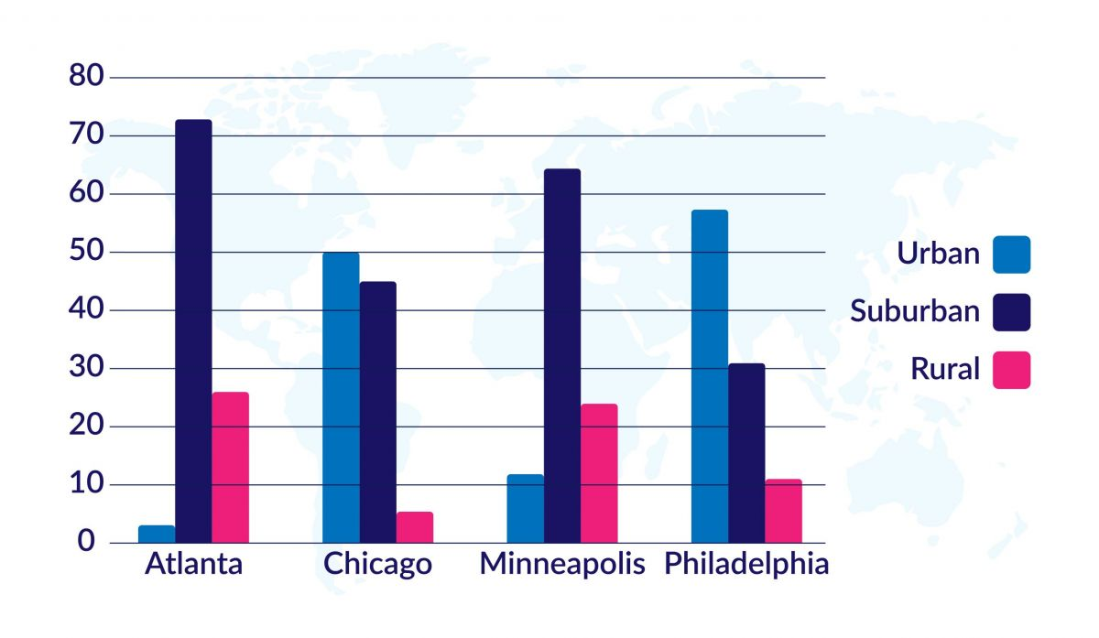

#### Based on Geography

The last dimension that is sometimes helpful in creating market segments is geography. This can be important when certain geographic areas have a higher or lower propensity to purchase a product or service. It could also be important when the other segmenting variables being used tend to be found in certain geographic areas. For example, within a city, you can often use zip codes to identify higher-income areas or neighborhoods occupied predominately by senior citizens.

Once you understand the demographics of a market segment, you can then look at geography; or if you understand product usage, you can then look at cities or markets that tend to use a product more than others. Using the example above of the style-minded, self-expressive clothing brand, they might choose to target college towns in larger cities. Internationally, your target market might be focused geographically due to proximity to resources and infrastructure, or perhaps you might start with bigger cities or proximity to a port.

#### Based on Competitive Factors

In selecting your final target market, once you have segmented the market according to the factors previously discussed, it is also important to take a look at the competition. Consider which market segment has the most **unmet** needs that you can satisfy with your product or service. Avoid segments that are already satisfied with existing products or services, unless you have a new and meaningful benefit to offer that can give you a sustainable competitive advantage.

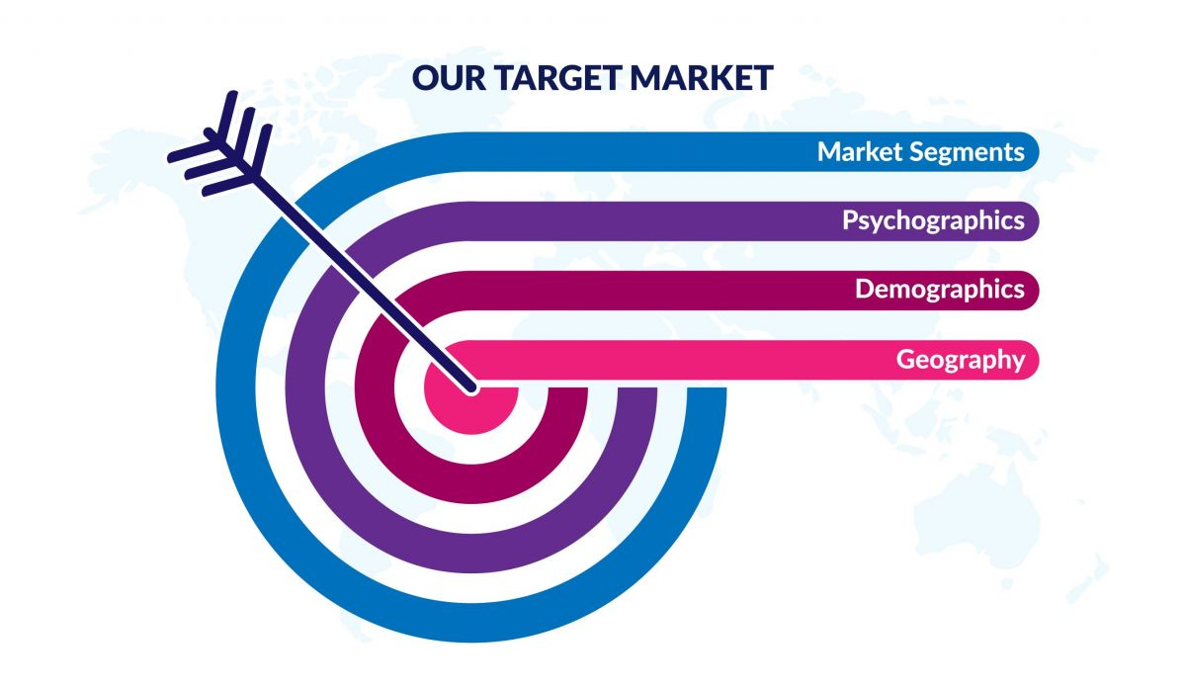

### Comprehension Check

________ refers to the process of identifying groups of potential consumers with distinct characteristics, behaviors, and needs. The aim is to cluster customers into groups that clearly differ from one another but show a great deal of similarity within the group.

1. Demographic Profiling
2. Consumer Differentiation
3. Customer Analysis
4. Market Segmentation

Where possible, segmenting should first be done by ________.

1. Psychographics
2. Benefits Sought
3. Demographics
4. Geography

## Use the 4 P’s of Marketing to tailor your Product, Pricing, Promotion and Place (distribution strategies) to the needs of your target market

The 4 P’s of Marketing (Product, Price, Promotion, and Place) are like four levers, or decisions, you can make to meet your target market’s needs and cater your marketing in a way that will be attractive to your market.

This from Hubspot gives a brief and effective introduction to the 4P’s.

If you want to watch a short video instead, another option.

The following section addresses your Product Strategy. The remaining 3 P’s will be addressed in the next chapter.

### Product Strategy

Once you have identified your target market, it’s time to tailor your product strategy to fit their needs, especially their unmet needs. When you plan to enter new international markets, you have to decide whether you can standardize your product to be the same throughout the world, or if you will need to adapt to meet the specific needs of each market.

Standardization is less costly and easier to manage. It also provides a global identity if that’s important in your category. However, you may need to adapt or vary your marketing mix in each country to be locally responsive. In review, the marketing mix is the product strategy, the pricing strategy, the promotion strategy, and the placement or distribution strategy. In reality, standardization may be the exception rather than the rule, at least in many consumer goods markets. Standardization is more likely to be successful in industrial markets.

There are two pressures for companies that affect both product and promotion strategies. The pressure for cost reduction calls for global standardization; for example, most electronics industries have fairly standardized global marketing strategies. This saves money and allows for modular interchangeable components. Other industries require greater local responsiveness and local adaptation. This is very common in food services and restaurants. For example, McDonald’s identifiably varies their menu to attract consumers from each country in which they are located.

Another concept that is important to think about as you develop your product strategy is your product line. What products or services will you provide? You also need to consider the breadth of your product mix. The Procter & Gamble image shown below has a broad mix of product categories including laundry detergents, toothpastes, shampoos, skin care products, household cleaning products, and more. On the other hand, the Sno Shack, located in Rexburg (the hometown of BYU-Idaho), has a narrow product mix; all they sell is snow cones.





Finally, each product line may vary in breadth and depth. For example, Procter & Gamble’s detergent line for washing clothes has eight different brands, so they are very broad in their detergent product line.

Product lines that have many sizes, flavors, styles, or colors are deep product lines. For example, the General Mills cereal brand Cheerios is very deep. They have all kinds of flavors and multiple box sizes as you can see listed in the graphic below. They have one of the deepest cereal product lines.

#### Examples of Product Adaptations from Around the World

Please review the following examples to understand more fully how some companies have made product adaptations to improve sales by better serving their international customers:

#### [Box of Bread in Japan!](https://www.youtube.com/watch?v=114SbG13fbA)

White bread is most popular, and crusts are not liked by many, and therefore, it is sold in smaller packages.

[Box of Bread in Japan! Video Transcript](https://docs.google.com/document/d/e/2PACX-1vQhZXmyzUdHtgRNNCfmqnLrs70i5xRswmu84WZme9yLMgNAcbpV97e8WiMxdyczMHlk2JXhEiDG1bVO/pub)

#### [Tang a Hit Again, Just Not in U.S.](https://www.nbcnews.com/id/wbna36852847#.U9fcjWOTFj5)

#### [Oreos Global Marketing Video](https://www.youtube.com/watch?v=75NpeAN-z4k)

[Oreos Global Marketing Video Transcript](https://docs.google.com/document/d/e/2PACX-1vTuJjVkQHrhTgN8sspjhDlqr1FZExxtVNr_gtt061EvXY5P8fXohFWaw0dY-ejYCFUhYEU3D6psRs1R/pub)

### Using VRIO Analysis to Evaluate the Competitive Viability of Your Product

Once you’ve determined the products you wish to sell in a given country, it is also important to understand whether your product will perform well in a new competitive environment. VRIO analysis is an effective tool for thinking through whether or not your product will thrive or be crushed by competitors. Please read the information  to better understand the framework shown below:

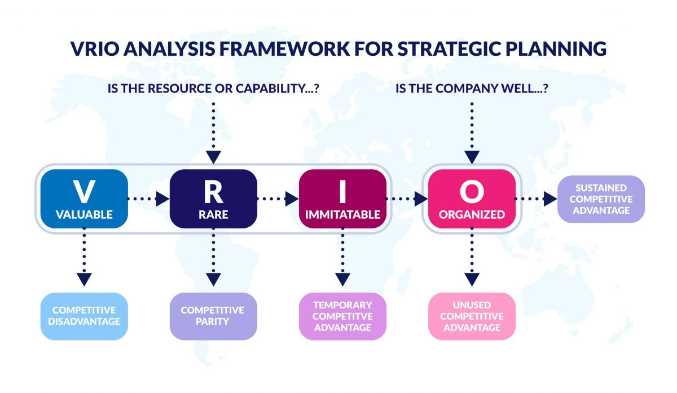

### Positioning Statement

A positioning statement is a brief description of a product or service and how it fulfills a market need for a target consumer. It is an internal tool that helps marketers align their decisions and communication with the brand's value proposition and reputation. A positioning statement also explains how the product or service is unique or different from the competition. A great marketing positioning statement should be clear, concise, and memorable. It should also be unique and differentiate your product or service from the competition. One commonly used form is:

Our ____________ (Product/Brand) is ___________ (single most important claim) among all ____________ (competitive frame) because ____________ (single most important support)

Here are a few generic examples:

1. Our **brand** is the **most trusted** among all **online retailers** because we offer the **best customer service** and the **most competitive prices**.
2. Our **product** is the **most innovative** among all **smart home devices** because it has the **most advanced features** and the **most intuitive user interface**.
3. Our **brand** is the **most eco-friendly** among all **fast food chains** because we use only **sustainable ingredients** and our packaging is made from **100% recycled materials**.

A great marketing positioning statement is important because it helps you maintain focus on your brand and its value proposition while you work on market strategy and tactics. It guides the creation of your marketing materials by giving everyone a consistent message to work with. It also helps you appeal to your buyer personas in a relevant way by establishing all the fundamental concepts of your brand, product or service. It tells customers the value points of your concept, establishing why they should buy it instead of other alternatives.

### Comprehension Check

Which of the following is NOT true of marketing mix adaptation?

1. It complicates the international marketer's job
2. It leads to better local responsiveness
3. It usually reduces costs related to marketing
4. It usually increases costs related to marketing

Cheerios has many different flavors and sizes, all sold under the same brand name, and all a variation of the same O-shaped cereal. It would be appropriate to say that Cheerios has a ________.

1. Narrow Product Mix
2. Deep Product Line
3. Shallow Product Line
4. Broad Product Mix

## Conclusion

While there are many important decisions to be made when taking your company global, perhaps some of the most important decisions are to whom you will sell (your target market) and how will you design and market products that meet the needs of that market. As you implement the concepts and tools discussed in this chapter, your probability of success will be much greater.

Read this online at <https://books.byui.edu/international_business/intl_marketing>